**Food hygiene questions**

Using your food hygiene knowledge, answer each of the questions below.

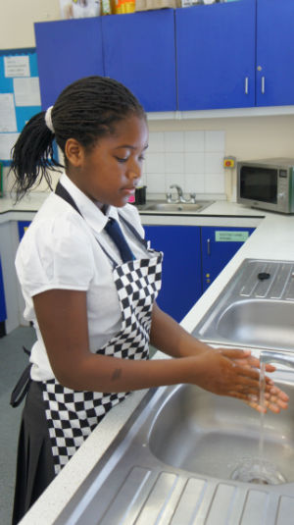

Thoroughly wash and dry hands before and during cooking. If possible, use anti-bacterial soap. Why?

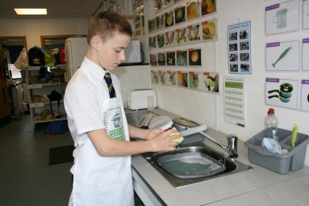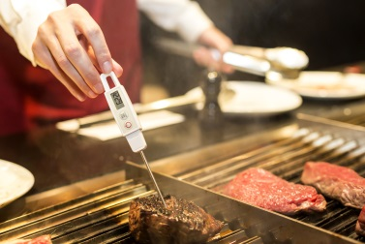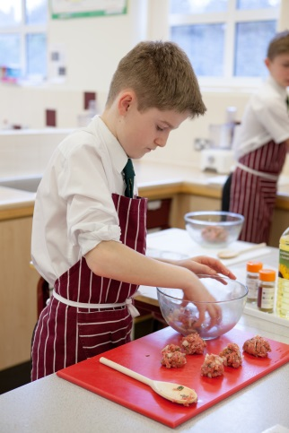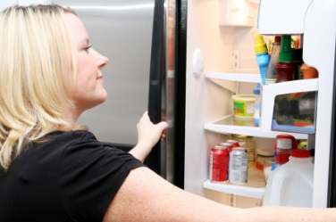

High risk ingredients, such as meat, should be stored below 5°C. Why?

**Extension task**

Choose one of the points above and produce a ‘Food Hygiene Top Tip’ poster which could be displayed in your classroom.

Always use a separate clean board for raw meat. Why?

Equipment should be thoroughly washed and dried after use.

Why?

Meat should be thoroughly cooked. Check that there are no pink bits remaining and the juices run clear. Why?