Judaism Beliefs and teachings Revision Guide

NAME ............................................... FORM GROUP.........
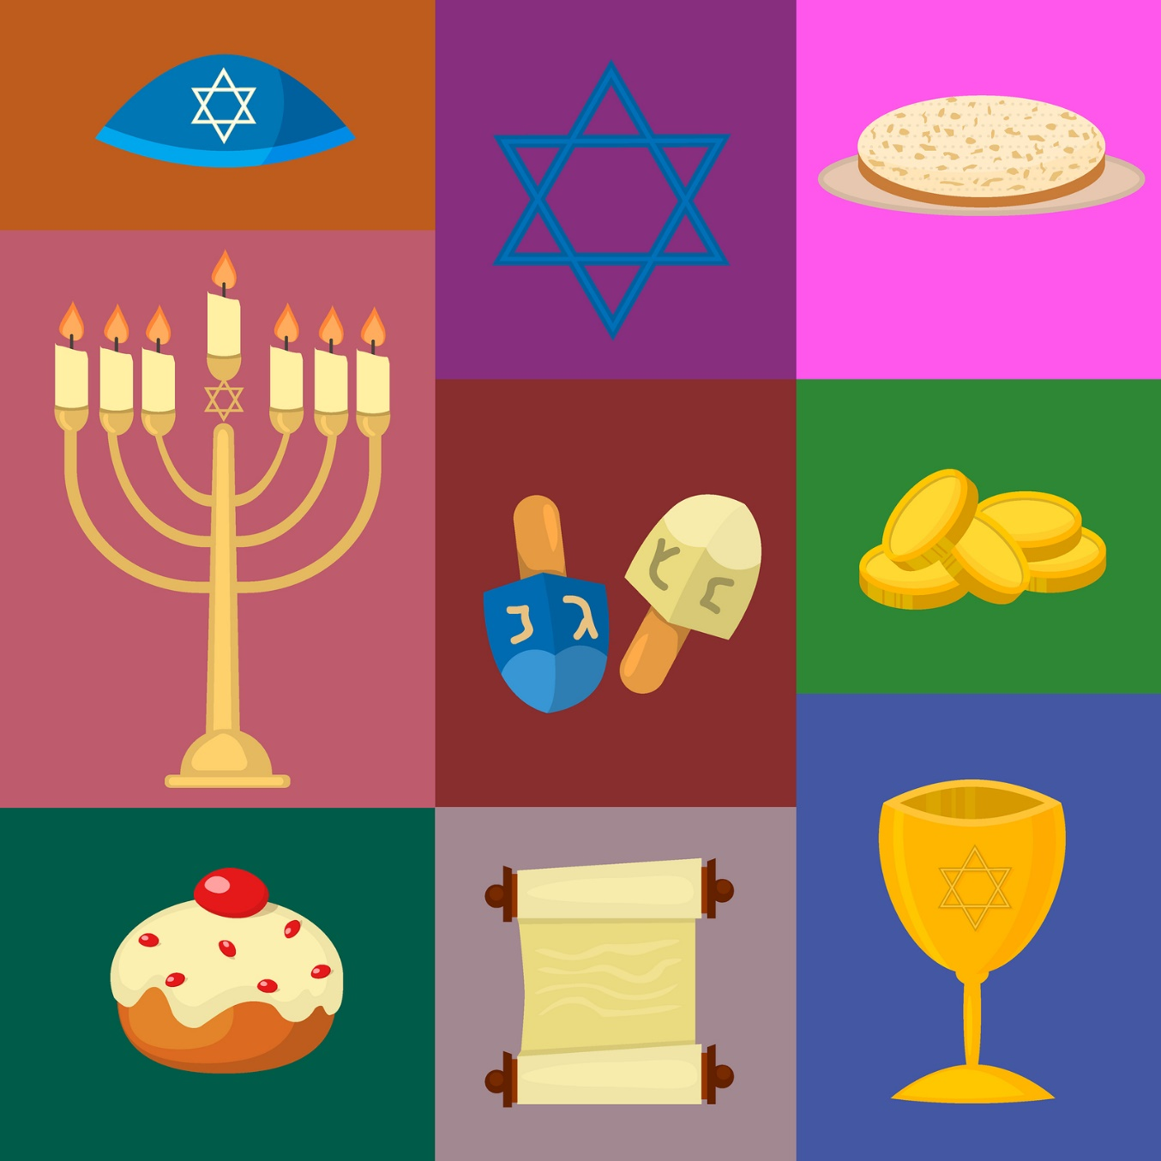
Basic Information about Judaism

• There are about 17 million Jews in the world
• It is one of the oldest religions at about 3,500 years old
• Most Jews, about 6.5 million, live in America
• Many Jews, about 6 million, live in Israel
• In this country, the UK, about 300,000 Jews live
• the main holy book is called the Torah
• the main founders of the religion are Abraham and Moses
• There are many different types of Jewish people, such as Orthodox and Reform.
• Jewish people believe in one God are think they are God’s chosen people
• Jewish people have been persecuted and treated badly many times through history, and experienced much anti-Semitism (racism) in the past
• Trying to find a homeland after the awful terrors of the Holocaust, the Jewish state of Israel was founded in 1948
• There are 613 rules (Mitzvot) in the Torah which they try to follow as best they can, whichever country they live in.
Differences between Ultra-Orthodox Jews, Orthodox Jews and Reform Jews
• Ultra-Orthodox Jews are very strict in how they read the Torah. They often take parts of it word for word and try not to break the rules at all
• they often look different as they have long forelocks of hair, have all their clothes in black and wear large hats
• Examples: they would wear a tallit under their clothes all day long, may have big families and often live in communities separate from non-Jews
• Orthodox Jews believe they should live their lives as close to the rules laid down in the Torah as possible
• Orthodox keep many rules of Torah very strictly such as not working on Shabbat and only allowing men and women to have certain roles in the synagogue
• Reform Jews think that the Jewish religion should move with the times
• Reform Judaism started off about 150 years ago and tries to understand the Torah alongside modern day life

Beliefs in God
The Shema:
Hear, O Israel: Hashem is our G-d, Hashem is the One and Only. You shall love Hashem, your G-d, with all your heart, with all your soul, and with all your resources. And these matters that I command you today shall be upon your heart. You shall teach them thoroughly to your children and you shall speak of them while you sit in your home, while you walk on the way, when you retire and when you arise. Bind them as a sign upon your arm and let them be ornaments between your eyes. And write them on the doorposts of your house and upon your gates.
Deuteronomy 6:4-9

Core ideas include belief in one God that is also the creator, the law-giver and judge of all things. The divine presence of God is called the Shekhinah

The Nature of God God is one.
• Jews believe that is only one God. Therefore Jews are Monotheists.
God is a single, whole being that cannot be divided
God is everlasting and beyond something that humans can understand because of how great God is.
• The commandments also state you shall have no God’s before me.
• The Shema is the basic prayer of Judaism and is said every morning and evening
• The Shema a declaration of Jewish faith this states the basic belief of Jews which is that there is one God (monotheism)
God is creator
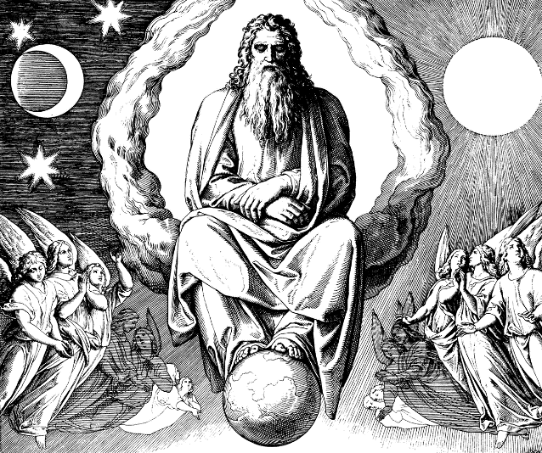
• Genesis states that God created the world and everything within the world. God has a purpose for the world.
• Creation is too wonderful not to have a powerful creator. Jews have a duty to care for God’s creation.
He has almighty power over the world as He was the one to create it.
• God rested on the 7th day of creation so Jews observe Shabbat and do not work on this day of rest too.

God as Judge
• God judges people especially at Rosh Hashanah (the Jewish New year) and after death.
•Psalm 50 ‘And the heavens declare His righteousness, For God Himself is judge’
• Judaism teaches that God has set his laws and they should be followed. God is the ultimate judge of all human beings
• God’s role as judge is strongly associated with death and the afterlife, it is not possible to say sorry after death. This makes it more important to act justly and seek peace in daily life.
•God gave laws to help people exercise their free will in the correct way
God judges everyone on how they follow these laws. He judges them on their beliefs and actions

Why are these characteristics important to Jews today?
Understanding God as a Creator, Lawgiver and Judge helps Jews act ‘in the image of God’ with justice and mercy.
Reciting the Shema twice a day (a prayer about the oneness of God) reinforces the importance of worshipping only One God.
Jews worship a single God although they have plural names for Him. He is more complex than a single part
The main beliefs about God as ONE are: use the information here and page 138
•
•
•
•

This might influence a Jew in the following ways:
•
•

Answer the following questions on this sheet use the information here and page 139
What do Jews believe about each of the following?
CREATION (ORTHODOX JEWS)
CREATION (REFORM JEWS)
EVIL AND FREE WILL
GOD AS SUSTAINER
What do Jews believe about God as Judge? Use the information here and page 140
What are the two main times when God’s judgement takes place?

Shekinah
Comes from the Hebrew meaning dwell. It is the divine presence of God in the world today.
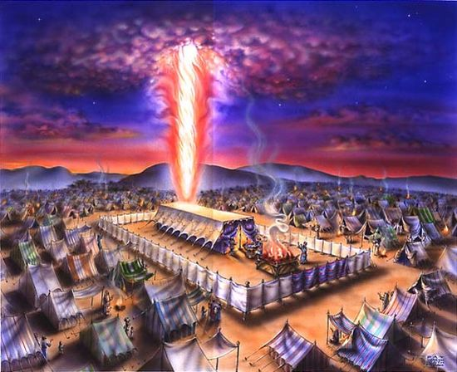
• Adam and Eve “heard the sound of Yahweh walking in the garden” (Gen3:8) this is symbolic to show God is present to humanity within his creation.
• Another example is when God spoke to Moses through the burning bush
• The divine presence of God is important during prayer as it means Jews can have their own personal relationship with God. “Whenever 10 are gathered for prayer (Minyan), there the Shekinah rests.” Talmud.
• Some Jews see the Shekinah as a feminine presence of God, Shekinah nurtures an understanding that God cares just like a mother cares for her children. This aspect of Shekhinah can be more approachable.
After God told Moses to lead the Israelites out of Egypt in search of the promised land (Israel), he also instructed him to build a tabernacle, a portable temple, which God would dwell within as they travelled. It is a key belief in Judaism that God led the Jews out of Egypt.
The Tabernacle kept the presence of God with the Jews as they travelled, and maintained their connection with him.
This connection has continued through worship today in the synagogue. As God directed, a light burns in front of the Ark within the synagogue. This represents Gods divine presence.
Why is the Shekinah important?
1. The Tenakh references the Shekinah being at the temple, Mount Zion and Jerusalem which is what makes it special for some Jews.
2. When Moses received the Torah he was surrounded by the Shekinah which means the Mitzvot comes directly from God.
3. The Shekinah teaches that God’s presence is in the world and therefore believers may come across it at any time.
4. The Shekinah shows that the prophets of the Tenakh were truly inspired by God and so their message must be true
Sources of Wisdom and Authority
2 Chronicles 7:1-3
The Dedication of the Temple
“When Solomon finished praying, fire came down from heaven and consumed the burnt offering and the sacrifices, and the glory of the Lord filled the temple. The priests could not enter the temple of the Lord because the glory of the Lord filled it. When all the Israelites saw the fire coming down and the glory of the Lord above the temple, they knelt on the pavement with their faces to the ground, and they worshiped and gave thanks to the Lord, saying, “He is good; his love endures forever.”
Answer the following questions on this sheet
1. Where can the Shekinah be found?
2. How did it help the Jews of the past?
3. How many people need to be gathered for the Shekinah to be present?
4. Where do Orthodox Jews believe it is present?
5. Give one reason why the Shekinah is important.

Exam Questions
Explain two reasons the Shekinah is important (4)

Explain two ways Jews connect with the Shekinah (5)
In your answer you must refer to a source of wisdom and authority.

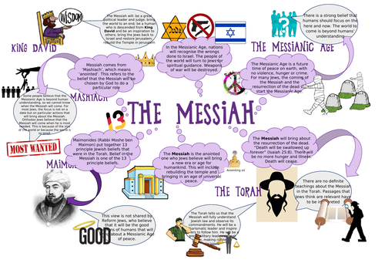
Messiah
The Origins of the Messiah
• The word ‘Messiah’ (anointed one) was originally used in the TeNaKh to refer to the kings of Israel.
• The first king was Saul. In preparation for his role as King the prophet Samuel anointed him to show that he was chosen by God

The Nature and role of the Messiah

• One day there will be a man who is the Messiah and he will come along and save the world
• the Messiah will lead the Jewish people and show everyone in the world what to do and how to behave, there will be peace on earth.
• The Messiah may come when we need him the most and the earth is so full of sin.
• Orthodox Jews are still waiting for the Messiah to come and pray for his arrival, the believe the prophets are God’s messengers and their word is truth.
• Many reform Jews believe we should work together to achieve peace and harmony this is known as the Messianic age. Jews would rather focus on the world we live in today and carry out good actions as a way to repair the world.

Why is the Messiah important?
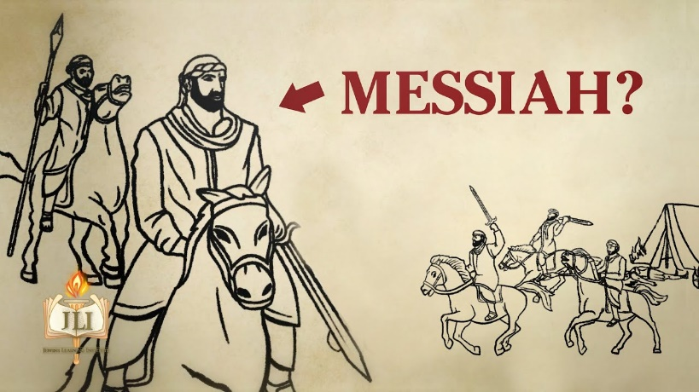
For many Jews the ideal world will come with the Messianic Age, this is the time when God will send the Messiah to put the world right
Jews look forward to the coming of the Messiah-God’s messenger of peace. Everyone will obey God’s commandments and the world will be at peace
Jews believe that the Messiah will come for one of two reasons:
1. the world will get better and be ready or worthy of redemption by the Messiah
2. it will get worse and the Messiah will need to put it right
There are many different Jewish beliefs about the messiah will be like: some believe that the Messiah will be a man, an ideal leader and ruler other Jews believe that the messiah will not be a man but a spiritual force. the world will eventually become good and peaceful and a golden age will be created. all Jews agree that with the messianic age the world be much better
The Messiah is therefore believed to be the one that will be anointed as King at the ‘End of Days
Although the Torah does not make reference to the ‘Messiah’, it does make several references to the ‘End of Days’ which is the time of the Messiah -or the ‘Messianic Age’
The Prophets state the Messiah will:
• Come unexpectedly
• Be the prince of peace
• Restore the temple and Jewish law
• Be a great leader and be powerful

Some Jews believe the Messiah will be a great political leader, descended from King David.

Answer the following questions on this sheet use the information here and page 142
1. What does Messiah mean?
2. What is the Messianic age?
3. Why is King David so important to the Jewish faith?
4. What do Christians believe about the Messiah?
5. Why doesn’t the Jewish faith agree with the Christian beliefs?

Covenant and Abraham
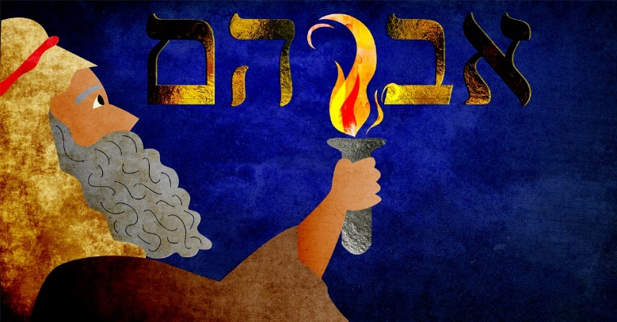
• A Covenant is a sacred promise between God and His people. This may involve certain conditions.
• God called Abraham to leave his home and move to another land.
Abraham started Judaism when he made the covenant (the promise) to God to worship Him and move away from worshipping many false gods.
• God promised him he would be the father of all nations. His name was changed to Abraham from Abram
• Abraham was told that all of his people would be looked after so long as they worshipped God and God alone.
• The Jewish people had to believe in one God and also circumcise all baby boys when they were born
• God would protect His people and give them a promised land (which is Israel)
• God asked Abraham to sacrifice his son to God, although he stopped Abraham from doing this at the last minute.
•Then God said to Abraham, “As for you, you must keep my covenant, you and your descendants after you for the generations to come. This is my covenant with you and your descendants after you, the covenant you are to keep: Every male among you shall be circumcised. You are to undergo circumcision, and it will be the sign of the covenant between me and you. For the generations to come every male among you who is eight days old must be circumcised.”
• Abraham and his son Isaac were both circumcised on the same day.
• This Covenant is a sign that Jews are God’s chosen people.
The Covenant- God promised to be the God of the Jews and protect them from harm. In return, they had to follow the commandments that would allow them to establish a society with rights and peace.

Answer the following questions on this sheet use the information here and page 143

1. What does covenant mean?
2. Why did Abraham and his family leave their home?
3. Where were they travelling?
4. What is circumcision?
5. Why must the Jewish community still follow these covenants today?
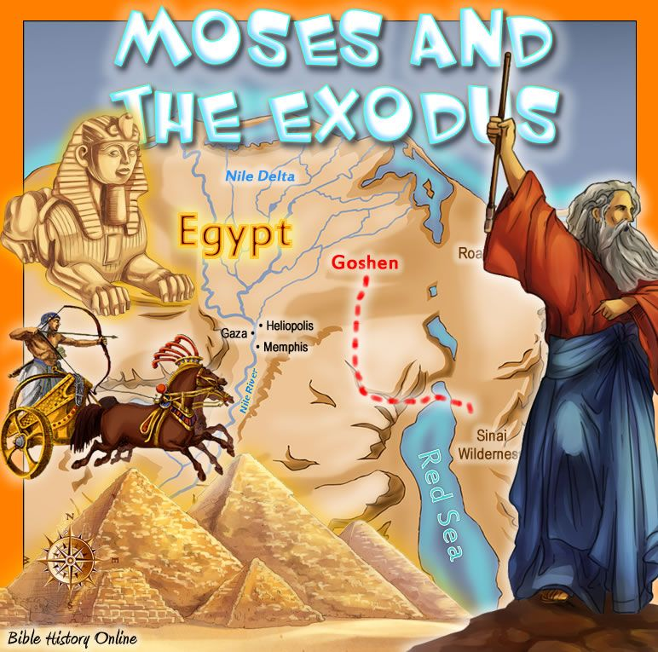
The Covenant at Mount Sinai God’s covenant with Moses at Mount Sinai followed numerous covenants with many of the main patriarchs of Judaism including Noah, Abraham, Isaac and Jacob. As centuries passed, the descendants of these leaders became slaves to the Egyptians and suffered greatly as a result of the Pharaohs. Moses was chosen by God to lead the Jewish people out of slavery and to the promised land.
Why is the Covenant at Sinai important tor Jews today?
The Torah is the most important part of the Tenakh for Jews as it contains the laws of the covenant and was given to the Hebrews. These are still the Jewish guide for living
Jews believe they are bond to follow the teachings of the Torah because of the covenant. Obedience will be blessed and disobedience will be punished
Torah scrolls are still made today for use in the synagogue for prayer and worship. They are stored in the Ark, (Aron Hakodaesh)
Studying the torah is part of Jewish life and forms significant amount of Jewish education

The 10 Commandments.
Exodus 20:3-14
1. You shall not recognise the gods of others in My presence
2. You shall not make yourself a carved image
3. You shall not take the name of Hashem, your God, in vain.
4. Remember the Sabbath day to sanctify it
5. Honour your father and your mother
6. You shall not kill
7. You shall not commit adultery
8. You shall not steal
9. You shall not bear false witness against your fellow
10. You shall not covet your fellow’s house…nor anything that belongs to your fellow
The Ten Commandments are the first ten of the 613 commandments given by God to the Jewish people.
These commandments are mentioned in order twice in the Torah, in Exodus 20:1-17 and then at Deuteronomy 5:4-21
Different Understandings of How and Why the Decalogue is important for Jewish People Today
The First Commandment is important because Jewish people:
• Touch the mezuzah when they go into a room as it contains the Shema: ‘One God’
• Pray 3 times a day to one God: the men wear tefillin which also contains the Shema (reminding them that they believe in one God).
• Say Grace before meals and many of the prayers refer to belief in one God.
The Second Commandment is important because Jewish people:
• Don’t have any statues in the synagogue/home
The Third Commandment is important because Jewish people would not use God’s name in a negative way. Many Jews don’t even speak or write the word God.
The Fourth Commandment is important because Jewish people:
• Observe the Sabbath on this day. Orthodox Jews literally do not do anything classed as work.
The Fifth Commandment is important to Jewish people because:
It helps them in their family life, they also support charities that care for the elderly.
The Last 5 Commandments are also important because Jewish people:
• Use them for moral guidance when making moral decisions.
• If Jewish people follow these guidelines they will have a good relationship with their neighbours.
• They reject violence
• They promote marriage and family life
• They will not lie, cheat, etc
• They reject all forms of greed and materialism.
• Observe the Sabbath on this day. Orthodox Jews literally do not do anything classed as work.
As a Reform Jew, I believe that the Torah Law –especially the Decalogue -is very important.
However I don’t believe that the whole of the Torah was given at Sinai, or that it was all given by God.
I believe that as Jews we should work out which parts are significant for today.
We are more flexible about how the Torah should be applied today.

As an Orthodox Jew, I believe that the entire Torah was given at Sinai.
It is therefore binding for all time and should never be changed.
We study the Torah carefully, discussing its meaning.

Exam practice:
Give two of the Ten Commandments [2 marks]

Explain two ways in which the covenant at Mount Sinai influences Jews today [4 marks]

The afterlife
In Hebrew the afterlife is referred to as Olam Ha Ba which translates as the world to come.
Jews do not have a single understanding of the afterlife as Jews place greater emphasis on the present day not the afterlife. Jews also believe God’s ways are beyond our understanding, scripture has no clear guidance.
Jewish understanding of the afterlife comes from understanding the following key terms.
Soul – Jews believe God created the soul of all humans starting with Adam Genesis 2:7
The rabbis teach that the soul leaves the body while a person is asleep and visits heaven for refreshment. During the Sabbath (a weekly day of rest and worship), God gives everyone an extra soul.
Sheol – a place of the dead awaiting purification.
Resurrection – the belief that the dead arise on judgement day
Judgement – linked to resurrection, God will determine your fate.
Gan Eden – a place of spiritual perfection. Only the very righteous will enter this place.
Gehenna – a place of the dead in punishment (hell) this punishment will come after the day of judgement at the coming of the Messiah.
When people are judged by God their body and soul are reunited. The soul will blame the body for its actions. Judgement will take place after the coming of the Messiah. Although many Jews believe that they will be punished or rewarded after death for the way in which they have lived their lives, there is no clear teaching about heaven.
Jews believe that the importance of life is the way in which it is lived on earth. Whatever happens after death is in God’s hands and should be left to God to arrange.

Exam practice: use the information here and page 141
Give two Jewish beliefs about the after-life [2 marks]

Explain two ways in which Jewish beliefs in the after-life influences Jews today [4 marks]

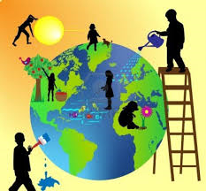
KEY MORAL PRINCIPLES
Judaism is seen as a complete way of life that helps believers to act in a way that is pleasing to God.
Justice- bringing about what is right and fair according to the law or making up for a wrong that has been
committed. The Torah and the Prophets were sent to help people understand and bring about justice.
Creating a just society requires all individuals to live their lives correctly.
Healing the World- this is action that brings people closer to God e.g. volunteering for a charity. Some
think this is too limited about that prayer and obeying the mitzvot is important to becoming closer to God.
Kindness to Others- Many laws in the Torah spell out ways to be kind to others. The Torah does not just prohibit bad acts but also encourages acts of kindness.

Links to Scripture and Teaching
Leviticus 19:18- Love your fellow as yourself.

Answer the following questions on this sheet use the information here and page 144
1. What is the World Jewish Relief?
2. How do they help to heal the world?

3. Why should Jews show kindness to others?
4. Why is pursuing justice a sacred duty?

Sanctity of Life
Life belongs to God so it is their duty to preserve life in all circumstances.
Changes in technology has meant making decisions around life and death more difficult. E.g. when do you turn off a person’s life support?
Some believe that life should be preserved at all costs whereas, others would argue that life should
be ended when a person is in great pain.
Jews have an obligation to save a human life. This is more important than any other Jewish laws.
Pikuach Nefesh is the Jewish principle that Jewish laws may be broken in order to save a life. Eg breaking a fast day on Yom Kippur to help somebody who was severely ill. Driving someone to hospital on the Sabbath.
The Talmud states you should always live by the laws but never die because of them.
Judaism also permits organ donation because of Pikuach Nefesh
Jews believe only God can ever take life, because of this nothing should ever be done which can bring about death. Euthanasia will never be permitted. Jews have a duty to care for those who are seriously ill.

Links to Scripture and Teaching
Sandhedrin 4:5- if someone destroys a human life the scripture considers it the same as destroying a whole world.
Leviticus 19:16- you should never profit from the blood of another person.

Questions use the information here and page 145
1. What does sanctity of life mean?
2. How does this belief link to Genesis?
3. Would a Jewish person agree with euthanasia? Explain your answer.
4. Why would donating an organ be considered a great honour to some Jews?
5. What does pikuach nefesh mean?
Free Will and Mitzvot
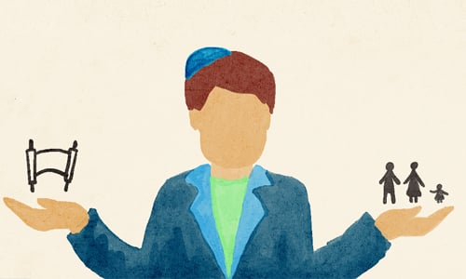
Jews believe that they are given free will to choose to act in a way that is pleasing to God and will be rewarded on the day of judgement. To use your free will for actions that are wrong will weaken a person’s relationship with God. To help people use their free will correctly Jewish people have 613 mitzvot (248 positive and 365 negative); they give guidance on worship, family issues and conduct in society.
Men and God- Many mitzvot are based on the first four commandments; don’t worship images or false Gods, not to misuse his name and to dedicate the Sabbath to honouring God. These mitzvoth give advice on how to deepen your relationship with God.
Man and Man- Loving God and your neighbour cannot be separated.
Positive relationships with others are pleasing to God. These mitzvot cover how to settle disputes, treatment of workers and the types of food they can eat.

Questions use the information here and page 147
1. How does following the mitzvot affect a person’s relationship with God?
2. Give two examples of mitzvot between men and God.
3. Give two examples of mitzvot between men and men.

