PE Design Challenge!
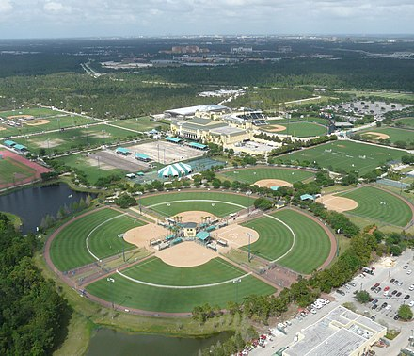
Pupils to re-design the sports facilities on our St Mary’s campus, to include sports complex, gym, pool/spa, and outdoor facilities e.g. 4G astro, sand dressed astro, floodlighting, storage facilities, basketball courts, tennis courts, outdoor table tennis tables, outdoor gym area, athletics track etc.

