|  |
| --- |
| Children & Families Directorate  **Chris Baird Director** |
| Please ask for: Carolyn Doyle |
| Direct line: 01432 260048 |
| Email: cbaird@herefordshire.gov.uk |
|  |

|  |  |
| --- | --- |
| **PRIVATE AND CONFIDENTIAL** | 28 August 2020 |

Dear parent/carer,

We would like to welcome your child back at a Herefordshire school, college or early years setting for the autumn term.

We are expecting all children to return unless they are unable to attend due to sickness, isolating, or have been told not to return by their clinician. We have continued to work with schools over the summer to ensure that measures are in place in keep staff and children as safe as possible.

Your school or college will be communicating the arrangements for the start of September and these will include a range of measures that have been put in place to reduce the risk of spreading coronavirus, including:

* Having good hand washing and respiratory hygiene ‘catch it, bin it, kill it’ practices in place
* Keeping the number of people who are in contact with each other as low as possible (this may be through staggered break times or keeping children in year group ‘bubbles’)
* Increased cleaning of school facilities and equipment
* Reinforcing the message that if someone in a household tests positive for COVID-19, their child must not attend school and everyone in that household must self-isolate (stay at home) for 14 days.

Education is essential for your child’s development, and school and college is the best place for your child’s education. Being with classmates and teaching staff is also important for your child’s emotional and mental wellbeing. We understand that some children may be nervous about returning, and this understandable. Schools and colleges are very aware of this and the staff have been working extremely hard to prepare for a safe return and will have support in place ready to meet children’s needs. We recommend that you talk to your child about how school or college will be different in September, taking on board information from your school. This will help to ease any anxiety or worries that your child may feel.

If your child is able to, you can help your child’s school or college to control coronavirus by:

* Encouraging your child to wash their hands regularly for at least 20 seconds
* Make sure they carry tissues and teaching your child to sneeze into a tissue or their elbow
* Keeping a social distance of 2m from people not in your household wherever possible outside of school
* Following the instructions provided by your child’s school
* If your child has a new continuous cough, high temperature, change in or loss of taste or smell, book a test and keep them off school to self-isolate for 10 days. Everyone in the household must then self-isolate (stay at home) for 14 days. For a free COVID-19 test call 119 or visit [www.gov.uk/get-coronavirus-test](http://www.gov.uk/get-coronavirus-test)

If your child has particular needs relating to their special educational or additional needs and COVID-19 please do follow these up with your school. The council’s SEN and disabilities teams have been working with individual parents and carers in preparation for a safe return to school. For pupils who have been previously shielded, work has been carried out and continues with Herefordshire’s Designated Medical Officer to understand the risks that particular conditions might present and how adjustments can be made to address these risks.

Further information on how to return to school safely is available on the Herefordshire Council website at [www.herefordshire.gov.uk/backtoschool](http://www.herefordshire.gov.uk/backtoschool)

We advise you to plan ahead to ensure your child can travel to and from school or college as safely as possible. The latest school transport information relating to the coronavirus is available on the Herefordshire Council website at [www.herefordshire.gov.uk/schooltransportcovid19](http://www.herefordshire.gov.uk/schooltransportcovid19)

COVID-19 travel restrictions remain in place on public transport, and this will reduce the number of seats available. The council has been able to put on some more transport in some situations where public transport has been used, to help with this reduction in the number of seats. The Government’s advice is for children and young people to avoid public transport and to walk or cycle to school where possible.

We will continue to support Herefordshire’s schools, colleges, nurseries, preschools and other childcare settings, focusing on the health, safety and welfare of children, staff and our communities.

Yours sincerely

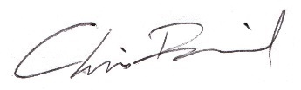 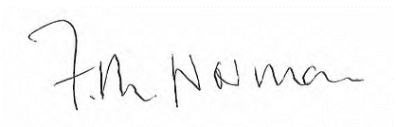

Chris Baird Felicity Norman

Director of Children & Families Cabinet Member for Children & Families

Herefordshire Council Herefordshire Council

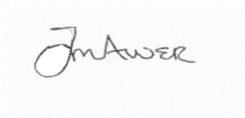

Jo-anne Alner

Managing Director (Herefordshire)

NHS Herefordshire and Worcestershire CCG

 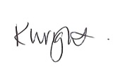

Jane Ives Karen Wright

Managing Director Director of Public Health for Herefordshire

Wye Valley Trust Herefordshire Council

