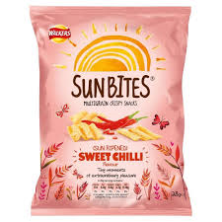 | PepsiCo Sunbites:  2018 Extension Strategy | 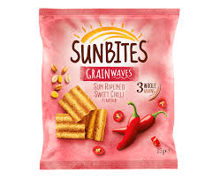
Old pack |  | New pack
Most businesses introduce an extension strategy when a brand hits maturity or decline. PepsiCo is unusual in re-launching its Sunbites brand in July 2018, while sales have been buoyant (see graph below). PepsiCo says “The new look is designed to increase stand-out on shelf, with a softer, subtly more attractive design than the previous branding”. It also looks like the pack is designed to emphasise the word ‘Grain’, which may fit in with the brand’s supposedly healthy image.
The relaunch will also involve a new, bigger advertising campaign and a new product launch. Sharon Barraclough, marketing director for UK Snacks at PepsiCo, commented: “Sunbites has a loyal fan base and we want to continue maximising awareness of the brand as the demand for ‘better for you’ options increases. The TV advert will ensure the brand is front of mind for shoppers and it will also encourage people to try the latest addition to our range, Sunbites Veggie Harvest.
When Sunbites was first introduced in 2011 it was unusual for a snack product in being targeted at 35-50-year old women. It used a series of social media campaigns on Facebook, Mumsnet and other U.K. channels popular with women. It has always been marketed as a multigrain, healthier snack.
The graph below shows the rise of Sunbites, while another PepsiCo product, French Fries, has been declining.

Questions: 20 marks, 20 minutes
1. Explain one disadvantage to a business of marketing its products only by social media. (3)
2. Discuss whether it is wise to introduce an extension strategy during a product’s growth stage. (6)
3. Calculate the % decline in sales of French Fries between 2010 and 2017. (2)
4. PepsiCo had two options with its Sunbites extension strategy: Option 1 to continue to target 35-50-year-old women or Option 2: re-target the brand at all adults. Evaluate which option PepsiCo should have chosen. (9)
Question 4 - 9 marks
1 mark – Definition of an extension strategy
1 mark – What type of extension strategy are PepsiCo using?
4 marks – Analyse options 1 and 2
3 marks – Decision and justification

