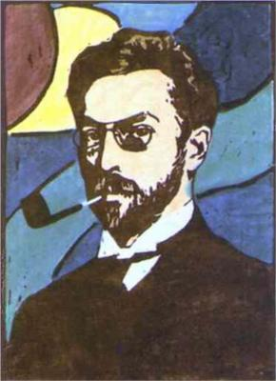**WASSILY KANDINSKY ARTISTS**

**Facts about the artist (use the internet to help!**

Wassily Kandinsky was a Russian painter and art theorist. Kandinsky is generally credited as the pioneer of abstract art. Follow the worksheet to research, copy and complete all of the tasks- using the internet to research and find out information about the artist

________________________________________________________________________________________________________________________________________________________________________________________________________________________________________________________________________________________________

________________________________________________________________________________________________________________________________________________

________________________________________________________________________________________________________________________________________________

**Artist Analysis.**

What do you see in the work? What colours? Do you like the work? What are the characteristics?

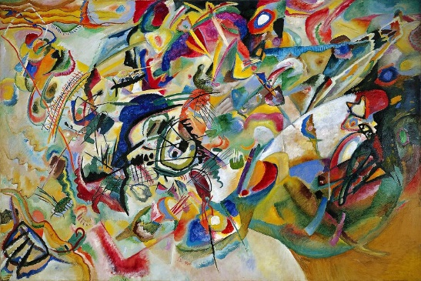 **RESEARCH SHEET**

**ARTISTS COPY-**

As best as you can copy the image on the left in the box using the right colours.

