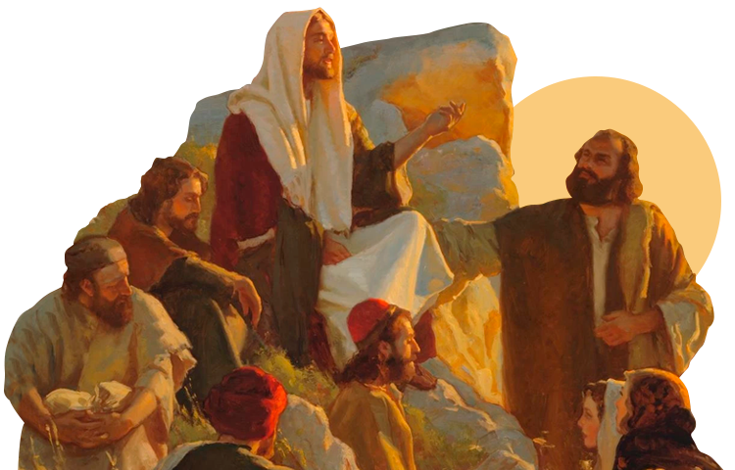
The Life of Jesus

Synopsis
Jesus Christ was born around 6CE in what is called Israel now. Little is known about his early life, but his life and his teachings are recorded in the New Testament.

Christians believe Jesus is the incarnation of God and his teachings are followed as an example for living a good and spiritual life. Christians believe he sacrificed his life for the sins of all people and rose from the dead.

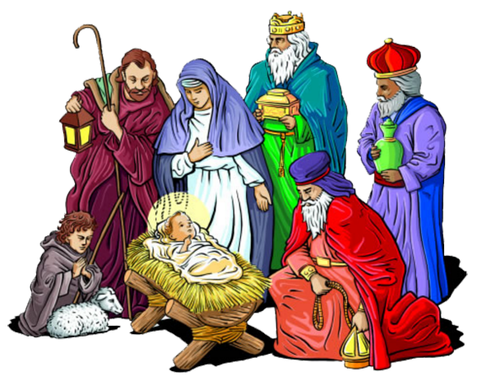
Background and Early Life
Most of Jesus's life is told in the four Gospels. These are the first 4 books of the New Testament. These were written by 4 of Jesus’ disciples Matthew, Mark, Luke and John. These are not biographies in the modern sense. They are written to encourage faith in Jesus as the saviour of humanity who came to teach the message of God, suffered and died to save people from sin.

Christians believe that Jesus’ birth was miraculous. This is because his mother Mary was a virgin who was betrothed to (due to marry) Joseph. One of the reasons that Christians believe that Jesus is special is that he was born through the ‘Immaculate Conception’. This means that his birth did not have any sin - it was pure from Original Sin.

The Gospels describe how Jesus began teaching at the age of 30. This was directly after his baptism by John the Baptist (a religious preacher and Jesus’ cousin) who when he saw Jesus declared him the ‘Son of God’. During his baptism a light shone from the sky highlighting Jesus and a voice said "This is my beloved Son, with whom I am well pleased; listen to him.".

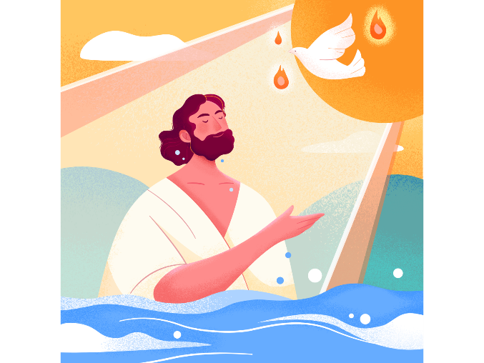
After his baptism, Jesus began a religious quest into the desert where he fasted and meditated for 40 days and nights. Here he was challenged by evil. This is called the Temptation of Christ. Christians believe that the devil appeared and tempted Jesus three times. Each was an attempt for him to use his powers for selfish goals. To turn stone to bread (and feed himself), to throw himself off a mountain and have angels catch him, and once to use his power to take over the world. All three times, Jesus rejected the Devil's proving he was pure and able to resist temptation.

Jesus's Ministry
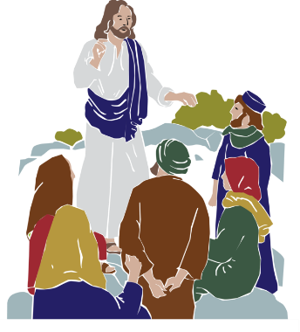
After his time in the desert, Jesus returned to Galilee (an area of Israel) and made trips to neighbouring villages preaching. During this time, several people became his followers. One of these was Mary Magdalene, an important figure in Jesus’ life. Though not officially one of the "12 disciples," she is considered to have been involved in Jesus's ministry from the beginning to his death and after. Mary Magdalene was the first person Jesus appeared to after his resurrection from the dead. She above all people showed she had faith in him.

The Gospels tell how Jesus travelled through Judea and Galilee. He used parables and miracles to explain how to know God’s will and that the kingdom of God was near. As word spread of Jesus's teaching and healing the sick and diseased, more people began to follow him.

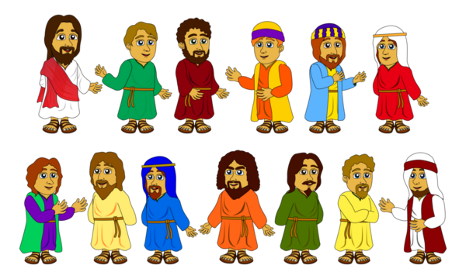
As Jesus continued preaching about the kingdom of God, the crowds grew larger and began to call him the Messiah (or saviour). The Jewish leaders heard of this and publicly challenged Jesus, accusing him of having the power of Satan. They began to develop a plan to have him arrested and killed.

Jesus gathered a number of disciples. Each of them were given a second chance from the life they had. His most loyal follower Peter. Peter showed the most faith in Jesus and he said to him “Peter you are my rock. After my death I will build my ministry upon you.” When Jesus died - Peter remembered what he said and became the leader of the disciples and travelling around spreading Jesus’ message.

In his third year of teaching Jesus told the disciples that he wanted to go to Jerusalem for the Jewish festival of Passover. The disciples warned him that the Jewish leaders would want him dead. He told not to worry and that they would all go.

Jesus arrived in Jerusalem and great numbers of people took palm branches and greeted him at the city's entry. The crowd praised him as the messiah and saviour. The priests and Pharisees became fearful and agreed that he must be stopped. However, they needed some help - nobody knew what Jesus looked like. One of the disciples, Judas, met with the chief priests and told them how he would deliver Jesus to them. They agreed to pay him 30 pieces of silver.

The Last Supper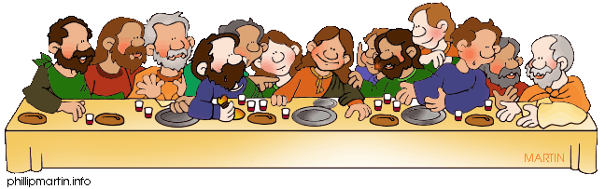
Jesus and his 12 disciples met for the Passover meal, and he gave them his final words of faith. He also told them that he would be betrayed by one of the disciples and privately let Judas know that Jesus knew it was him who was going to do it. Jesus then told Peter (his greatest follower) that he would also betray him by denying him three times. At the end of the meal, Jesus began the Eucharist (Holy Communion) and said to the disciples should eat bread and drink wine in memory of them.

After the Last Supper, Jesus left the disciples to pray. Jesus knew he was going to die but needed to pray for the strength to give himself over. He was met by Judas and a number of soldiers and officials who arrested him. Peter tried to defend Jesus and cut the ear off one of the soldiers. But Jesus stopped him and healed the soldier's wound. After his arrest the disciples met - they knew that everything Jesus had predicted had come true but they still couldn’t understand how he could come back from this.
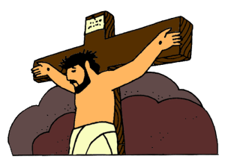

The Crucifixion
Jesus was crucified with two thieves, one at his left and the other at his right. Above his head was a sign "King of the Jews" as a way of mocking him. While Jesus was on the cross, he forgave the people who killed him saying “father forgive them for they know not what they do”. A soldier confirmed his death by sticking a spear into his side, which produced blood and water. He was taken down from the cross and buried in a nearby tomb.

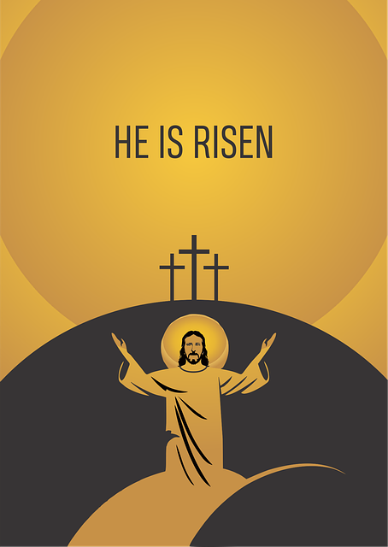
Risen from the Dead

Three days after his death, Jesus's tomb was found empty. He had risen from the dead and appeared first to Mary Magdalene and then to his mother Mary. They both informed the disciples, who were in hiding, and later, Jesus appeared to them and told them not to be afraid. During this brief time, he commanded his disciples to go into the world and preach the gospel to all humanity. After 40 days, Jesus led his disciples to Mount Olivet, east of Jerusalem. Jesus spoke his final words to them, saying that they would receive the power of the Holy Spirit, before he was taken upward on a cloud and ascended into heaven.

Questions:
Answer each of the following questions in full sentences:

- Jesus is the incarnation. What does this mean?
- Where within the Bible do Christians learn about the life of Jesus
- Describe his early life before he started teaching?
- What did Jesus do after his baptism?
- What methods of teaching did Jesus use to prove his point?
- What happened during Jesus’ first week in Jerusalem?
- What happened at the Last Supper?
- How could Peter be said to have betrayed Jesus?
- What happened at the crucifixion?
- What do Christians believe about his resurrection?

