Year 9: Freedom
Design a front cover for this topic

Week One: Freedom from Persecution
Lesson One: To be able to answer comprehension questions about Martin Luther King
Write the definitions under each word, then spell them four times.
 | Attempt 1 | Attempt 2 | Attempt 3 | Attempt 4
Persecution

Segregation

Protest

Justice

Answer these questions – research some of the words online or in a dictionary if you are unsure.
Have you ever witnessed persecution or felt persecuted?
What does it mean to segregate someone?
What is a protest? Have you ever taken part in one?

Have you ever seen justice carried out?

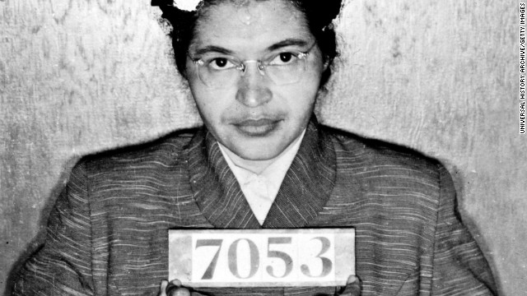

Who do you think this lady might be?

What does this picture make you think of?

What do you think she has done wrong?

Do you ever catch the bus? Where do you sit when you get on the bus?

Describe the last bus journey you were on. Include information about
- What the weather was like
- What the bus felt/looked/smelt like.
- Someone tries to make you move seats. Why? Do you move?

Rosa Parks
The lady in the picture is Rosa Parks.
On December 1st 1955, a black woman named Rosa Parks refused to give up her bus seat to a white passenger and as a consequence was arrested for violating Montgomery’s segregation law. This was the beginning of the bus boycott. Black people refused to use the buses in the area as a protest against the way they were treated by society.
Do you think Rosa Parks was right to refuse to give up her seat? Why?

How do you think it would have felt to have been treated like this?

Martin Luther King
The boycott was led by Martin Luther King, who at the time was a Baptist preacher in Alabama. In 1956 the government passed a law making it illegal to segregate people on buses.
Would you have supported the bus boycott? Why?

Why do you think the bus boycott was successful?

How do you think it felt for the supporters of the bus boycott when the law was passed?

Although Martin Luther King’s home was attacked and bombed, he received death threats and his family’s safety threatened, he continued to lead the civil rights movement without using violence. He believed that all people are equal and it was right to protest to achieve equality and justice for all. He believed that because Jesus had taught non-violence when He was persecuted, as a Christian he must also ‘turn the other cheek.’

Do you think that non-violent forms of protest are the right way to protest? Why?

Lesson Two: To be able to analyse Martin Luther King’s use of language.
Match the correct word with the definition
Noun: hostility or ill treatment because of race, religion or beliefs. | Noun: the right, moral thing being carried out. | Noun: The act of setting someone or something apart from others. | A statement or action expressing unhappiness and a wish for change.

Justice Segregation Persecution Protest

Can you unscramble these words associated with Martin Luther King?
- onn vlcnioee
- tcbotyo
- rdaem
- eacep
- torpets
- sgriht
- cetjsui
- iracal

Read the following extracts from a speech given by Martin Luther King on the subject of segregation.
I HAVE A DREAM
I have a dream that one day this nation will rise up and live out the true meaning of its creed: We hold these truths to be self-evident, that all men are created equal.
I have a dream that one day on the red hills of Georgia the sons of former slaves and the sons of former slave owners will be able to sit down together at the table of brotherhood.
I have a dream that one day even the state of Mississippi, a state sweltering with the heat of injustice, sweltering with the heat of oppression, will be transformed into an oasis of freedom and justice.
I have a dream that my four little children will one day live in a nation where they will not be judged by the color of their skin but by the content of their character. I have a dream today!
I have a dream that one day, down in Alabama, little black boys and black girls will be able to join hands with little white boys and white girls as sisters and brothers. I have a dream today!
I have a dream that one day every valley shall be exalted, and every hill and mountain shall be made low, the rough places will be made plain, and the crooked places will be made straight, and the glory of the Lord shall be revealed and all flesh shall see it together.
This is our hope. This is the faith that I will go back to the South with. With this faith we will be able to hew out of the mountain of despair a stone of hope. With this faith we will be able to transform the jangling discords of our nation into a beautiful symphony of brotherhood. With this faith we will be able to work together, to pray together, to struggle together, to go to jail together, to stand up for freedom together, knowing that we will be free one day. And this will be the day, this will be the day when all of God's children will be able to sing with new meaning, "My country 'tis of thee, sweet land of liberty, of thee I sing. Land where my fathers died, land of the Pilgrim's pride, from every mountainside, let freedom ring!" And if America is to be a great nation, this must become true.
And so let freedom ring -- from Stone Mountain of Georgia.
Let freedom ring -- from the mighty mountains of New York.
Let freedom ring -- from the snow-capped Rockies of Colorado.
But not only that.
Let freedom ring -- from every hill and molehill of Mississippi, from every mountainside, let freedom ring!
How does Martin Luther King use language here to describe his attitude towards equality for all men?
MODEL | In this extract, Martin Luther-King shows his attitude towards equality when he says that “all men are created equal.” The use of the verb “created” has connotations of God and creation, suggesting we are all put on earth by God and that we are all “equal”. It suggests that all people are equal in the eyes of God so going against that is unchristian.
Give another attitude towards equality.

What is your quote?

What technique is being used here?

What does it show about King’s attitude?
Give another attitude towards equality.

What is your quote?

What technique is being used here?

What does it show about King’s attitude?
Give another attitude towards equality.

What is your quote?

What technique is being used here?

What does it show about King’s attitude?
Give another attitude towards equality.

What is your quote?

What technique is being used here?

What does it show about King’s attitude?
Give another attitude towards equality.

What is your quote?

What technique is being used here?

What does it show about King’s attitude?

OR
Choose some hey quotes from the speech and analyse them on this table
Quote | Technique/Word Type | What does it show?

Lesson Three: To be able to write my views on equality.
Fill in the gaps using the words below.
In Martin Luther King’s lifetime, ………………….. was carried out on buses, separating black people and white people. Martin Luther King encouraged people to ……………………… non-violently. He wanted an end to the ………………………… of black people but wanted it achieved peacefully. There is a real sense of in-………………….. in the fact that he was killed by a violent protestor.

segregation persecution justice protest

In 1968 a white man called James Earl Ray shot Martin Luther King dead in Memphis. The world was stunned. He was only 39. His wife Coretta later wrote, “The killers of the dream could end his mortal existence with a single bullet but not all the bullets in the arsenals of the world can affect his death.”
You are going to write a speech to give to your classmates about treating people equally.
First of all, match up these techniques with their defintions.
Alliteration |  | Using factual numbers
Facts |  | A person’s own beliefs and thoughts about something.
Opinions |  | Using language that directly appeals to the reader’s emotions.
Rhetorical questioning |  | Using the same sound or letter at the start of a few words.
Emotive language |  | Using three adjectives together in a list to describe something.
Statistics |  | Information that is accurate and correct.
Tripling (rule of three) |  | Asking a question and not expecting an answer.
Plan your speech here
Paragraph one: | Paragraph two: | Paragraph three:
Paragraph four: | Paragraph five: | Paragraph six:

Write your speech below.

Week Two: Freedom to Learn
Lesson one: I can make informed comments about Human Rights
Write the definitions under each word, then spell them four times.
 | Attempt 1 | Attempt 2 | Attempt 3 | Attempt 4
Education

Inspiration

Public

Consequence

What do we mean by Human Rights?

How many Human Rights can you name?

Can you think of anywhere in the world where Human Rights are being breeched?

Do you think you’ve ever had your Human Rights breached?

“Human rights are rights inherent to all human beings, whatever our nationality, place of residence, sex, national or ethnic origin, colour, religion, language, or any other status. We are all equally entitled to our human rights without discrimination. These rights are all interrelated, interdependent and indivisible.”
– United Nations Human Rights

Label some of these pictures with how they relate to human rights?
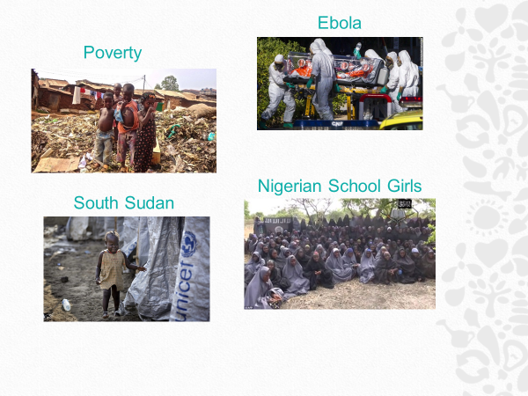
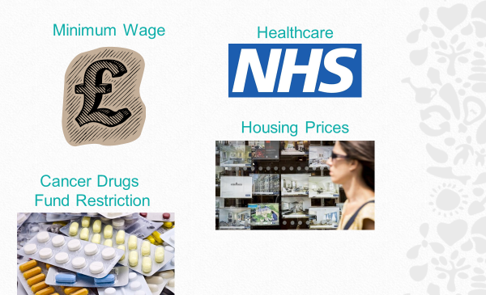

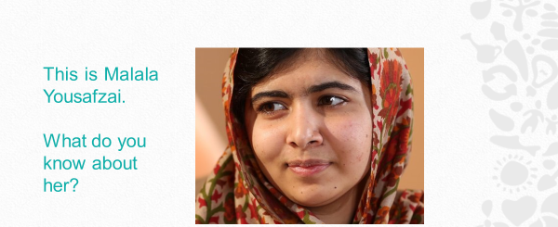
What does Malala have to do with Human Rights?

Would you rather…?
Read through the sheet carefully.
You will be faced with two choices, but you can only choose one. Think of why you chose the option you did.

- Would you rather go for a week without internet OR a day without food?

- Would you rather drink be able to drink only one glass of clean water a day OR 3 litres of dirty water a day?

- Would you rather walk an hour and back to school every day OR have no education at all?

- Would you rather spend your money on a new item of clothing OR on vegetables so that your whole family can eat?

- Would you rather your parents paid for your education OR paid for your family to have 2 meals a day?

- Would you rather be able to read OR write?

Extension Activity:
Can you think of your own CHOOSE situations?.

Lesson Two: To be able to extract information from texts

Match the correct word with the definition
In front of other people | The process of being mentally stimulated to do or feel something. | An outcome of a person’s actions | The process of receiving instruction and information.

education inspiration public consequence

Read the following information, answering the questions as you work through.

Malala Yousafzai

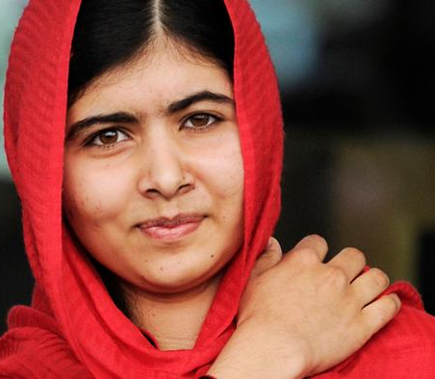
Malala Yousafzai is a Woman and Child’s Rights Activist, who heavily promotes the need for education, and how everyone (especially girls) has the right to have one. Already recognised in Pakistan for her advocacy, Malala rose to international fame in 2012 following an attempt on her life by the Taliban.

Malala was born on 12th July 1997 in Mingora, Pakistan, to a Sunni Muslim family. Her father, Ziauddin Yousafzai, is also an educational activist, and is well-known for founding a chain of schools within Pakistan, one of which Malala attended. From an early age, and heavily influenced by her father, Malala expressed a keen interest and passion for equal educational rights, and outwardly defied the Taliban, who believed that girls should not be allowed an education.

As the Taliban’s hold in Pakistan began to grow stronger, and they started to attack girls’ schools, Malala grew even bolder and began to publicly speak out against them. This started with a talk in September 2008, which was titled: “How dare the Taliban take away my basic right to education?”

Where was Malala born?

True or False: Malala’s father thinks girls do not have the right to education.

Who did Malala speak out against?

In early 2009, at just 11 years old, Malala started a blog for the BBC which centred on what it was like to live under the threat of the Taliban, and how they were trying to deny her an education. For her safety, Malala wrote under the pseudonym Gul Makai; however, she was eventually revealed as the writer in December of that year.

Her public platform growing, Malala continued to speak out about a woman’s right to an education. As a result of her activism, in 2011 she was nominated for the International Children’s Peace Prize. That same year she won Pakistan’s National Youth Peace Prize.

How old was Malala when she started writing a blog for the BBC?

Why did Malala write under a pseudonym?

What prize did Malala win and why?

However, as a result of rising support and success in the promotion of girls’ education, at 14 years old Malala learnt that the Taliban had issued a death threat against her. Despite this warning, and although she was frightened, this did nothing to deter Malala’s campaign, stating “I raise up my voice – not so I can shout, but so that those without a voice can be heard.”

On 9th October 2012, the Taliban set out to kill Malala while she was on her way home from school. As she sat on her school bus, an armed man boarded it and demanded to know which girl Malala was. Her location was given away by her friends looking in her direction. The gunman fired at her and hit Malala in the left side of her head, the bullet travelling down her neck. Two other girls were also hurt.

How old was Malala when the Taliban tried to kill her?

Did her friends intentionally give her away?

Where had Malala been the day she was shot?

Malala was left in a critical condition,and was initially flown to a military hospital in Peshawar to be treated. She had severe swelling on her brain. A part of her skull had to be removed to help treat it.

What does it mean to be in a critical condition?

What treatment did Malala have to have in Peshawar?

Countries throughout the world offered Malala support and medical treatment. Once in a more stable condition, she was then transferred to Birmingham, England, where she received further care. Alongside the swelling, she had suffered severe brain damage, and also had to undergo multiple surgeries to help repair a nerve, which had left the left side of her face paralysed. Slowly but surely Malala began to make a miraculous recovery, and in March 2013 she even began to attend school again!

List three consequences of the shooting for Malala?

Since the shooting, and despite the fact that the Taliban still perceive her as a target, Malala continues to campaign and raise awareness for women’s rights in education, speaking all over the world. Such places include the United Nations, Harvard University and European Parliament. In October 2013, she released an autobiography called I Am Malala, which tells of her story and what life was like growing up with the Taliban.

Did the Taliban succeed in stopping Malala from speaking out?

Why do you think she wrote an autobiography?

Although nominated the previous year, in October 2014, and alongside Kailash Satyarthi, an Indian children’s rights activist, Malala received the Nobel Peace Prize. At only 17 years old, Malala is the youngest person to ever receive this honour.

True or False: Someone younger than Malala has won the Nobel Peace Prize?

Considered to be “the pride of Pakistan” by Prime Minister Nawaz Sharif, Malala’s story is one of inspiration, determination and hope. Her willingness and selflessness illustrates what one person can achieve in the hopes of making a positive impression and impact throughout the world. Malala has shown that no one is too young to make a difference.

What change would you like to see in the world? Give reasons for your answer.

Annotate these questions with your responses to them.

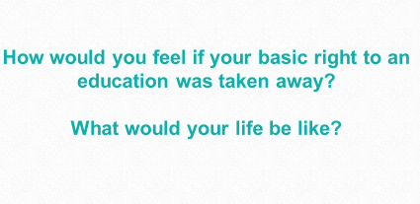

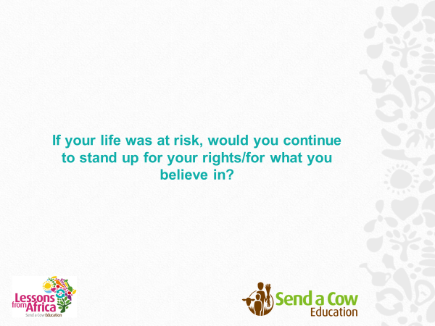

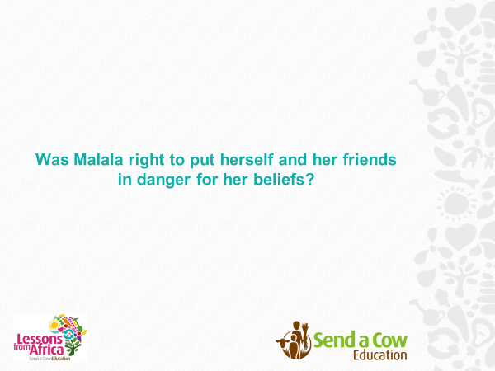
Lesson three: Analysing Malala’s use of language
Fill in the gaps using the words below.
Malala Yousafzai lived in Pakistan at a time when the Taliban believed it was wrong for women to receive an ………………………… Malala disagreed and spoke out in …………………………. about her beliefs; she challenged the Taliban and pushed on. As a ……………………………, Malala was shot in the head by the Taliban. By some miracle, she survived. She now lives in the UK and is an …………………………. to people all over the world.
Inspiration Education Consequence Public

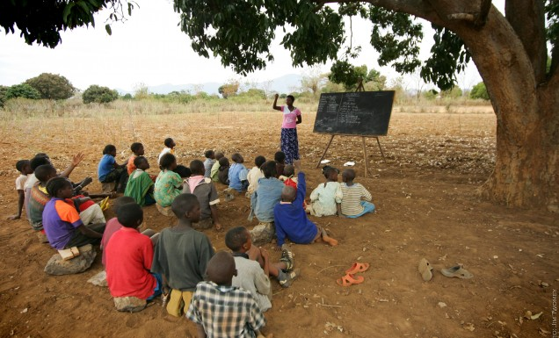
This is a photograph taken of children at school in an African country.
What can you infer from this picture?

What is the school itself like?

How many classrooms are there?

List some of the similarities and differences between your school and this one?

This text is an extract from Malala Yousafzai’s memoir ‘I Am Malala’.
When I close my eyes, I can see my bedroom. The bed is unmade, my fluffy blanket in a heap, because I’ve rushed out for school, late for an exam. My school timetable is open on my desk to a page dated 9 October, 2012. And my school uniform – my white shalwar and blue kamiz – is on a peg on the wall, waiting for me.
I can hear the kids playing cricket in the alley behind our home. I can hear the hum of the bazaar not far away. And if I listen very closely I can hear Safina, my friend next door, tapping on the wall we share so she can tell me a secret.
I smell rice cooking as my mother works in the kitchen. I hear my little brothers fighting over the remote – the TV switching between WWE Smackdown and cartoons. Soon, I’ll hear my father’s deep voice as he calls out my nickname. ‘Jani,’ he’ll say, which is Persian for ‘dear one’, ‘how was the school running today?’ He was asking how things were at the Khushal School for Girls, which he founded and I attended, but I always took the opportunity to answer the question literally.
‘Aha,’ I’d joke, ‘the school is walking not running!’ This was my way of telling him I thought things could be better.
I left that beloved home in Pakistan one morning – planning to dive back under the covers as soon as school was over – and ended up a world away.
Some people say it is too dangerous to go back there now. That I’ll never be able to return. And so, from time to time, I go there in my mind.
But now another family lives in that home, another girl sleeps in that bedroom – while I am thousands of miles away. I don’t care much about the other things in my room but I do worry about the school trophies on my bookcase. I even dream about them sometimes. There’s a runner’s-up award from the first speaking contest I ever entered. And more than forty-five golden cups and medals for being first in my class for exams, debates and competitions. To someone else, they might seem mere trinkets made of plastic. To someone else, they may simply look like prizes for good grades. But to me, they are reminders of the life I loved and the girl I was – before I left home that fateful day.
When I open my eyes, I am in my new bedroom. It is in a sturdy brick house in a damp and chilly place called Birmingham, England. Here there is water running from every tap, hot or cold as you like. No need to carry canisters of gas from the market to heat the water. Here there are large rooms with shiny wood floors, filled with large furniture and a large, large TV.
There is hardly a sound in this calm, leafy suburb. No children laughing and yelling. No women downstairs chopping vegetables and gossiping with my mother. No men smoking cigarettes and debating politics. Sometimes, though, even with these thick walls between us, I can hear someone in my family crying for home. But then my father will burst through the front door, his voice booming. ‘Jani!’ he’ll say. ‘How was school today?’
Now there’s no play on words. He’s not asking about the school he runs and that I attend. But there’s a note of worry in his voice, as if he fears I won’t be there to reply. Because it was not so long ago that I was nearly killed – simply because I was speaking out about my right to go to school.
In lines 5-7, identify two things that Malala (the narrator) can hear from her bedroom.
Give one example in lines 27-30 of how the writer uses language to paint a picture of her new home in Birmingham. Support your example with a detailed text reference.
Evaluate how Malala feels about moving home. Is she happy about it? Sad? Mixed?
Model Paragraph: Malala remembers her old home with fondness. For example, she describes how “when I close my eyes”, she can see her old bedroom. She used the symbol of dreaming and imagining to show that, when she dreams, she goes to her old room, suggesting it is the place of her dreams and she misses it dearly.
Point one
How does Malala feel about moving home?
What quote can you use?
What method is the writer using?
What does this reveal about her feelings towards moving home?
Point Two
How does Malala feel about moving home?
What quote can you use?
What method is the writer using?
What does this reveal about her feelings towards moving home?
Point Three
How does Malala feel about moving home?
What quote can you use?
What method is the writer using?
What does this reveal about her feelings towards moving home?

Fortnightly Feedback Sheet

SUBJECT ____________________ DATE ______________

Something my teacher thinks I have done well:

What my teacher thinks the next step is for me:

Something I am pleased with:

What I think I could do to improve my work:

Evidence that I have improved my work :

Week Three: The Freedom to be Equal
Lesson one: to be able to summarise the most important points of a piece of text.
Write the definitions under each word, then spell them four times.
 | Attempt 1 | Attempt 2 | Attempt 3 | Attempt 4
Gender

Suffragettes

Democracy

Equality

Write an Acrostic Poem about democracy in the United Kingdom
D
E
M
O
C
R
A
C
Y
Read the following information
Millicent Fawcett and the start of the suffragette movement Suffrage Movement
A political movement by a group of women in the early 20th century to gain the right to vote.
Millicent Fawcett and the start of the suffragette movement
Millicent Fawcett founded the National Union of Women's Suffrage in 1897. She believed in peaceful protest. She felt that being aggressive or obstructive would harm their cause as it would persuade men that women were too irresponsible to vote. Fawcett presented informed arguments to those in power to persuade them that women should have voting rights. For example:
• Women hold responsible jobs in society so why are they not trusted to vote?
• Why should women obey laws made by Parliament if they were not part of the law-making process?
• Why should women pay taxes to Parliament if Parliament did not answer women?
The Suffragettes
Fawcett’s campaign was convincing but slow. Most men in Parliament still believed that women would never be able to understand how Parliament worked and so could not be allowed to take part in an election. A new political action group called the Women’s Social and Political Union was founded by Emily Pankhurst in 1903. Its members became known as the suffragettes. They believed the same thing as Millicent Fawcett but thought her methods were too slow. They were prepared to take more extreme action to bring about the change.
Taking direct action
The first direct action taken by the group was by two suffragettes disrupting a public meeting in Manchester in 1905. They demanded that the two politicians speaking tell them if they thought women should have the right to vote and waved a banner when they refused to answer. At the time, people were expected to listen in silence at public meetings. The pair were arrested and sent to prison because they refused to pay the fine. This was the start of a more extreme and violent campaign. Examples include:
• chaining themselves to Buckingham Palace and to areas in Parliament;
• shouting abuse at politicians from boats on the River Thames;
• refusing to pay taxes;
• attacking politicians and firebombing their houses;
• burning down churches (as the Church of England was considered to be against their cause) and vandalising buildings on Oxford Street in London to draw attention to their message.
Hunger strikes
The suffragettes used their time in prison as a way to draw attention to their cause by going on hunger strike. The government ordered them to be force fed as they didn’t want them to die in prison and be given martyr status. This outraged people as it was something done only to people considered not able to make a choice about whether to eat or not (people referred to as ‘lunatics’ at the time).
The Cat and Mouse Act
This was a new government law to help combat the hunger strikes. Suffragettes in prison would not be force fed but allowed to become very weak. They would be released when they were too weak to take part in any direct action. If they grew strong enough to take part in action again, they would be re-arrested and sent to prison. Although it was an effective short term government measure, it only served to make the suffragettes angrier and, some argue, more extreme.
Emily Davison
Perhaps the most extreme action taken by any suffragettes was that of Emily Davison. She threw herself in front of the King’s horse at the 1913 Derby horse race. Her death meant that she was hailed as a martyr by the suffragettes but it may not have helped their cause. Men argued that if this very educated woman could be this irresponsible, then how could they give the vote to less educated women?
The impact of the First World War
The war in Britain started in the summer of 1914. Emily Pankhurst felt that it was more important to help the war effort than to carry on her campaign. She focussed on getting women to do men’s jobs to keep Britain running when men went to fight. In 1918, the Representation of the People Act was passed by Parliament giving women over the age of 30 the right to vote. Other reform acts followed which gave more people the right to vote.

Summarise the Suffragette movement in one paragraph

Summarise the Suffragette movement in one sentence

Summarise the Suffragette movement in one word

Lesson two: to be able to make inferences based on pictures
Match the correct word with the definition
A woman seeking the right to vote through organised protest | The state of being make of female. | The state of being the same as everyone else in status, rights and opportunities. | A Government or state which is voted for and elected by the people themselves.

Gender Suffragettes Equality Democracy
Look at the following pictures and use your inference skills to answer questions about them.
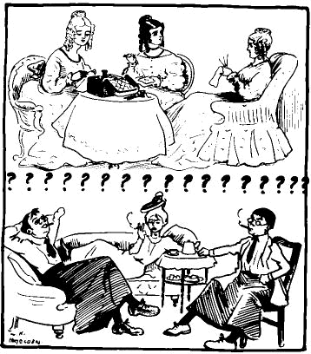
What is this saying about what will happen if women get equality with men?

Who would produce a cartoon like this?

What does it tell you about attitudes to women at this time?

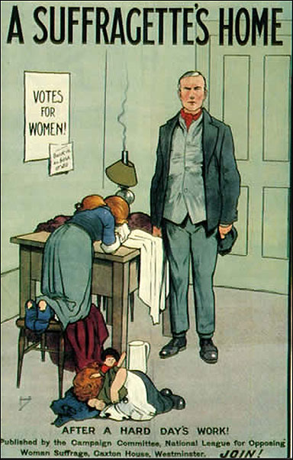
What do you infer from this picture?

What message do you think it was trying to send to the families of Suffragettes?

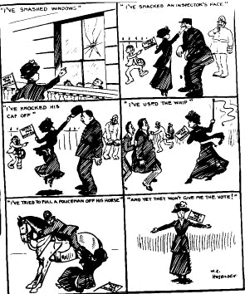What does this cartoon from the time tell you about the tactics of the Suffragettes?

Is this source in support or against the Suffragettes?

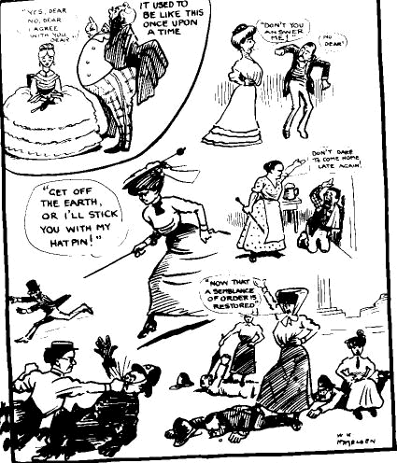
What does this cartoon from the time tell you about attitudes towards the Suffragettes?

Would everyone at the time agree with this source?

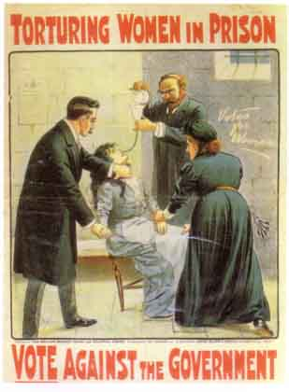
Label the poster above with all the ways it encourages support for The Suffragettes.
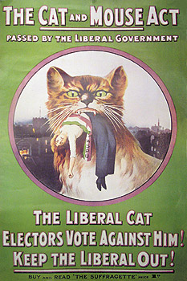
The Government now let the women who were on hunger strike out of prison when they became ill.
After they had been home for a while and were better the Government arrested them again?
The Women then went back on hunger strike so the Government.....
Why do you think this was called the Cat and Mouse Act?

Why wouldn’t it happen in today’s society?

What do you think the message behind this poster is?
Think of a cause today that you feel strongly about. Design your own poster for it, showing your viewpoint through picture and text.

Lesson three: To produce a diary entry, using historical information and description to describe the life of a suffragette.
Fill in the gaps using the words below.
Fill in the blanks:
In the UK, we live in a ………………………. which means we vote for the political party that we want to govern the country. But, 100 years ago, there was a lack of …………………………. when it came to voting, with only one …………………..having the right to vote: men. The …………………………. movement protested for Women to have the vote too.
Gender Equality Democracy Suffragette

On Youtube, watch the trailer for the film Suffragette.
Use information from the film, from the adverts and everything else we have looked at this week to write a diary entry, from the viewpoint of a Suffragette.
You should write it in FIRST PERSON. | You should be writing in a mixture of PAST and then PRESENT tense. | You need to use full stops at the end of sentences, capital letters and any other appropriate punctuation. | You need to use the five senses:  Smell  Touch  Taste  Hear  See
Plan:
Where is she?
What happened this morning?
How did she feel when they woke up?
What happened during her day?
Why has she chosen to be a suffragette?
What happened just before she started writing?
What are her hopes for the future?

Write your diary entry below. Be sure to write the date at the top.

Week Four: Freedom in the 21st century
Lesson one: To be able to determine between true and false statements.
Write the definitions under each word, then spell them four times.
 | Attempt 1 | Attempt 2 | Attempt 3 | Attempt 4
Campaign

Choice

Slavery

Feminism


Do you recognise this person?

What do you associate her with?

What three adjectives would you use to describe her?

Read the source below and then highlight the four correct statements.
A transcript of Emma Watson’s speech to the UN in 2014 beginning the HeForShe Campaign.
Men, I would like to take this opportunity to extend your formal invitation. Gender equality is your issue, too. Because to date, I’ve seen my father’s role as a parent being valued less by society, despite my need of his presence as a child, as much as my mother’s. I’ve seen young men suffering from mental illness, unable to ask for help for fear it would make them less of a man. In fact, in the UK, suicide is the biggest killer of men between 20 to 49, eclipsing road accidents, cancer and coronary heart disease.

I’ve seen men made fragile and insecure by a distorted sense of what constitutes male success. Men don’t have the benefits of equality, either.

We don’t often talk about men being imprisoned by gender stereotypes, but I can see that they are, and that when they are free, things will change for women as a natural consequence. If men don’t have to be aggressive in order to be accepted, women won’t feel compelled to be submissive. If men don’t have to control, women won’t have to be controlled.

Both men and women should feel free to be sensitive. Both men and women should feel free to be strong. It is time that we all perceive gender on a spectrum, instead of two sets of opposing ideals. If we stop defining each other by what we are not, and start defining ourselves by who we are, we can all be freer, and this is what HeForShe is about. It’s about freedom.

I want men to take up this mantle so that their daughters, sisters, and mothers can be free from prejudice, but also so that their sons have permission to be vulnerable and human too, reclaim those parts of themselves they abandoned, and in doing so, be a more true and complete version of themselves.

In my nervousness for this speech and in my moments of doubt I’ve told myself firmly: If not me, who? If not now, when? If you have similar doubts when opportunities are presented to you I hope that those words will be helpful, because the reality is that if we do nothing it will take 75 years, or for me to be nearly a hundred, before women can expect to be paid the same as men, for the same work. 15.5 million girls will be married in the next 16 years as children. And at current rates it won’t be until 2086 before all rural African girls can have a secondary education.
Shade the four correct statements
Watson thinks father’s parenting roles are overvalued by society.
Suicide kills more men between the aged of 20 and 49 than car accidents.
She believed that men do not have the benefits of equality.
She believes that men are not imprisoned by gender stereotypes.
Watson believes that gender comes from two sets of opposing ideals.
Watson believes that gender should be perceived as being on a spectrum.
It will take 75 years for women to be paid the same as men for the same work.
It will take nearly 100 years for women to be paid the same as men for the same work.

Emma Watson is trying to persuade her audience. What is she trying to persuade them to do?

Go back through the article, highlighting which of the following persuasive features are used by Emma Watson.
Use a different colour to highlight each of these features.

Direct Address: Using words that talk directly to the audience.

Rhetorical questions

Facts

Statistics

Emotive language

Tripling

Alliteration

Opinion

Repetition
Pick one of the quotes you have highlighted and use it to state exactly how her language persuades the audience.
Point:

Example:

Technique:

Analysis:

Lesson Two: To write a persuasive letter, using features explored last lesson.
MATCH THE WORD TO THE DEFINITION
The power of selecting something. | Work in an organised and active way towards a goal. | The advocacy of women's rights on the ground of the equality of the sexes | A system in which people are owned by other people.

campaign choice slavery feminism

Read the following article about gender-neutral toilets.

To those who oppose gender-neutral toilets: they’re better for everybody
An increase in gender-neutral toilets is one of the aims of Sadiq Khan’s draft London Plan. It will address the concerns of transgender people who face intimidation and harassment in gender-segregated facilities when they are perceived by others to be in the “wrong” one.
There are detractors. Some object that gender-neutral toilets take away safe spaces for women. Andrea Williams, chief executive of Christian Concern, said in an interview with the London Evening Standard that the mayor’s proposal was “the latest casualty of an ideological tsunami that sweeps common sense and biological reality aside”.
The waters of this ideological debate are deep. But there is one advantage of a move away from segregated facilities that should appeal to all: it will reduce waiting times for women..
There is much to be said for gender-neutral toilets. They are a welcome move for trans people, and for disabled people who have carers of a different gender. But what has been forgotten in this debate is a much broader benefit for everyone: they reduce waiting times without having to incur any overhead costs. Granted, some people may feel uncomfortable in gender-neutral toilets – there are many reasons for this. But long waiting times are also seriously uncomfortable.
We should move forward slowly in this matter and not alienate anyone. To respect concerns about gender-neutral toilets, we can, in larger establishments, introduce them gradually, keeping a few segregated toilets intact. This way we get some of the gains of gender-neutral toilets while respecting the concerns of those who prefer to answer the call of nature with members of their own gender.
And as we move ahead, and enjoy the benefits this has to offer, we can carefully monitor whether there are any untoward incidents in the newly set-up gender-neutral toilets.

“Gender neutral toilets should be introduced in schools with immediate effect.”
Write a letter to your headteacher arguing for or against this statement.
Try to use a range of persuasive devices. Think of some of the ones Emma Watson used in her speech.
Address

Date

Dear
Lesson three: To summarise your own feelings about freedom in the world in 2018
Fill in the gaps using the words below.
In 2018, the world has come far from the world our suffragette ancestors lived in. But how much has really changed? ………………………… has long been abolished but we still live in a country where humans are trafficked in and out like animals. Strong ………………… for women’s rights are stomping on sexual harassment, but have people forgotten that ……………………. is about EQUALITY between men and women? And teenagers today have more ……………. than ever before but are heavily criticised for every move they make through the nightmare of social media. Do we really live in a freer society today?
campaigns feminism choice slavery
Read the following poem
I DREAM A WORLD
By Langston Hughes
I dream a world where man
No other man will scorn,
Where love will bless the earth
And peace its paths adorn
I dream a world where all
Will know sweet freedom's way,
Where greed no longer saps the soul
Nor avarice blights our day.
A world I dream where black or white,
Whatever race you be,
Will share the bounties of the earth
And every man is free,
Where wretchedness will hang its head
And joy, like a pearl,
Attends the needs of all mankind-
Of such I dream, my world!
What do you want, in the future, for the world?

What do you want, in the future, for the UK?

What do you want, in the future, for the community you live in?

What do you want, in the future, for your school?

What do you want, in the future, for your family?

What do you want, in the future, for your friends?

What do you want, in the future, for YOU?

PUT YOUR THOUGHTS INTO A POEM WITH THE TITLE: I DREAM OF A WORLD.



Fortnightly Feedback Sheet

SUBJECT ____________________ DATE ______________

Something my teacher thinks I have done well:

What my teacher thinks the next step is for me:

Efforts merits_______________ Put on ScholarPack ______________
Something I am pleased with:

What I think I could do to improve my work:

Evidence that I have improved my work :

Advocacy is a political process by an individual or group which aims to influence decisions within political, economic, and social systems and institutions.

