AQA GCSE Drama

Task:

Access the GCSE Bitesize page for Drama. We are AQA:
https://www.bbc.co.uk/bitesize/examspecs/zrnjwty

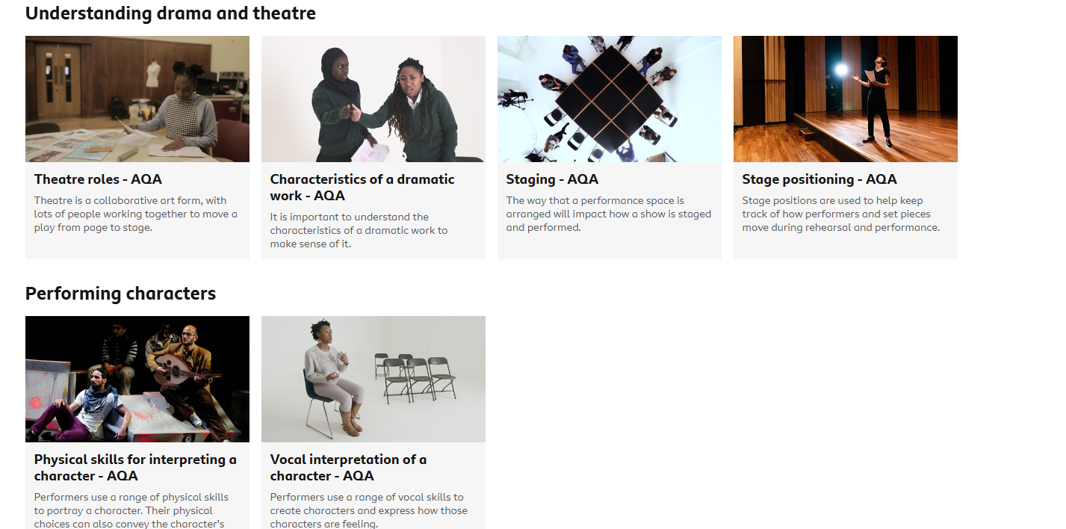

Access each topic – read the information, watch any videos and test your knowledge in the Revise tabs.

