Cooking Methods for Protein Foods
Q1. List 3 foods that provide us with protein?
-
-
-
Q2. Why do our bodies need protein? Circle the correct answer.
To keep our blood healthy To keep our muscles strong To protect our bones and teeth

Q3. Complete the fill in the blank activity. Use the words below to help you.
Protein is an important __________ that our bodies need to stay healthy. It helps our bodies __________ and repair muscles and tissues. Protein is also needed to make __________, which help control chemical reactions in the body, and __________, which help fight illness. Without enough protein, the body may feel __________ and take longer to heal after an injury.
Anti bodies Nutrient Tired Grow Enzymes

Q4. Outlines of different cooking methods. Draw the different protein foods that can be cooked in each method.
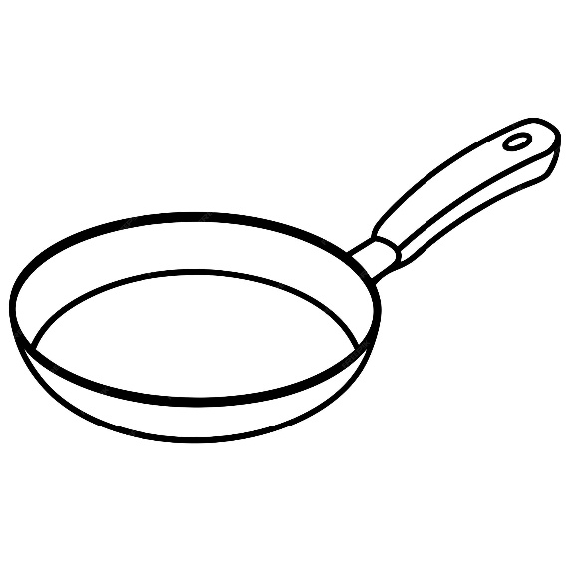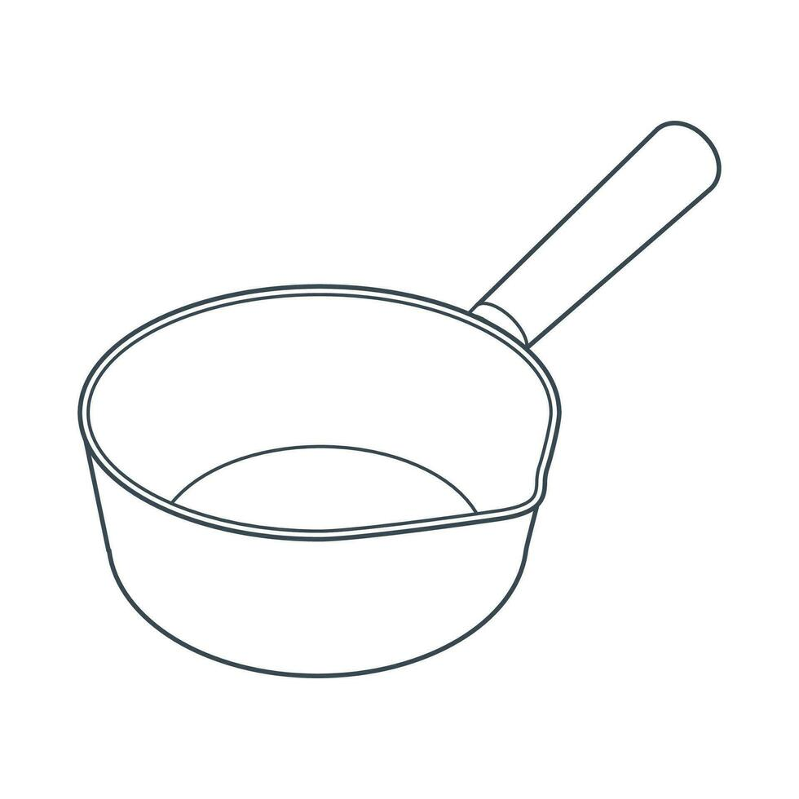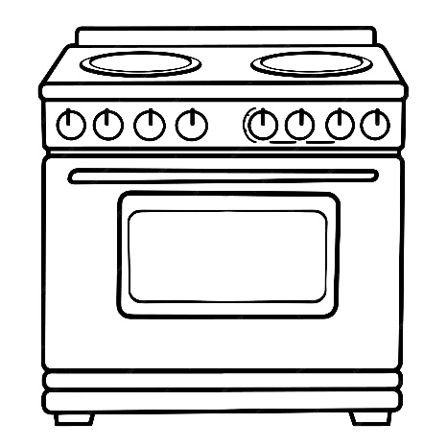
Fats and Fibre
What are fats?
Fats give us energy, help keep us warm, and protect our organs.
Healthier fats (unsaturated):
Oils, nuts, seeds, avocado, oily fish
Less healthy fats (saturated):
Butter, cream, pastries, fatty meat
👉 Eat more unsaturated fats and less saturated fat.

What is fibre?
Fibre helps keep the digestive system healthy.
Why we need fibre:
- Prevents constipation
- Keeps us fuller for longer
- Helps control blood sugar
High-fibre foods:
Wholemeal bread/pasta, brown rice, fruit, vegetables, beans, oats

Activity 1 – Fat or Fibre?
Circle fat or fibre, which one do you think each food contains more.
Avocado ☐ Fat OR Fibre
Wholemeal bread ☐ Fat OR Fibre
Butter ☐ Fat OR Fibre
Baked beans ☐ Fat OR Fibre
Crisps ☐ Fat OR Fibre
Apple ☐ Fat OR Fibre

Activity 2 – Healthy Swaps
Change the food to make it healthier.
Food | Swap | Why better?
White bread
Butter
Chips

Activity 3 – Label Check
Look at a food label.
- Fat per 100g: ______
- Saturated fat: ______
- Fibre per 100g: ______
- Eat often or occasionally? Why? __________________

Practical Link
Which ingredients in today’s dish contain:
- Fat: __________________
- Fibre: __________________

Key Words
Fat • Fibre • Saturated • Unsaturated • Digestive system

Name: _________________________Class: ___________ Teacher: ______________



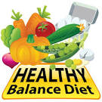

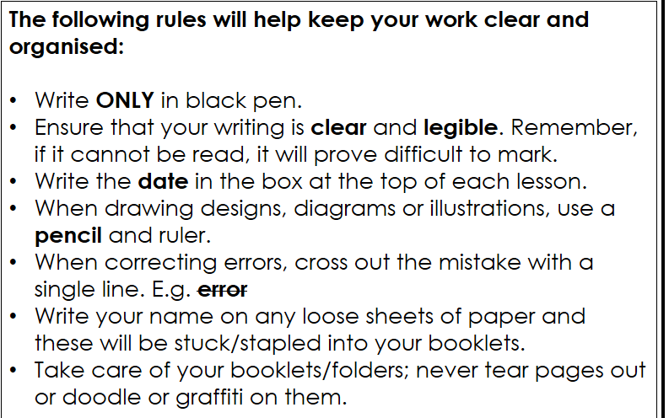

AREs | Eatwell Guide | Nutrition | Skills | Independence | Equipment | Time Management | Final Product | Hygiene and safety
Working towards | I know the colours for the Eatwell Guide and can name at least 1 food for each section | Have a basic knowledge of the sources and function in the body of 1 nutrient | I can recognise that different skills are used in different recipes | I can produce simple recipes with a lot of help | I can use equipment as directed to prepare basic ingredients | I can meet time targets with help | I can produce edible products with help | I can follow basic rules to keep the kitchen safe and clean with direction
Approaching | I know the colours for the Eatwell Guide and can name at least 3 foods for each section | I can name 2 nutrients, their food sources and function in the body | I can name 2 skills used in different recipes | I can follow instructions with some help to produce recipes. | I can choose & use equipment as directed with safety & care. | I can follow time targets with a little help | I can handle ingredients & equipment safely to produce edible products. | I can follow basic rules to keep the kitchen safe and clean with some direction.
Meeting | I know the colours, main nutrient and correct label for each section of the Eatwell Guide. I can name at least 5 foods for each section | I can name the micro & macronutrients. I can name 1 food source and 1 deficiency disease | I can name the food skills used in different recipes | I can follow instructions and use the method confidently with little help to produce recipes. | I can competently, accurately and safely choose and use the correct equipment. | I can manage my own time making any necessary changes to improve my time management for the future. | I can produce products of an acceptable standard | I can keep a tidy and organised kitchen area at most of the time.
Above | I know the colours, main nutrient plus its function and correct label for each section of the Eatwell Guide. I can identify a variety of foods for each section | I can explain the function and sources of the micro and macronutrients and name 2 deficiency diseases | I can name and explain the food skills used in different recipes | I can follow instructions and use the method to produce successful recipes. | I can select & use a range of equipment and use it safely and correctly | I can create and follow my own time targets | I can select & use a range of ingredients with some precision to produce recipes that are of a high standard | I can keep a tidy and hygienic kitchen area at all times organising my surface and sink area in the most hygienic way.
Working above | I know the colours, main nutrient plus its function, deficiency and excess and correct label for each section of the Eatwell Guide. I can identify a variety of foods for each section | I can name all the different micro and macronutrients. I can explain the function, source and deficiency for each nutrient | I can name and explain the food skills used in different recipes and give examples of appropriate products | I can independently follow instructions and use the method to produce very successful recipes | I can competently choose and use the correct equipment with precision and independence | I can create and follow my own time targets effectively and efficiently | I can work confidently with precision & accuracy to produce very exceptional products | I can work tidily and efficiently throughout and ensure a ‘clean as you go’ approach
Key Stage 3 Assessment Criteria – Food & Nutrition

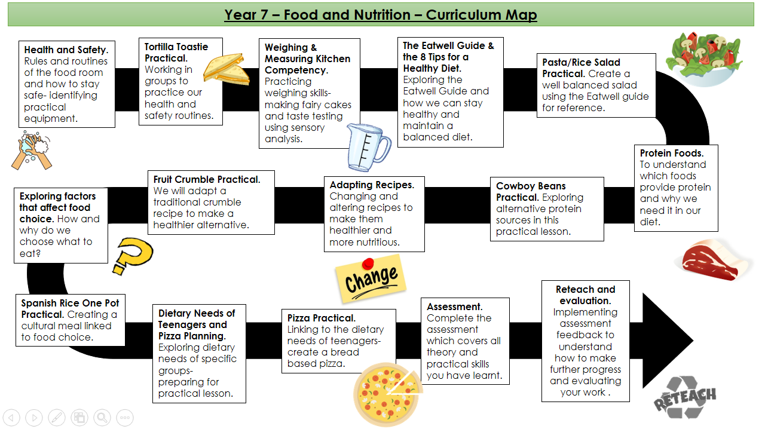
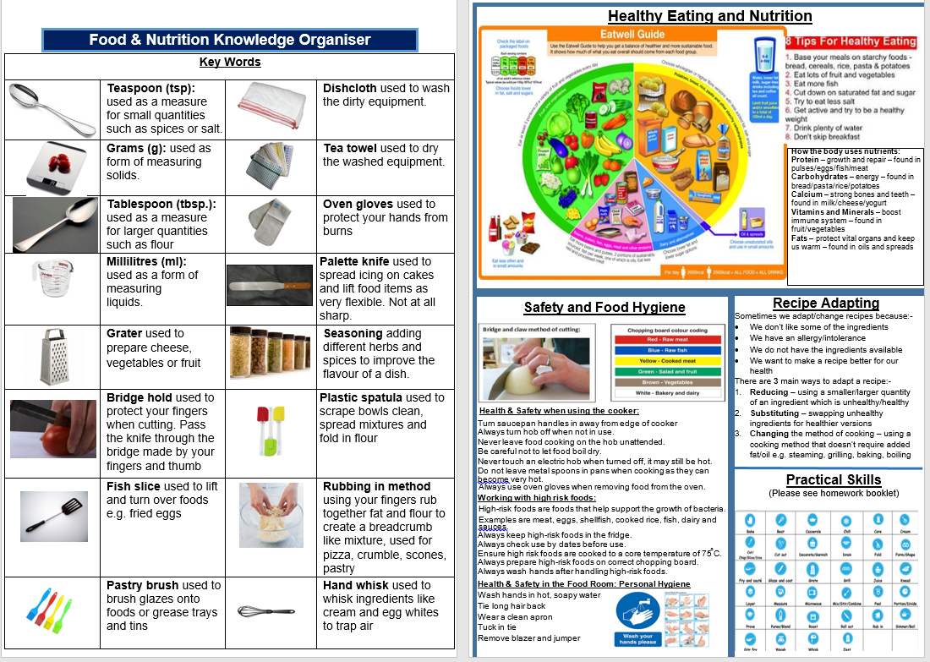
Health and Safety Rules in Food and Nutrition

- Hair should be ________________ up

- Bags, Blazers and jumpers should be put in the _________________

- You should ____________ your hands before ________________ food

- You should _____________ to the teacher

- You should wear an _______________

- You should ________________ a knife ______________

- You should wear a ___________ plaster if you _____________ yourself

- Tell the __________________ if there are any spillages on the floor

- Do not _________________ in the classroom

- Use different coloured ________________ boards for different foods

- Use _________________ _______________ when using the oven

- Keep _______________ and electrical items apart

Signed: ________________________ Date: ________

Food and Nutrition Equipment Hunt
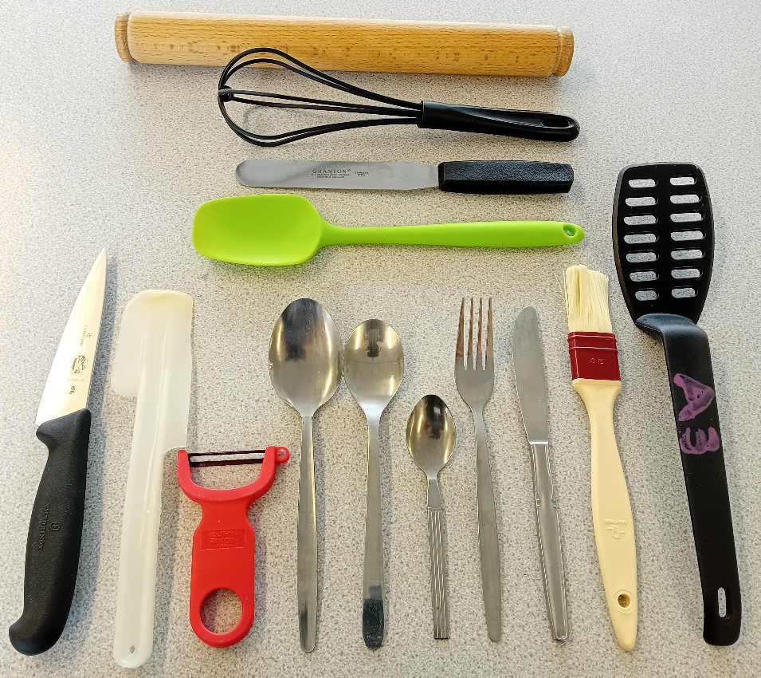
14

13
12
11

1
2
3
4
5
7
6
9
8
10

Your spelling is important in this activity

Locate and correctly name each piece of Equipment

1 |  | 8
2 |  | 9
3 |  | 10
4 |  | 11
5 |  | 12
6 |  | 13
7 |  | 14

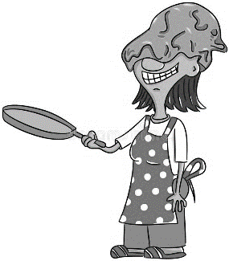

How competent are you in the kitchen?
OR

Complete the tasks below to find out!

Task 1 – Draw a line to label each part of the cooker
Challenge: Explain what the control panel does.
________________________________________________

Challenge: List some foods you could cook using the grill.
_________________________________________________
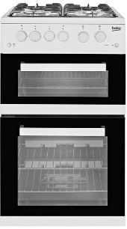
Oven
Grill
Hob
Control panel

Task 3 - Washing up activity – demonstration, card sort, questions
- Why do we not use anti-bacterial spray when there is food around?

- Why are surfaces wiped at the start of the washing up routine?

- Why do you wash up using hot, soapy water?

- Why are the clean dishes drained upside down on the draining board?
Task 4 – Measuring

Sensory Analysis

Sensory analysis is an important part of food. It means using your senses to describe what a food product is like.
You are now going to taste one of your fairy cakes and then using adjectives (describing words) complete the chart below
Try to have at least 2 words in each box

Appearance | Aroma/Smell | Texture | Taste/Flavour | Rating/10

Tasting Word Bank - These words are called sensory descriptors as they describe how our senses evaluate what we eat. Use these or make up your own to help you fill in the table above
Mouth Feel (Texture) | Looks (Appearance, colour, aesthetics) | Taste, Flavour, Smell
airy, brittle, chewy, crisp, crumbly, crunchy, dry, fine, firm, flaky, flat, foamy, gooey, greasy, gritty, hard, juicy, light, lumpy, mushy, powdery, rubbery, slimy, smooth, soft, soggy, springy, sticky, stiff, stringy, tender, thick, thin, watery | appetising, attractive, clear, cold, colourful, crumbly, dry, fattening, fresh, golden, greasy, healthy, hot, moist, smooth, soggy | acidic, bitter, bland, burnt, buttery, creamy, dry, fatty, old, salty, sharp, sickly, soggy, sour, spicy, stale, sweet, watery, wet, tangy, undercooked

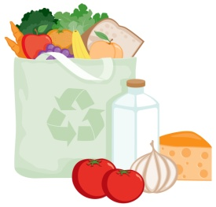
Eatwell Guide
What do you know?
- Label each section of the Eatwell Guide. Do you know what nutrient this section provides?
- Add the correct coloured bands for each section
Potatoes, bread, rice, pasta and other starchy carbohydrates
Oils and spreads
- Add foods (at least 4) to each section of the Eatwell Guide
- Label the outside areas of the Eatwell Guide

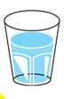

Question: How does the Eatwell Guide help us to eat a healthier diet?
____________________________________________________________________________________________________________________________________________________________________________________________________________________________________________________________________________________________

8 Tips for Healthy Eating
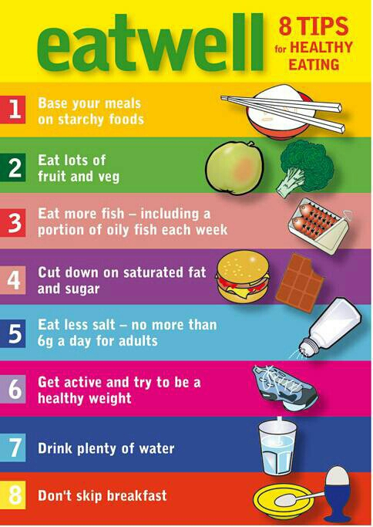
Use the 8 tips for healthy eating to answer the following questions:-

- Name 3 different types of starchy foods

- How much is one portion of fruit and vegetables?

- How many portions of fish should we eat per week?

- What type of fat should we be cutting down on?

- Give 2 reasons why can sugary foods be unhealthy between meals?

- How much salt should an adult have a day

- Name 2 ways we can all be more active

- How many glasses of fluid should we drink per day?

- Why is breakfast so important?

Protein
- Protein comes from different sources of food
  - Beef comes from a _______________
  - Pork comes from a _______________
  - Eggs come from ______________
  - Tuna is a type of ______________
  - Red kidney, broad and baked are all types of ________________
- B________, p__________, f_________, e_______ , n__________ and meat are all protein foods which help our bodies to g___________ and r_______________
- How many portions of fish should we be eating per week? ____________
- Fish provides us with __________, ___________________ and _____________
- Why should we eat more plant sources of protein? ______________________________
____________________________________________________________________
- Name 4 types of pulses (or legumes)
7. How should we cook protein foods to be healthier? ____________________________________________________________________________________________________________________________________________

  - ___________________
  - ___________________
  - ___________________
  - ___________________
- In the boxes below write at least 2 examples of each type of fish:
White Fish
Oily Fish

- Name the beans:
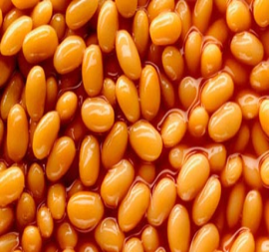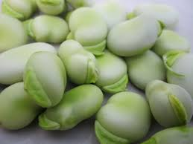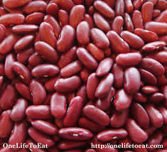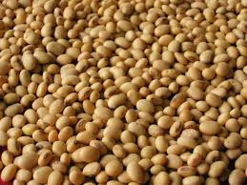

…………………………… ……………………………… ………………………….. ……………………………

- When food is canned, frozen or dried it is known as being processed. Put a tick in the box to show how each food can be processed

Food | Frozen | Dried | Canned
Fish
Meat
Beans
Eggs

- Using the images provided, list the foods that vegetarians can eat ……………………………………………………………………………………………………………………………………………………………………….
- Can you think of any advantages of being a vegetarian? ……………………………………………………………………………………………………………………………………………………………………………………………………………………………………………………………………………………………………………………………………………………………………………………………………………………………………………………………………………………………………………………….
- Can you think of any disadvantages of being a vegetarian? (Other than not being able to eat meat!) ……………………………………………………………………………………………………………………………………………………………………………………………………………………………………………………………………………………………………………………………………………………………………………………………………………………………………………………………………………………………………………………….
Adapting Recipes

Recipes can be adapted to make them healthier. Here are 3 methods of adapting recipes:
- Using a different QUANTITY of an ingredient
- Less sugar
- Less fat
- Less salt
- More fibre
- SUBSTITUTING an ingredient for one that is healthier
- Using a sweetener instead of sugar
- Using wholemeal flour instead of white
- Margarine instead of butter
- Changing the METHOD of cooking
- Grilling instead of frying
- Boiling instead of roasting

Circle the healthier alternative foods and how they are healthier
Food | Healthier Alternative | Reason Why it is Healthier
White bread | Brown bread, granary, garlic, bread, French stick | Lower in salt, lower in saturated fat, lower in sugar, higher in fibre, other
Roast Potatoes | Jacket potato, French fries, wedges, mashed potato | Lower in salt, lower in saturated fat, lower in sugar, higher in fibre, other
Crisps | Wotsits, hula hoops, Pringles, low fat crisps, peanuts | Lower in salt, lower in saturated fat, lower in sugar, higher in fibre, other
Butter | Margarine, lard, cheese spread, low fat spread | Lower in salt, lower in saturated fat, lower in sugar, higher in fibre, other
Coca Cola | Tango, Pepsi, diet coke, milk, water, orange juice, ribena | Lower in salt, lower in saturated fat, lower in sugar, higher in fibre, other
Full Fat Milk | Semi-skimmed, skimmed, evaporated, condensed, cream | Lower in salt, lower in saturated fat, lower in sugar, higher in fibre, other
Cheddar Cheese | Brie, edam, cheese slices, cottage cheese, soft cheese | Lower in salt, lower in saturated fat, lower in sugar, higher in fibre, other
Beef | Pork, chicken, lamb, tofu, Quorn | Lower in salt, lower in saturated fat, lower in sugar, higher in fibre, other
Fish in Batter | Boil in a bag, grilled fish, fish in breadcrumbs | Lower in salt, lower in saturated fat, lower in sugar, higher in fibre, other

Frying is a quick and popular method of cooking but it is very unhealthy because it adds extra fat as oil. Suggest other methods of cooking the following foods which do not do this.
Eggs | Potatoes | Fish | Bacon | Sausages
Adapting Recipe Practical

Name of Crumble: __________________________________

Original recipe | Adapted recipe
Crumble  - 100g plain flour  - 50g butter  - 50g sugar  Fruit Filling  - 400g fruit  - 50g sugar  Equipment from Home  - ovenproof dish | Crumble  - 100g plain flour + 25g  - 50g  Fruit Filling  Equipment from Home  ovenproof dish

Now give 3 reasons why your new crumble recipe is healthier. Be detailed in your answer e.g. I have reduced the sugar by 20g NOT I have reduced the sugar

- I have

- I have

- I have

What Affects the Foods we Choose to Eat?
1) Complete the table below, matching the description to the title

Factors influencing food choice |  | Description
- Individual energy  and nutrient needs |  | The time we eat and what occasion/day it is can hugely affect what we eat e.g., we eat cereal in the morning for breakfast. We have a roast lunch on a Sunday and if it is our birthday, we might eat cake or go out for a celebration meal.
- Diet and health |  | Human welfare and fair-trading, where growers or producers in developing countries are paid a good minimum price to cover their costs, can be a high concern for some people.  Animal welfare can also be a concern for some people. This can affect the choice between caged or free-range hens, or ‘dolphin friendly’ tuna.
- Religion and  culture |  | The media (TV, radio, internet, radio, posters, magazines and newspapers) encourages us to choose certain foods.
- Cost of food |  | People have different likes and dislikes. The taste, texture or appearance of foods can appeal to one person but not another.
- Time of day and occasion |  | Some people may not be able to eat certain foods. They may have allergies or intolerances. These people need to plan their meals carefully.
- Food  preferences |  | The price of food effects what we buy  Food prepared at home is often cheaper than eating out or buying take-away  People are influenced by special offers and promotions.
- Food availability |  | Different religions and cultures cannot eat certain foods and this effects the choices they have to make  Muslims do not eat pork.  Vegans do not eat meat, fish, dairy or eggs.
- Environmental considerations |  | Men and women need different amounts of nutrients.  Age and activity levels also effects how many nutrients we need
- Advertising |  | People may choose their food based on where it comes from or how it is packaged. Some foods travel a long way or have lots of packaging or have been treated in ways that damages our surroundings or us when we eat them.
- Social Issues |  | Some foods are only available at certain times of year. This is called seasonality. Seasonal foods are cheaper and taste better!  Farm shops are good sources of fresh, seasonal, local produce.  Frozen foods are a good alternative to fresh

2) What are six sources of information to help people make healthier food choices?

1.
2.
3.
4.
5.
6.

3) Look at the food labels. What information on them helps consumers make informed choices?

  - ________________________________________________________________

  - _______________________________________________________________

  - _______________________________________________________________

4) What is the difference between a use by date and a best before date?

Use by date:

_______________________________________________________________________

Best before date:

_______________________________________________________________________

Dietary Needs of Teenagers
- In your groups read the information on the laminated sheets carefully
- Identify and write down what you think are the key messages
- Write the top 10 most important points around the stick man
- Which ingredients on a pizza would provide these nutrients? Add your ideas to each of your top 10 points.

Add your 10 most important facts around the stick man



Pizza Practical

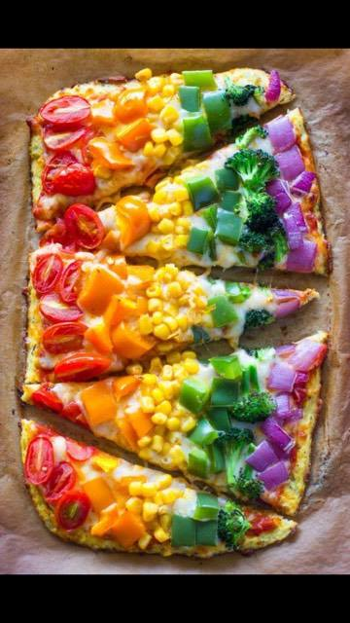
You are going to make a pizza for a teenager which must meet the following criteria:
- You must use at least 2 portions of fruit or vegetables
- You must use ingredients from the beans, pulses, fish, eggs, meat and other proteins
- You must use ingredients from the potatoes, bread, rice, pasta and other starchy carbohydrates
- You must use ingredients from the
dairy and alternatives section
Using your top 10 important facts about teenagers, what will your pizza be like and why?
Pizza Base: ________________________________________________________
Reason: ___________________________________________________________
Cheese: __________________________________________________________
Reason: ___________________________________________________________
Topping 1:__________________________________________________________
Reason: ___________________________________________________________
Topping 2:__________________________________________________________
Reason: ___________________________________________________________
Topping 3:__________________________________________________________
Reason: ___________________________________________________________

Pizza Evaluation
Copy the information from your homework booklet into this table
Remember: 5 = liked a lot, 1 = disliked
 | Good Shape | Flavour | Looks Appetising | Different Textures | Improvement  Comment
Taster 1
Taster 2
Taster 3
Taster 4
Add the ingredients for your pizza into the correct sections of the Eatwell Guide
Potatoes, bread, rice, pasta and other starchy carbohydrates
Potatoes, bread, rice, pasta and other starchy carbohydrates
Fruit and vegetables
Oils and spreads

Beans, pulses, fish, eggs, meat and other proteins
Oils and spreads
Dairy and alternatives
Oils and spreads
Oils and spreads
Assessment Question

- Analyse the suitability of your pizza for a teenager (8 marks)
___________________________________________________________________________________________________________________________________________________________________________________________________________________________________________________________________________________________________________________________________________________________________
___________________________________________________________________________________________________________________________________________________________________________________________________________________________________________________________________________________________________________________________________________________________________
___________________________________________________________________________________________________________________________________________________________________________________________________________________________________________________________________________________________________________________________________________________________________
_______________________________________________________________________

- Evaluate how your pizza could be improved to meet the nutritional needs of a teenager
___________________________________________________________________________________________________________________________________________________________________________________________________________________________________________________________________________________________________________________________________________________________________
___________________________________________________________________________________________________________________________________________________________________________________________________________________________________________________________________________________________________________________________________________________________________
___________________________________________________________________________________________________________________________________________________________________________________________________________________________________________________________________________________________________________________________________________________________________

