Food Labelling & Food Provenance

What is Food Labelling?
Food labelling is the information found on food packaging that helps consumers:
- Stay safe
- Make healthy choices
- Understand where food comes from
- Check if food is suitable for their needs (e.g. allergies, diet)

Activity 1 – Label Spotting
Look at a food package (or example shown by your teacher).
Write down:
- Name of food: __________________________
- One allergen listed: ____________________
- Use-by / Best-before date: ______________
- Storage instructions: __________________

Food Provenance
Food provenance means:
Where food comes from and how it is produced
Knowing food provenance helps us to:
- Understand animal welfare
- Support British farmers
- Reduce food miles
- Make ethical choices

Quality Marks & Symbols
Quality Mark | What it Means
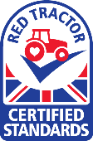  Red Tractor | British farming standards, animal welfare & food safety
Free Range | Animals have access to the outdoors
Organic  | Fewer chemicals, higher animal welfare standards
Fairtrade | Fair pay and working conditions for farmers

Activity 2 – Match the Meaning
What does each mark mean?
Red Tractor →
Free Range →
Fairtrade →

Why is Food Labelling Important?
Food labelling helps us:
- Avoid foods we are allergic to
- Choose healthier options
- Decide if food matches our beliefs (religion, vegetarian, ethical)
- Understand how food impacts the environment

Activity 3 – Think & Explain
Choose ONE quality mark and answer:
Which quality mark did you choose? __________________________
Why might a consumer (customer) choose this food?

Key Words
- Food Labelling – Information printed on food packaging
- Provenance – Where food comes from
- Allergen – A food that can cause an allergic reaction
- Quality Mark – A symbol showing how food was produced

Lesson Reflection
One new thing I learned today about food labelling is:

Name: __________________________ Class: ________ Teacher: _____________

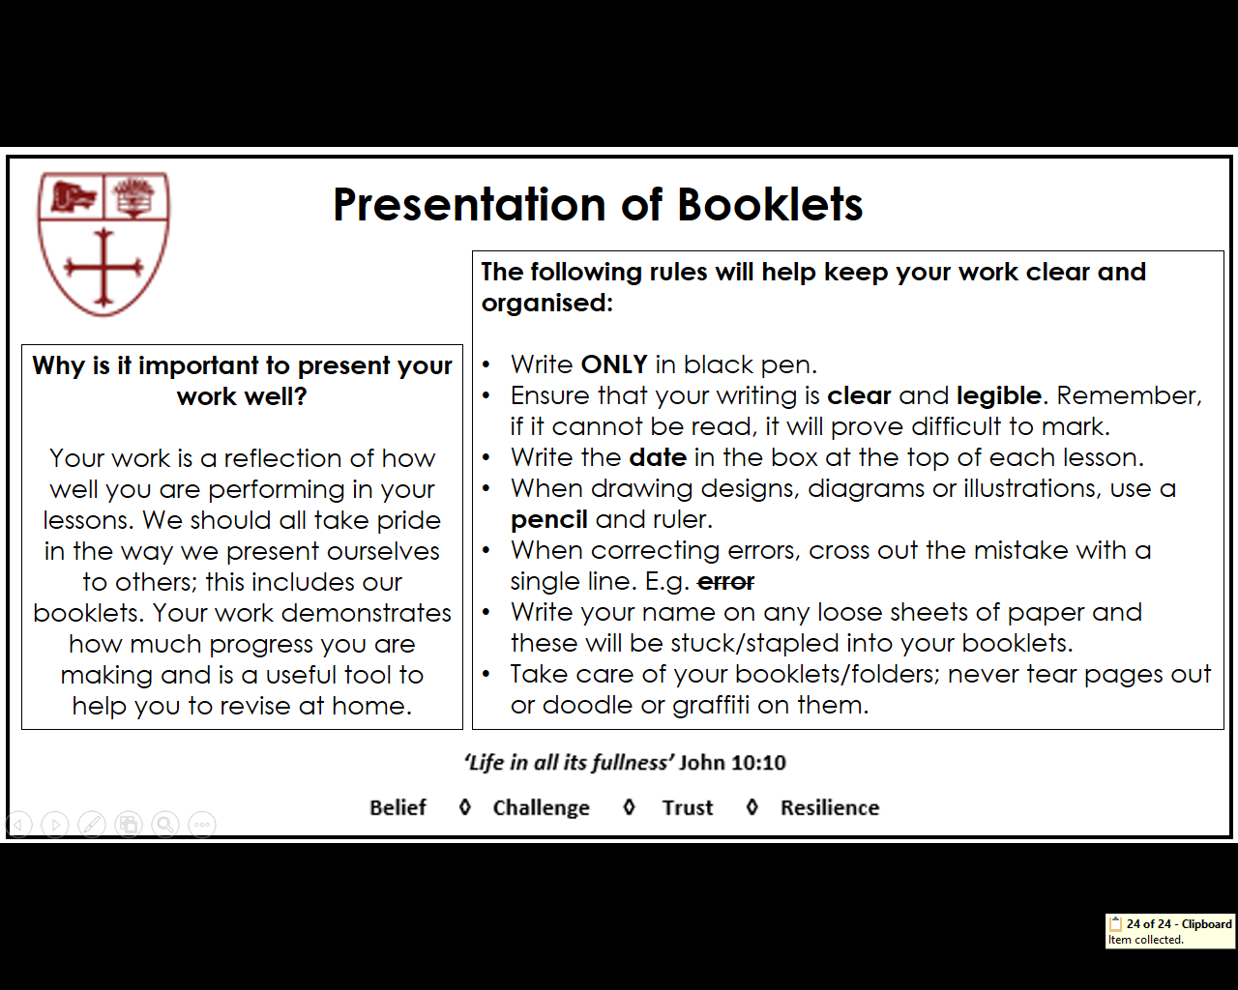

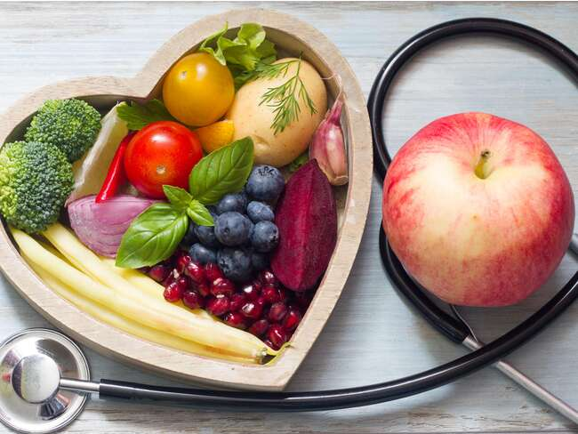



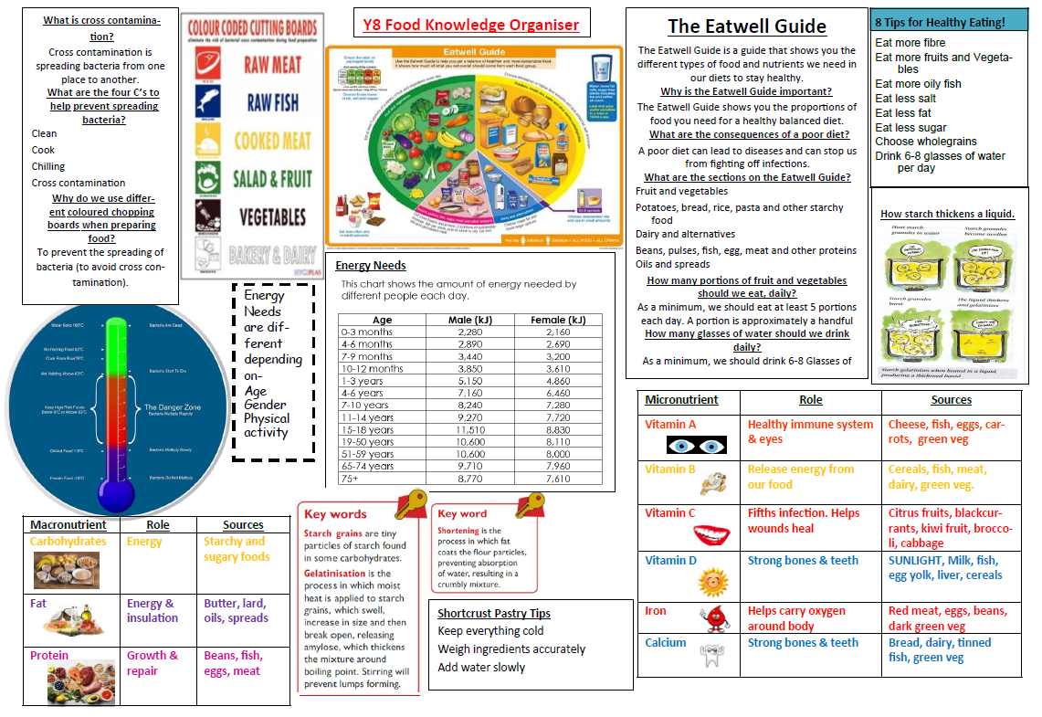

What can you remember about good food hygiene?

Using your food hygiene knowledge to answer each of the questions below.

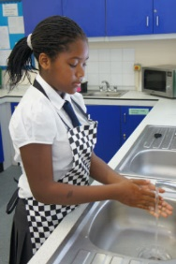
Thoroughly wash and dry hands before and during cooking. If possible, use anti-bacterial soap. Why?

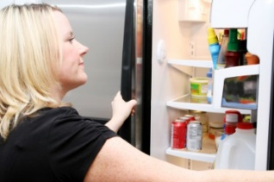
High risk ingredients, such as meat, should be stored in a fridge, below 5°C. Why?

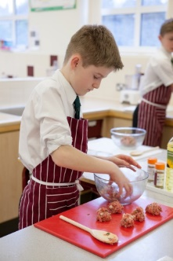
Always use a separate red clean board for raw meat. Why?

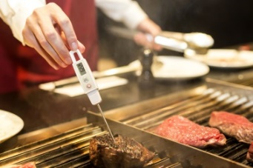
Meat should be thoroughly cooked. Check that there are no pink bits remaining and the juices run clear. Why?

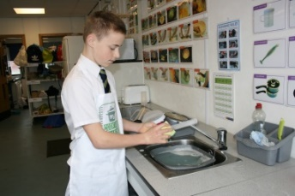
Equipment should be thoroughly washed and dried after use using hot soapy water
Why?

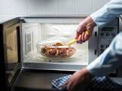
Food products should be reheated until piping hot. Why?

What temperature should they reach before being eaten?


Long hair should be tied back and all jewellery removed. Why?

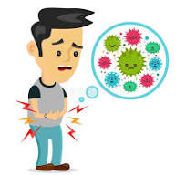
Food Poisoning Bacteria
Use the information around the room to complete a profile for each of these food poisoning bacteria
Name of bacteria and picture:

Found In:

Illness caused:

Name of bacteria and picture:

Found In:

Illness caused:

Name of bacteria and picture:

Found In:

Illness caused:

Name of bacteria and picture:

Found In:

Illness caused:


Top 5 Tips for Preventing Food Poisoning

Key Temperatures in Food

The temperature we keep food at is key in preventing food poisoning. Can you complete the boxes to show what is happening to the bacteria at each key temperature?

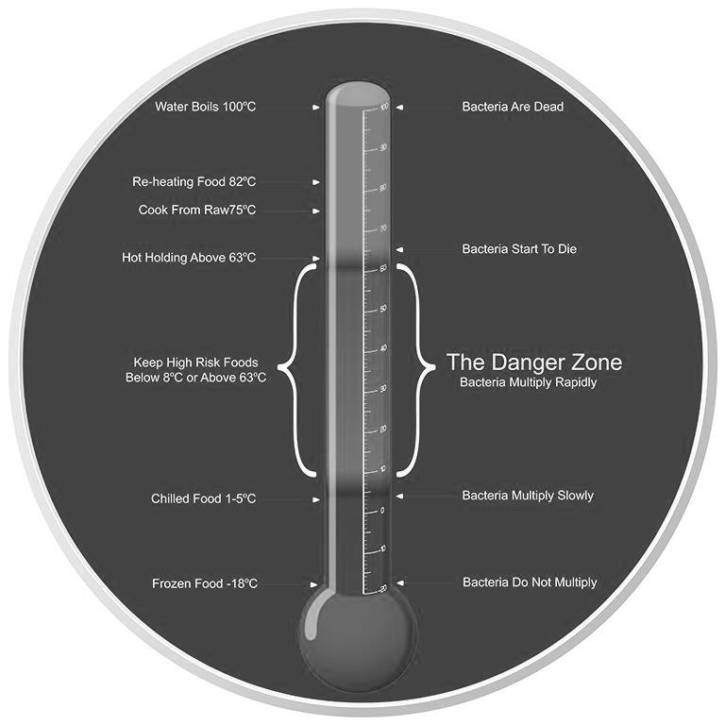
Bacteria

Bacteria
Bacteria
Bacteria
Bacteria

Start to die Multiply Slowly Do not multiply

The Danger Zone Dead Multiply Rapidly

A Question of Hygiene – How well will you do?
Answer the multiple choice questions by circling the correct answers

- The conditions bacteria need to multiply are:
  - Food, warmth and other bacteria
  - Food, warmth and blood
  - Food, warmth and moisture

- Food should be cooled before putting it in a refrigerator
  - To keep the fridge temperature at a safe level
  - To stop the food going soggy
  - To prevent it absorbing smells from other food

- Before preparing food you should
  - Wipe the work surface with anti-bacterial spray
  - Wash your hands with hot soapy water
  - Tie back long hair and put on an apron
  - All of the above

- What time of day should you store food for a practical lesson?
  - At the start of your lesson
  - First thing in the morning
  - At any time

- Which of the following foods should be stored in a fridge?
  - Sugar d. Pork pie g. Cheese
  - Pate e. Flour h. Pasta
  - Carrots f. Milk i. Cooked meat

Your teacher will give you the correct answers!
Add up your score. Out of 14 I scored ______
14-11 = well done you are hygienic and safe in the kitchen
10-9 = check your answers and revise the points you got wrong before cooking
8 or less = you need to learn about hygiene before cooking!!!
Check with your teacher if you are unsure about how to be hygienic in the kitchen

- The temperature in a fridge should be below:
  - 10ºC
  - 5ºC
  - -1ºC
  - -18ºC

- Staphylococcus Aureus is most commonly spread by:
- People
- Poultry
- Eggs
- Milk

- Food poisoning is particularly dangerous for which of the following groups?
- Teenage girls
- Teenage boys
- Pregnant women
- Adult males

- Which of the following does bacteria need in order to multiply?
- Light
- Moisture
- Sugar
- Salt

- After cooking what should you do to avoid attracting vermin?
  - Empty bins and cover
  - Eat all your food
  - Set mouse trap
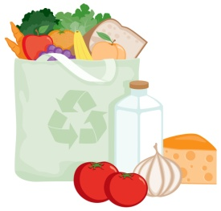
Eatwell Guide
- Add the following headings to the correct box around the Eatwell Guide
- Potatoes, bread, rice, pasta and other starchy foods
- Fruit and vegetables
- Beans, pulses, fish, eggs, meat and other proteins
- Oils and spreads
- Dairy and alternatives
- Put the foods listed into the correct section of the Eatwell Guide
- In the outside band write which nutrient each section provides and then colour in the band

Butter | Milk | Salmon | Lettuce | Cream | Porridge
Potatoes | Banana | Chocolate | Yogurt | Nuts | Chick peas
Quorn | Cabbage | Cheese | Chips | Rice | Couscous
Fromage frais | Orange juice | Baked beans | Cola | Cornflakes | Chicken
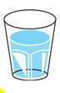

Macronutrients - Pointers on Protein
Match up the 2 halves of the statements with a number or colour coded dot
If there is no other energy source available
We need protein for growth

Is a very pure source of protein

Protein is needed to repair

Because they contain protein and calcium
Protein can be used for energy

And the white of an egg is pure protein
Seafood is one of the best sources of protein

Because it produces new muscle tissue in our bodies
Dairy products are very important

Zinc and iron which are very important for our health
Eggs are a cheap form of protein

As 75g of steak

Beans contain just as much protein

Lean beef is full of protein and also contains
Because it is so low in fat and contains omega 3

The tissues in our body

The white, lean meat of a chicken or turkey

Energy Balance through Life
Energy comes from all food and drinks we consume. Energy needs vary for different people. Match the average estimated energy requirements of these people.
Person | Energy (kJ)
2 month old baby girl
15 year old teenage boy
30 year old woman
30 year old woman breastfeeding a 2 month old child
30 year old male weighing 80kg with a physical job
75 year old lady
13500
2160
7610
10300
11510
8100
Why do people need different amounts of energy?
Give 3 reasons and explain your answers

Energy requirements quiz

1. Why is energy important?
- To keep the heart beating
- To maintain body temperature
- For muscle contraction
- All of the above

2. Which of the following provides 9 kcals per gram?
- Alcohol
- Fat
- Carbohydrate
- Protein

3. What percentage of energy is recommended to be provided by carbohydrate?
- 15%
- 35%
- 50%
- 65%

4. True or false? The average energy requirements for older adults are less than for younger adults.
- True
- False
5. Which of the following can mean energy requirements differ throughout life?
- Body size
- Gender
- Level of activity
- All of the above

6. What is the daily physical activity recommendation for children aged 2-15 years?
- At least 30 minutes
- At least 60 minutes
- At least 90 minutes
- At least 120 minutes

7. True or false? Average physical activity levels in the UK are higher than recommendations.
- True
- False

8. Which of the following BMI ranges shows someone in the desirable or healthy BMI range?
- Under 18
- 18.5 to 25
- 25 to 30
- 30 to 40

Macronutrients - Concentrating on Carbohydrates
A variety of food is needed in the diet because different foods contain the different substances that are needed for health. These are nutrients, water and fibre.

Colour in the triangles using the Eatwell Guide colours.
What are the main nutrients provided by each group in the Eatwell guide?
- Why does the body need carbohydrate?

- There are 3 forms of carbohydrate found in food. What are they?

= ___________________________
= ___________________________

= ___________________________

= ___________________________

= ___________________________

- Rank the Nutrient cards for foods providing the most carbohydrate

- Compare the amount of energy provided by different nutrients using the Nutrient Cards
Why do we need to eat fibre?
Why
- Is there a link?

- Explain:

Fibre
Use the Nutrient Cards to identify those foods that provide fibre

Which provide the most fibre?

Which provide the least?

Make a list of 5 starch based carbohydrate foods:

Life Stages
Identify the main dietary differences with each life stage. Which nutrients are of high importance at this stage of life and why?



Young Children (aged 1 to 4 years)

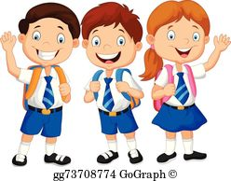
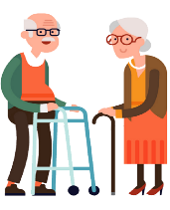



School Children (aged 5 to 12 years)
The elderly (over 65)
Teenagers
Adults
Life Stages
Diet Related Illness
If we do not eat a healthy diet, we risk getting diet related illnesses/diseases. Eating a well-balanced and healthy diet will help us prevent illnesses. However, energy balance also plays a part in preventing diet related diseases too.
Below is a list of common diet related diseases, make notes on each.
______________________________________________________________________________________________________________________________________________________________________________________________________________________________________________________

Coronary Heart Disease
______________________________________________________________________________________________________________________________________________________________________________________________________________________________________________________

Obesity

High Blood Pressure
______________________________________________________________________________________________________________________________________________________________________________________________________________________________________________________

Type 2 Diabetes
______________________________________________________________________________________________________________________________________________________________________________________________________________________________________________________

______________________________________________________________________________________________________________________________________________________________________________________________________________________________________________________

Tooth Decay & Gum Disease
______________________________________________________________________________________________________________________________________________________________________________________________________________________________________________________

Osteoporosis


Challenge: Using what you have learnt so far. Explain who would benefit from eating a Frittata and would it help prevent/ or contribute to an illness listed above (you should mention ingredients and nutrients provided).
____________________________________________________________________________________________________________________________________________________________________________________________________________________________________________________________
____________________________________________________________________________________

Micronutrients - Vital Vitamins & Minerals
The body needs micronutrients in small amounts but we need to eat a variety of foods containing micronutrients to get the small amount we need.
Complete the boxes to show you understand why it is important for us to eat foods containing these important vitamins and minerals
Vitamin B
Function:

Sources:

Reminder Image:

Vitamin A
Function:

Sources:

Reminder Image:

Vitamin C
Function:

Sources:

Reminder Image:

Vitamin D
Function:

Sources:

Reminder Image:

Iron
Function:

Sources:

Reminder Image:

Calcium
Function:

Sources:

Reminder Image:

Complete the following questions whilst watching the demonstration of how to make a sauce. Please write detailed answers in full sentences.

- Give 4 reasons for adding a sauce to a food or food product

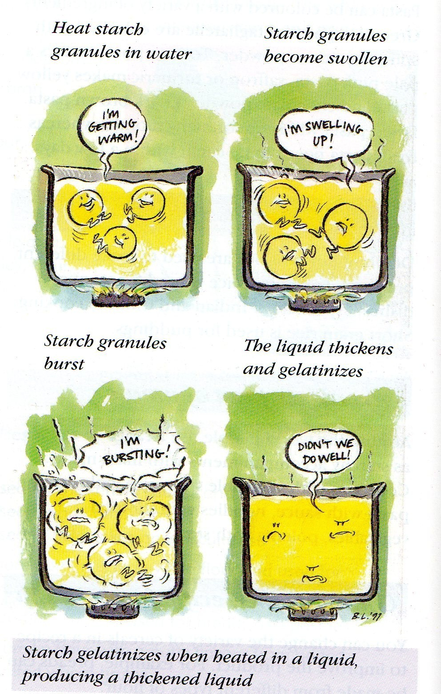
- Explain how starch (e.g. flour) thickens a liquid

- Raw starch tastes _ _ _ _ _ _ and needs to be cooked

- When flour is _ _ _ _ _ _ in a _ _ _ _ _ _ , the walls of the starch become soft and allow liquid to pass through them

- The granules of flour start to _ _ _ _ _ and eventually they _ _ _ _ _

- This is called _ _ _ _ _ _ _ _ _ _ _ _ _ _ and means to
_ _ _ _ _ _ _

Gelatinisation Heated Floury Liquid Swell Thicken Burst

- Suggest 3 different flavourings you could add to a basic white sauce and suggest suitable food products

Suggested Flavouring | Suggested Food Product

- Make a list of ‘Tips’ for making a successful sauce

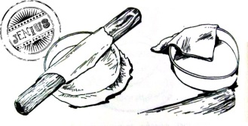
Pastry & Shortening
- Name at least 3 types of pastry

  - ___________________ b. __________________ c. _________________

- Which type of pastry is used to make quiche?

________________________________________________________________

- What are the ingredients in all types of pastry?
________________________________________________________________________________________________________________________________
- What is the ratio (balance) of fat to flour in Shortcrust pastry?
________________________________________________________________

- What types of fats can be used in Shortcrust pastry?
________________________________________________________________

- Make a list of ‘Tips for making successful pastry’
________________________________________________________________________________________________________________________________________________________________________________________________________________________________________________________________________________________________________________________________
- Describe the process of shortening (you can use diagrams if it helps you)
________________________________________________________________________________________________________________________________________________________________________________________________________________________________________________________________
- Complete the table below to show your knowledge of different types of pastry
Type of pastry | Types of products
Shortcrust
 | Sausage roll, vol-au-vents, ___________
Choux pastry
Hot water crust pastry

