Name: _______________________ Class: _________ Teacher: _______________

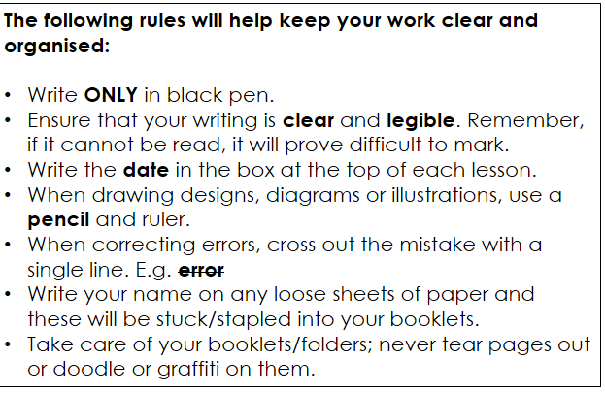

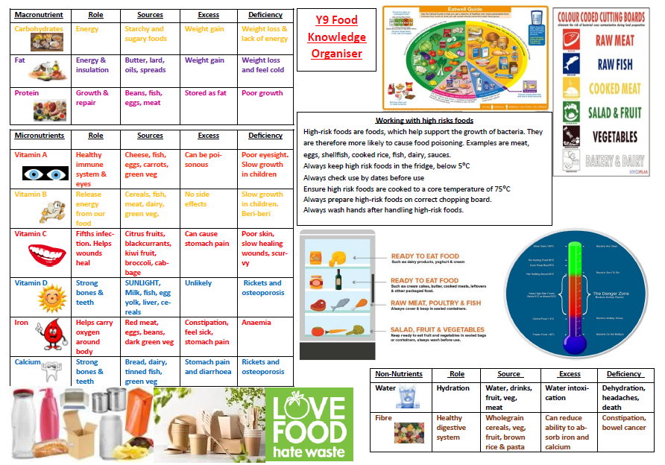
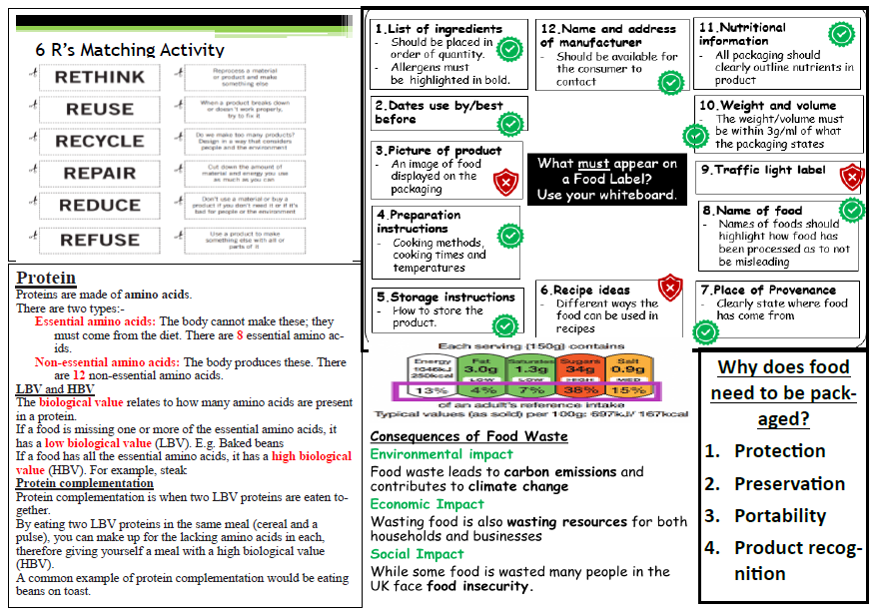
Food Safety and Hygiene

By the end of this lesson you should be able to: identify how food poisoning is caused, explain what conditions bacteria need in order to multiply, understand how you can help to prevent food poisoning bacteria spreading.

The Food Technology classroom is one of the most dangerous rooms in the school. There are 20 students using hobs, ovens, electrical appliances, hot water and knives. Therefore, everyone must agree to follow some simple safety rules to prevent accidents from happening.

Card Sort
Look at cards. Which statements are concerned with hygiene and which are to do with safety?

We all need to eat and drink to stay alive. However, if you don’t take care when you buy, prepare and cook food it can make you ill.
Micro-organisms are found everywhere in our environment, most are completely harmless; a few of them (mostly bacteria and viruses) can make you ill if they contaminate your food. These are called pathogens and cannot be seen by the naked eye. You cannot tell if the food you are eating will give you food poisoning.

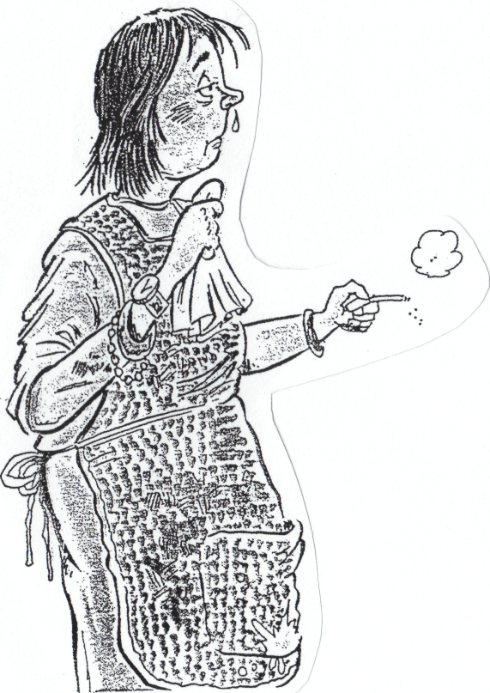
Would you want this woman cooking your food?
What is wrong?

Personal Hygiene
Having good personal hygiene, when cooking, keeps bacteria and dirt that may be on your body or your clothes away from your food, therefore keeping it safe to eat.
Bacteria can also get on food from dirty utensils and surface
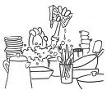
Washing Up
Fill in the missing words; you may use a word twice
To wash up properly you will need:

- …………….....…..................... and ………………............. .... to reduce bacteria and remove grease.
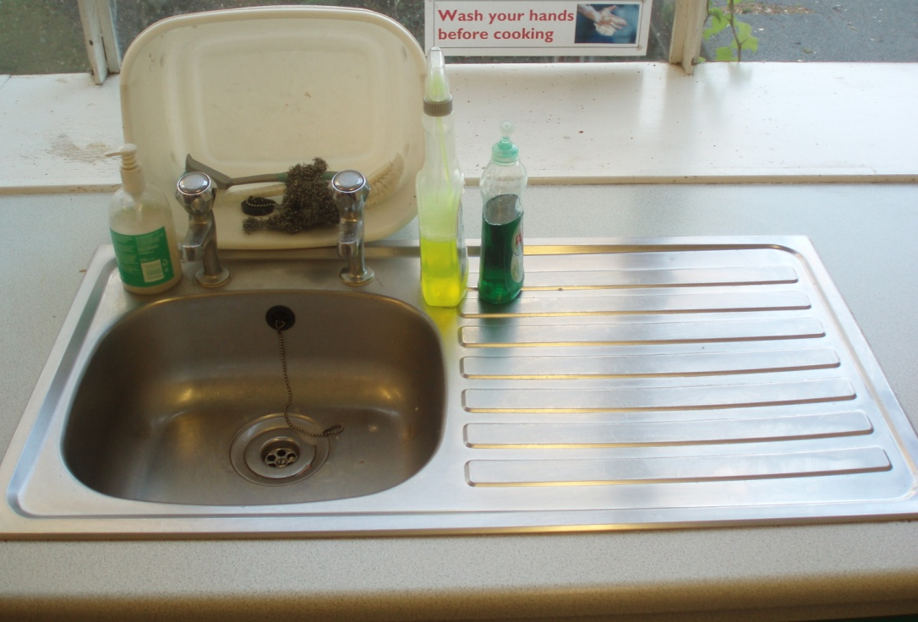
- A ………………………..... to scrub stubborn foods.
- A ……………......…………. to wipe the equipment in the soapy water.
- A …………………........…… to dry the dishes.
The sink should be left clean and dry. No food scraps in the bottom of the sink. Last job to wipe it over with a tea towel

- Stack up all the dirty equipment at the side of the ………………………
- Fill the saucepans and cooking dishes with water and leave to ……………......, until you are ready to wash-up.
- Do not put …………………… into the washing up bowl as you cannot see them in the bowl.
- Drain the dishes ………………………………………… on the draining board.
- Wash all work surfaces with a …………………….wrung in hot soapy water.

Missing words
Dishcloth Scourer Sink Tea towel Knives
Hot water Upside down Detergent Soak

Contract
Please read and sign this contract
Personal Hygiene  - I will always wear my apron to avoid bacteria and dirt getting from my clothes to my food.  - I will not cough or sneeze over food  - I will wash my hands before I work with food, after I have been to the toilet and after I have wiped my nose  - I lose 100 hairs a day so I will always tie my hair back  - I will cover my cuts with a blue plaster  - I will not lick food, spoons or fingers  - I will ensure I do not wear nail varnish  - I will not wear any items of jewellery | Equipment and Environment  - I will thoroughly clean the surfaces of my work area  - I will only use equipment from my assigned work area and replace it at the end of the lesson  - I will wash all equipment in HOT soapy water  - I will listen to the teacher and wait for instructions when the teacher tells me to stop  - I will work co-operatively with others in the room, both teachers and students

Signed............................................... Date...........................................
Bacteria!
Fill in the gaps to show your knowledge of bacteria and how they multiply
The ‘danger zone is between__________ as when bacteria has warmth, ___________, moisture & time it will multiply. Bacteria is kept dormant at -18°C when it is kept in a _______________. By law a fridge can be 8°C but best practice is to keep it at _______, at this temperature bacteria multiplies _____________. By cooking food to a core temperature of ______ ensures that most of the bacteria is killed and is at a safe level to prevent food ___________________. Cooked food should be cooled and placed in the fridge within 90 minutes.



100°C

75°C
63°C


DANGER
ZONE

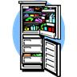
5°C
0°C

-18°C

food slowly freezer
poisoning 5°C 75°C 5-63°C

Name 4 high risk foods:

Name 4 low risk foods:

Bacteria need certain conditions to grow—what are they?
1.

2.

3.

4.

Bacteria cannot move themselves they need something else to move them .g. a chopping board, unwashed hands, clothes and knives.

We call the movement of bacteria from one place to another cross-contamination. The item involved in the movement is called a vehicle.

To prevent cross-contamination in the preparation of foods we use coloured chopping boards and knives.

Identify the correct colour for the chopping boards and colour them in.

Raw Fish

Salad/Fruit

Vegetables

Cooked

Meat

Bakery & Dairy

Raw Meat

Storage

Why might it be important to store foods in the correct places in the fridge?
Golden Rules for the Fridge
- High-risk and perishable foods must be refrigerated at (0˚C to 5˚C)
- Raw meat and poultry must be kept on a separate shelf below other foods so juices/blood does not drip onto other foods.
- High-risk foods must be kept on a separate shelf to other foods (particularly raw meat).
- Fruit & vegetables must be kept separate to prevent physical contamination.

Storing food – Put the shopping into the correct section of the fridge.
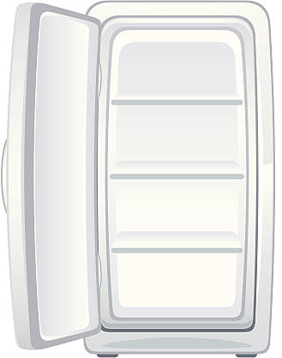
Drawer
Middle shelf
Bottom shelf
Top shelf
Shopping:

Lettuce
Cooked chicken
Cheddar cheese
Left over pizza
Raw cod fillets
Milk
Tomatoes
Sirloin steak
Pork pie

What have you learnt?
Write 3 sentences to explain how will you ensure your product it safe to eat and will not cause food poisoning?

What question do you still have?

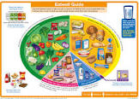
Recap Eatwell Guide
What can you remember?
Do Now: Tick the appropriate Eatwell Guide colour for each food.

Food | Pink | Purple | Yellow | Green | Blue | Outside
Rice
Salmon
Butter
Kidney beans
Wholemeal flour
Lentils
Olive oil
Almond Milk
Orange Juice
Nuts
What are the 5 nutrients?
______________________________________________________________________________________________________________________________

Match the Eatwell Guide statements using numbers
- 5 portions | 6-8 cups or glasses a day
- Fruit juice/smoothies | Plant based proteins
- Starchy food | 1 portion a week
- Wholegrain | Fruit and vegetables
- Source of calcium | Brown rice, wholewheat pasta, wholemeal pitta
- Fish | Max combined 150ml a day
- Oily fish | Eat less often
- Unsaturated oils and spreads | 2 portions a week
- Cakes, biscuits, sugary soft drinks | 1/3 of the food we eat
- Fluids | Vegetable, rapeseed, olive, sunflower
- Try to include more of these in your diet | Milk, cheese, yogurt

Improving Exam Answers

50% of our energy should come from carbohydrates.
Ideally most of this energy should come from starchy foods.
Free sugars should make up no more that 5%.
On average, people in the UK consume too much sugar.
Too much or too little carbohydrate in our diet is unhealthy and can have serious effects on how our body functions.

Which of these would have ‘empty calories’?
- Pasta
- Cake
- Apples

Checking understanding (answer in full sentences).

Extended Response Question
A marathon runner would be advised to have a meal of wholewheat pasta the night before a race whereas a sprinter would be advised to have a high sugar snack just before the race. Explain why each runner would be advised this. (6 marks)

__________________________________________________________________________________________________________________________________________________________________________________________________________________________________________________________________________________________________________________________________________________________________________________________________________________________________________

Functions and Sources of Macro and Micro Nutrients
Research and then complete the boxes below to explain why each of these nutrients is needed in the body.

Nutrient | Role in the Body | Sources | Deficiency/Excess
Carbohydrates |  |  | D =  E =
Fat |  |  | D =  E =
Protein |  |  | D =  E =
Vitamin A |  |  | D =  E =
Vitamin B |  |  | D =  E =
Vitamin C |  |  | D =  E =
Vitamin D |  |  | D =  E =
Iron |  |  | D =  E =
Calcium |  |  | D =  E =
Water |  |  | D =  E =
Fibre |  |  | D =  E =

- Add 2 brackets to identify the macro and micro nutrients in this list
- Which vitamin helps our body to absorb iron?
- Which vitamin helps our body to absorb calcium?

Packaging and Labelling
By the end of this lesson you should be able to explain why food products need to be packaged and understand the information provided on food labels

Consumers are becoming more and more worried about the amount of food packaging we throw away. They want food manufacturers to use less packaging and to make it from materials that can be reused or recycled. Food packaging is essential for keeping our food fresh and intact.
Why does food need to be packaged?
Explain each of the following terms by inserting the missing words:
Protection
- Packaging _ _ _ _ _ _ _ _ the food from _ _ _ _ and _ _ _ _ _ _ _ _
- _ _ _ _ _ _ / _ _ _ _ _ / _ _ _ _ _ _ _ _ _ protects anyone from interfering with food e.g. clicker buttons on jars and plastic seals around the top of drinks bottles and cartons

Preservation
- Some packaging can _ _ _ _ _ _ the _ _ _ _ _ / _ _ _ _ of a product. Examples include cans to store fruit or soup and glass jars for pickles and pasta sauces

Portability
- Packaging often makes a product easier to _ _ _ _ _ _ _ _ _ and _ _ _ _ _ and prevents it from breaking up e.g. biscuits packaged in moulded plastic trays

Product recognition
- The shape and colour of the packaging can make the product _ _ _ _ _ _ _ _ _ _ _ _ so that it stands out on the supermarket shelf. The packaging is also printed with lots of useful information about the product for the consumer

BACTERIA RECOGNISABLE DIRT EXTEND SHELF LIFE

PROTECTS STORE TRANSPORT TAMPER PROOF PACKAGING

Packaging Materials
- What are the 4 materials used to package foods?
- Name 1 advantage and 1 disadvantage of using each packaging material
Packaging Material | Advantage | Disadvantage

Nutritional Labelling

Baked beans:
Find the baked beans which provides the most protein per 100g.
Product name is:

Describe the following:
Use-by date:
Best before date:

Find the labels around the room and fill in the required information.

Cereals:
Find a breakfast cereal that provides the least sugar per 100g.
Energy
Fat
Saturates
Sugars
Salt

Product name is:
Protein
Fibre
Protein

Energy
Fat
Saturates
Sugars
Salt
Fibre

What information MUST be on a food label by law?

__________________________________________________________________________________________________________________________________________________________________________________________________________________________________________________________________________________________________________________________________________________________________________________________

Breads:
Find a bread that provides the most fibre per 100g.
Product name is:

Fibre
Energy
Fat
Saturates
Sugars
Salt

Protein

Yoghurts:
Find a yoghurt that provides the least fat per 100g.
Product name is:

Fibre
Protein

Energy
Fat
Saturates
Sugars
Salt

Ketchups:
Find the ketchup that provides the least salt per 100g.
Product name is:
Protein
Fibre
Energy
Fat
Saturates
Sugars
Salt

Environmental Issues
By the end of this lesson you should be able to list the six R’s and explain what each one means

Every product that is made causes some damage to the environment. Increasingly both manufacturers and consumers are aware of this and looking for ways to reduce it. The six R’s are points that designers and consumers should consider to reduce the impact of their products on the environment.
The Six R’s Activity:
- Add a definition for each ‘R’
- Add an example for each ‘R’ to show your understanding

Love Food: Hate Waste
What is Food Waste?
Food waste is food that is discarded or not consumed. This can happen at any stage from production to household consumption.

Types of Food Waste
Match the types of food waste with their definitions:
- Household Waste
- Food lost during farming, processing, or transportation.
- Unsold food discarded by supermarkets
- Food thrown away by consumers.

- Retail Waste
- Production Waste

Causes of Food Waste
Fill in the blanks with the appropriate causes of food waste

- Household Causes:
  - ________________ and overcooking

  - Not using food before it ________________
- Retail and Production Causes:

  - Strict ________________ standards for fruits and vegetables

  - ________________ and logistical issues.
Consequences of Food Waste
Complete the sentences with the correct consequence.
- Environmental Impact: Food waste leads to ________________ emissions and contributes to climate change.
- Economic Impact: Wasting food is also wasting ________________ for both households and businesses.
- Social Impact: While some food is wasted, many people in the UK face ________________.

Reducing Food Waste
List three tips for reducing food waste at home:

Case Study
Scenario: You notice that your family often throws away leftovers and spoiled fruits and vegetables.
Task: Write down at least three practical solutions you and your family can implement to reduce food waste based on the scenario.

Reflection
Answer the following questions:
- Why is it important to reduce food waste?

- What is one action you can take to reduce food waste in your own home?

Plant Based Diets and Vegetarians
Multiple Choice Questions:
- What are proteins made of?
a) Sugars
b) Amino acids
c) Fatty acids
d) Nucleotides

- Which of the following is a complete protein source?
a) Rice
b) Beans
c) Chicken
d) Bread

- What is protein complementation?
a) Eating only animal proteins
b) Combining different plant proteins to get all essential amino acids
c) Eating more carbohydrates
d) None of the above
Fill in the Blanks:
- Proteins are essential for ______ and ______ of body tissues.
- ______ amino acids cannot be made by the body and must be obtained from the diet.
- ______ is a process of combining different plant proteins to get all essential amino acids.
Types of Vegetarians
Investigate and write a definition for the following types of vegetarians:
- Lacto-Ovo Vegetarian:-
- Ovo Vegetarian:-
- Lacto Vegetarian:-
- Vegan:-
Questions:
- Explain why vegetarians need to be aware of protein complementation

- Provide an example of a meal that uses protein complementation

Create a Meal:
Create a balanced meal that includes all the essential amino acids using plant-based proteins. List the ingredients and explain why this meal is nutritionally complete.
Description of Meal:

Ingredients:

Explain why this meal is nutritionally complete

Plant Based Product Analysis
Product Name

Description
found on packaging

Cooking time | Microwave  Oven
Weight of whole and  one portion | Whole  Per portion
Cost of whole and one portion | Whole  Per portion
Calories per 100g

Protein Food

Sensory Analysis Section
Appearance
(use descriptive words)
Taste
(use descriptive words)
Smell
(use descriptive words)
Texture
(use descriptive words)

