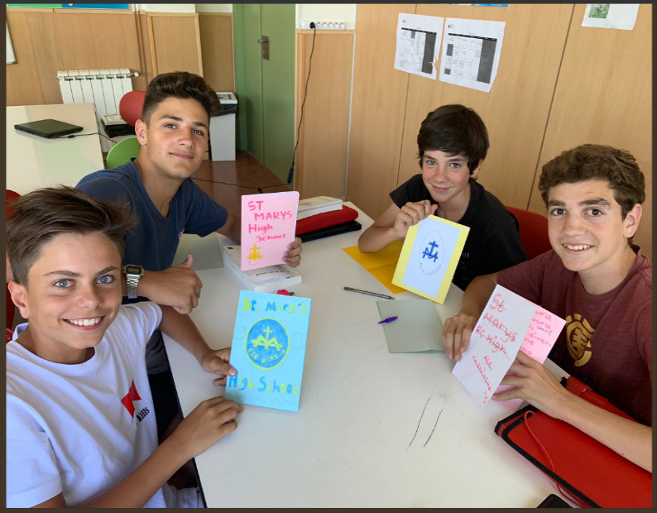
Recently, class 93B took part in a Spanish project involving Virolai School, a school near Barcelona. 93B made small booklets talking about their 2-week timetable lessons, favourite teachers and lessons, places around the school (e.g. hall/cantine, gym, etc.), school uniform as well as our opinions about these topics. We also left the students an area in our booklets or pieces of paper where they could respond to us and discuss their opinions on our school and their school. We handwrote all of this in Spanish with help from our Spanish teacher, Miss Sheringham.
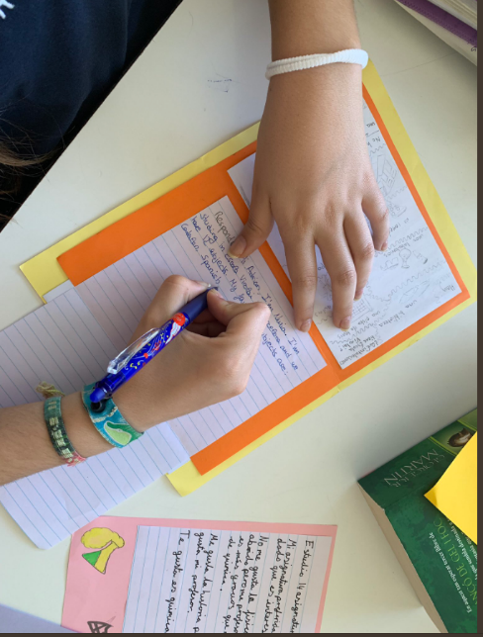
On their Twitter page (@EscolaVirolai), Virolai School retweeted a post from @Suzannedavis of students in Virolai, roughly around the same age as us (13-14), holding and replying to our booklets. Our class saw these photos and felt proud that we could talk with someone over the English Channel in a language that we’re still learning and in the form of a booklet rather than social media.
By Adrian Elegado and Joshua Wilkinson

