Year 8 Reading List

Mistress Masham’s Repose by T H White
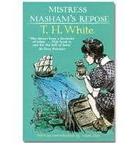
Ten-year-old orphan Maria lives in her ancestors' crumbling mansion, with warm-hearted Cook and the eccentric Professor as her only friends. Exploring the grounds one day, Maria discovers a wild, half-forgotten island in the middle of a neglected lake - and an extraordinary secret. For the island is home to a community of tiny people - the Lilliputians that Gulliver first met on his famous travels.
But as Maria grows closer to her new friends, her own life is in grave danger. Her wicked governess and the cruel vicar are plotting to steal her rightful inheritance - and they will stop at nothing. How can Maria keep the Lilliputians safe, while protecting herself?

Curious Incident of the Dog in the Night-time – Mark Haddon
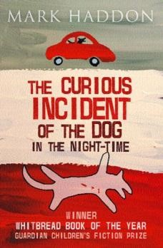
The Curious Incident of the Dog in the Night-Time is a murder mystery novel like no other. The detective, and narrator, is Christopher Boone. Christopher is fifteen and has Aspergers Syndrome. He knows a very great deal about maths and very little about human beings. He loves lists, patterns and the truth. He hates the colours yellow and brown and being touched. He has never gone further than the end of the road on his own, but when he finds a neighbour's dog murdered he sets out on a terrifying journey which will turn his whole world upside down.

Stormbreaker – Anthony Horrowitz

When his guardian dies in suspicious circumstances, fourteen-year-old Alex Rider finds his world turned upside down. Forcibly recruited into MI6, Alex has to take part in gruelling SAS training exercises. Then, armed with his own special set of secret gadgets, he's off on his first mission to Cornwall, where Middle-Eastern multi-billionaire Herod Sayle is producing his state-of-the-art Stormbreaker computers. Sayle has offered to give one free to every school in the country - but there's more to the gift than meets the eye.

Private Peaceful – Michael Morpurgo

Private Peaceful captures the memories of a young First World War soldier awaiting the firing squad at dawn. From his early childhood adventures in rural Devon to the battles and injustices of war that brought him to the Front Line, Private Tommo Peaceful spends these lonely hours re-living his short but vivid past

Artemis Fowl – Eoin Colfer
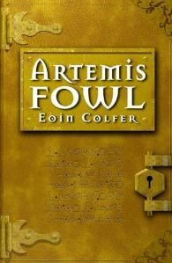
Twelve-year-old villain, Artemis Fowl, is the most ingenious criminal mastermind in history. His bold and daring plan is to hold a leprechaun to ransom. But he's taking on more than he bargained for when he kidnaps Captain Holly Short of the LEPrecon (Lower Elements Police Reconnaissance Unit). For a start, leprechaun technology is more advanced than our own. Add to that the fact that Holly is a true heroine and that her senior officer
Commander Root will stop at nothing to get her back and you've got the mother of all sieges brewing!

Noughts and Crosses – Malorie Blackman
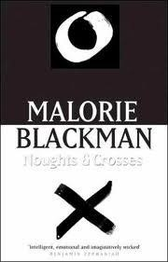
Sephy is a Cross – a member of the dark-skinned ruling class. Callum is a nought – a ‘colourless’ member of the underclass who were once slaves to the Crosses. The two have been friends since early childhood. But that’s as far as it can go. Until the first steps are taken towards more social equality and a limited number of Noughts are allowed into Cross schools… Against a background of prejudice and distrust, intensely highlighted by violent terrorist activity by Noughts, a romance builds between Sephy and Callum – a romance that is to lead both of them into terrible danger…

The London Eye Mystery – Siobhan Dowd
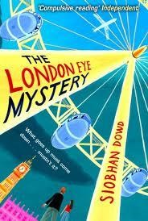
When Ted and Kat watched their cousin Salim get on board the London Eye, he turned and waved before getting on. After half an hour it landed and everyone trooped off - but no Salim. Where could he have gone? How on earth could he have disappeared into thin air?
Since the police are having no luck finding him, Ted and Kat become sleuthing partners. Despite their prickly relationship, they overcome their differences to follow a trail of clues across London in a desperate bid to find their cousin. And ultimately it comes down to Ted, whose brain works in its own very unique way, to find the key to the mystery.

Lion Boy – Zouzou Corder
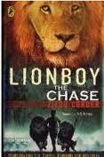
Charlie Ashanti, the hero of LIONBOY, speaks cat - the language of all cats wild and domestic alike. His unusual talent helps him on his quest to find his kidnapped parents who have discovered a cure for asthma. The local cats of his home town (a futuristic London) start him on his search to solve the mystery of his missing parents, which leads him across the channel on board a circus ship bound for Paris. It is on this wonderful vessel that Charlie establishes a close relationship with the homesick circus lions who become his accomplices. But Charlie is in danger, for close behind him on his trail, is a crony of the mysterious group who have kidnapped his parents. They want Charlie too.

The Thief Lord – Cornelia Funke

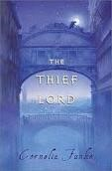
Winter has come early to Venice. Two orphaned children are on the run, hiding among the crumbling canals and misty alleyways of the city. Befriended by a gang of street children and their mysterious leader, the Thief Lord, they shelter in an old, disused cinema. On their trail is a bungling detective, obsessed with disguises and the health of his pet tortoises. But a greater threat to the boys' new-found freedom is something from a forgotten past - a beautiful magical treasure with the power to spin time itself.

Holes – Louis Sachar
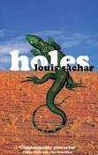
Stanley Yelnats' family has a history of bad luck going back generations, so he is not too surprised when a miscarriage of justice sends him to Camp Green Lake Juvenile Detention Centre. Nor is he very surprised when he is told that his daily labour at the camp is to dig a hole, five foot wide by five foot deep, and report anything that he finds in that hole. The warden claims that it is character building, but this is a lie and Stanley must dig up the truth. In this wonderfully inventive, compelling novel that is both serious and funny, Louis Sachar has created a masterpiece that will leave all readers amazed and delighted by the
author's narrative flair and brilliantly handled plot.

Inkheart – Cornelia Funke

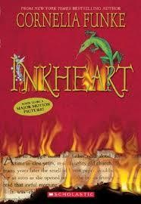
Meggie loves books. So does her father, Mo, a bookbinder, although he has never read aloud to her since her mother mysteriously disappeared. They live quietly until the night a stranger knocks at their door. He has come with a warning that forces Mo to reveal an extraordinary secret - a storytelling secret that will change their lives for ever.

A Series of Unfortunate Events – Lemony Snicket

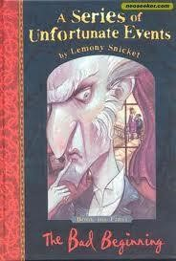
This book follows the turbulent lives of Violet, Klaus, and Sunny Baudelaire after their parents' death in an arsonous house fire. The children are placed in the custody of their distant cousin Count Olaf, who begins to abuse them and openly plots to embezzle their inheritance. After the Baudelaires are removed from his care by their parents' estate executor, Arthur Poe, Olaf begins to doggedly hunt the children down, bringing about the serial slaughter and demise of a multitude of characters.

The Spiderwick Chronicles – Tony Di Terlizzi and Holly Black
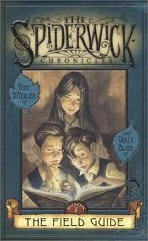
Beware! The faeries will use all their power to stop you from reading these books. Book 1 of The Spiderwick Chronicles in which Mallory, Simon and Jared get acquainted with their new home but find many unexpected things. It all starts when Jared Grace find their great uncle's book, "Arthur Spiderwick's Field Guide to the Fantastic World Around You." and realises that are not alone in their new house. Now the Grace kids want to tell their story but the faeries will do everything to stop them...It’s up to you to spread the word about their discovery. But heed their warnings, wear some red, turn your clothes inside out - all anti-faerie devices - and get ready to enter a world that you never knew existed...It’s closer than you think!

The Named – Marianne Curley

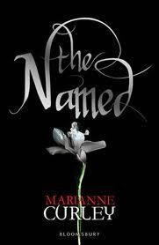
Imagine if you were able to change history. By altering one tiny thing you could start a chain of catastrophic events. Ethan is one of the Named, fated to stop this ever happening, although the forces of chaos have other ideas and Ethan is finding it more and more difficult to stay one step ahead. He is also a normal schoolboy, whose life is rapidly becoming far too confusing. So when Isabel arrives on the scene she is only going to make matters worse ...or is she? This is history in the making - literally.

Diary of Anne Frank – Anne Frank
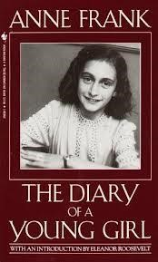
Thez Diary of a Young Girl is among the most enduring documents of the 20th century. Anne Frank kept a diary from 1942 to 1944. Initially she wrote it strictly for herself. Then, one day in 1944, a member of the Dutch government in exile announced in a radio broadcast from London that after the war he hoped to collect eyewitness accounts of the suffering of the Dutch people under the German occupation, which could be made available to the public. As an example, he specially mentioned letters and diaries. Anne Frank decided that when the war was over, she would publish a book based on her diary. Anne's diary ends abruptly when she and her family were betrayed.

My Family and Other Animals – Gerald Durrell

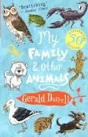
Sometimes it's pretty hard to tell them apart... my family and the animals, that is. I don't know why my brothers and sisters complain so much. With snakes in the bath and scorpions on the lunch table, our house, on the island of Corfu, is a bit like a circus. So they should feel right at home...

Goodnight Mr Tom – Michelle Magorian

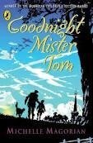
Young Willie Beech is evacuated to the country as Britain stands on the brink of WW2. A sad, deprived child, he slowly begins to flourish under the care of old Tom Oakley - but his new-found happiness is shattered by a summons from his mother back in London...

The Ruby in the Smoke – Philip Pullman
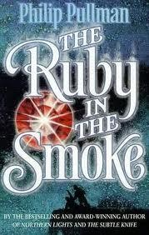
Soon after Sally Lockhart's father drowns at sea, she receives an anonymous letter. The dire warning it contains makes a man dief fear at her feet. Determined to discover the truth about her father's death, Sally is plunged into a terrifying mystery in the dark heart of Victorian London, at the centre of which lies a deadly blood-soaked jewel.

The Silver Sword – Ian Serraillier

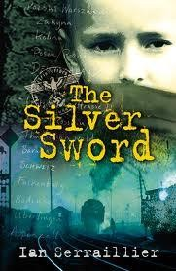
Alone and fending for themselves in a Poland devastated by World War Two, Jan and his three homeless friends cling to the silver sword as a symbol of hope. As they travel through Europe towards Switzerland, where they believe they will be reunited with their parents, they encounter many hardships and dangers. This extraordinarily moving account of an epic journey gives a remarkable insight into the reality of a Europe laid waste by war.

Carrie’s War – Nina Bawden

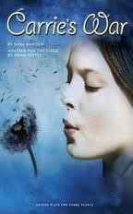
Set in WW2, Carrie and her little brother are evacuated to Wales and billeted at the home of the bullying Mr Evans and his timid sister Lou. Unhappy at home, they love visiting fellow evacue, Albert, at the farm of Druid's Bottom. Here they meet Hepzibah Green, who knows magical stories, and Mister Johnny, who speaks a language all his own. But then things go wrong and Carrie takes things into her own hands - without guessing the awful consequences.

I Coriander – Sally Gardner

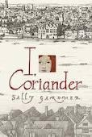
The story is told by Coriander, daughter of a silk merchant in 1650s London. Her idyllic childhood ends when her mother dies and her father goes away, leaving Coriander with her stepmother, a widow who is in cahoots with a fundamentalist Puritan preacher. She is shut away in a chest and left to die, but emerges into the fairy world from which her mother came, and where time has no meaning. When she returns, charged with a task that will transform her life, she is seventeen.

The Graveyard Book – Neil Gaiman
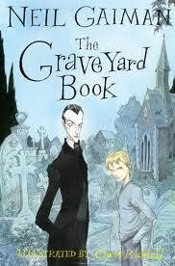
When a baby escapes a murderer intent on killing the entire family, who would have thought it would find safety and security in the local graveyard? Brought up by the resident ghosts, ghouls and spectres, Bod has an eccentric childhood learning about life from the dead. But for Bod there is also the danger of the murderer still looking for him - after all, he is the last remaining member of the family. A stunningly original novel deftly constructed over eight chapters, featuring every second year of Bod's life, from babyhood to adolescence. Will Bod survive to be a man?

The Edge – Alan Gibbons
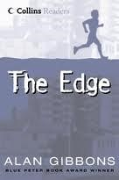
We’ve got to go. Now! It’s early morning and Danny’s mother is at his bedside, urging him to get up. They’re on the run from Chris, his mother’s boyfriend, a violent man who beats them both up, and won’t let them go.
Chris pursues Danny and his mother from London to the north, where they take refuge with Danny’s grandparents. But even there, nothing is safe. Danny is conspicuous as the only mixed-race boy in their small community, and with the ever-present threat of discovery, he has to learn how to live continually on the edge.

The Other Side of Truth – Beverley Naidoo
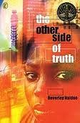
This is the story of 12 year-old Sade and her brother Femi who flee to Britain from Nigeria. Their father is a political journalist who refuses to stop criticising the military rulers in Nigeria. Their mother is killed and they are sent to London, with their father promising to follow. Abandoned at Victoria Station by the woman paid to bring them to England as her children, Sade and Femi find themselves alone in a new, often hostile, environment. Seen through the eyes of Sade, the novel explores what it means to be classified as 'illegal' and the difficulties which come with being a refugee.

Journey to the River Sea – Eva Ibbotson
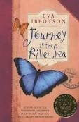
Miss Minton and Maia are sailing to the city of Manaus, a thousand miles up the mighty Amazon river. Maia, a lonely orphan, is excited to be starting a new life with relatives she's never met. Mysterious Miss Minton has secret reasons of her own for making the journey. But years of living in the jungle have sent Maia's uncle and aunt slightly mad. And their twin daughters are definitely not like normal children... In her wildest dreams, Maia could never have imagined the extraordinary adventures that await her on the shores of the River Sea. Eva
Ibbotson's latest novel, for readers of all ages, is one of the richest, funniest, most
touching, most satisfying books you will ever read

Five Children and It – E Nesbit
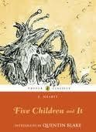
When Cyril, Anthea, Robert, Jane and their baby brother go digging in the gravel pit, the last thing they expect to find is a Psammead – an ancient Sand-fairy!
Having a Sand-fairy for a pet means having one wish granted each day. But the children don't realize all the trouble wishes can cause . . .

Charlie and the Chocolate Factory – Roald Dahl

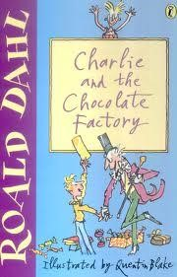
The gates of Willy Wonka's famous chocolate factory are opening at last--and only five children will be allowed inside.

Pegasus and the Flame – Kate O’Hearn

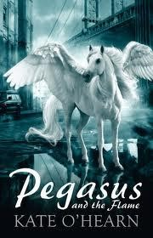
When Pegasus, the majestic winged-stallion, crashes on to her roof in the middle of a storm that blacks-out New York City, 13-year-old Emily's life becomes that of legend: epic battles with gruesome monsters, desperate chases from a corrupt governmental agency, captivating flights astride the beautiful winged-stallion, and one heroic quest to save Olympus before the Olympic flame burns out ...

Silverfin – Charlie Higson
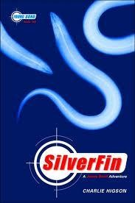
The dark waters around a remote Scottish castle hold a sinister secret. One man with a thirst for power will use it - whatever the cost.

SilverFin is DANGEROUS
SilverFin is the FUTURE
SilverFin must be DESTROYED

The Recruit – Robert Muchamore
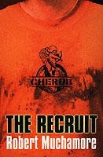
A terrorist doesn't let strangers in her flat because they might be undercover police or intelligence agents, but her children bring their mates home and they run all over the place.

The terrorist doesn't know that a kid has bugged every room in her house, cloned the hard drive on her PC, and copied all the numbers in her phone book. The kid works for CHERUB.

CHERUB is not James Bond. There are no master criminals or high-tech gadgets. CHERUB kids live in the real world. They slip under adult radar and get information that sends criminals and terrorists to jail.

Once Trilogy – Maurice Gleitzman
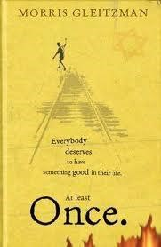
For three years and eight months Felix has lived in a convent orphanage high in the mountains in Poland. But Felix is different from the other orphans. He is convinced his parents are still alive and will come back to get him. When a group of Nazi soldiers come and burn the nuns' books, Felix is terrified that his Jewish, bookseller parents will also be in danger. After escaping from the orphanage, Felix embarks on a long and dangerous journey through Nazi occupied Poland, befriending a little orphan girl called Zelda and a kindly
dentist, Barney, who hides and cares for Jewish children. But when the Nazis discover them, Barney makes the ultimate sacrifice for the children.

