British Values at St Mary’s RC High School
At St Mary’s RC High School, we are committed to preparing our pupils for life after they leave us in wider society, and to ensuring that we promote and reinforce British Values to all of our young people.
We help pupils in all year groups to develop the knowledge, understanding and skills which will enable them to be confident, healthy and active citizens and members of society. Furthermore, our ‘Learning 4 Life’ programme as part of the PSHRE provision, promotes fundamental British Values which are taught implicitly in lessons and throughout all key stages.
Our inclusive approach at St Mary’s builds on the pupils’ prior learning and life experiences, and provides them with a framework to develop these further.
Everything we do at St Mary’s is based on establishing a strong sense of social and moral responsibility both within and beyond our school community. British Values support us in creating an environment that is free from discrimination and where we can challenge prejudice, extremism and stereotyping.
The 5 Key British Values are:
- Democracy
- The rule of law
- Individual liberty
- Mutual respect
- Tolerance of those different faiths and beliefs
Our Mission Statement at St Mary’s reflects these values, indeed, one of its 5 key pillars is to ‘Prepare pupils for their future life in today’s world’. Within our mission, we are also committed to ‘Supporting initiatives which train pupils to develop as independent young adults able to take responsibility’.
We believe strongly that staff and pupils must ‘live’ and model these values rather than simply be taught them. We pride ourselves on the relationships between pupils and their peers and those that exist between pupils and their teachers at St Mary’s.
Similarly, the Virtue Pairs which are key to all that we teach our pupils at St Mary’s also link closely to the five key values:
- Grateful & generous
- Attentive & discerning
- Compassionate & loving
- Faith-filled & hopeful
- Eloquent & truthful
- Learned & wise
- Curious & active
- Intentional & prophetic

As a result of our provision, pupils at St Mary’s develop:
- An understanding of how citizens can influence decision-making through the democratic process
- An appreciation that living under the rule of law protects individual citizens and is essential for their wellbeing and safety
- Understanding of the reasons for accountability of institutions and why courts maintain independence
- Understanding that the freedom to choose and hold other faiths and beliefs is protected in law
- An acceptance that other people having different faiths or beliefs, should be accepted and tolerated, and should not be the cause of prejudicial or discriminatory behaviour
- The importance of identifying and combatting discrimination and extremism
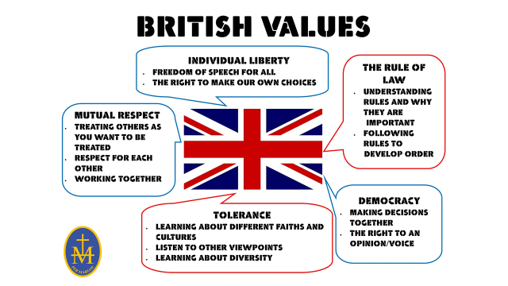

The wider curriculum at St Mary’s
The wider curriculum at St Mary’s is used to highlight British Values as part of the school’s ethos and Mission Statement. Year group assemblies, led by our Heads of Year, focus on themes related to the individual values and, in addition, our pupils experience assemblies about Remembrance, Keeping safe online, and Bullying etc


