Computer Science Department

Curriculum Statement

Intent
Our aim in Computer Science aim is two-fold: to inspire students – as pioneers of the future; and to nurture a love of our subject. As computer programs pervade every aspect of our lives, our society needs computer scientists – passionate individuals to develop Computer Science in every type of industry.
In practice, this means that students need to see the wider picture and to relate their learning to the real world and possible career paths. They need to become digitally literate, and digitally resilient. We will achieve this by teaching them to understand and apply the fundamental principles and concepts of Computer Science. They will acquire this knowledge by learning key facts and words, by analysing problems in computational terms, and through repeated practical experience of writing computer programs in order to solve problems. Students will thus learn to evaluate and apply information technology (including unfamiliar technologies) and will become competent and creative users of it – in both home and work contexts.

Implementation

Curriculum and Scheme of Work
The scheme of work for all year groups is reviewed each year, involving all teachers of the subject to ensure suitability, quality and compliance with statutory requirements of the National Curriculum. Schemes of work are held on the Central Resource Library and the Microsoft Teams team for each year group and can be accessed by any member of the department. Pupils have visibility of the Learning Journey which is a visual representation of the scheme of work.

At Key Stage 3 students will be introduced to how computers work, programming, computational thinking, spreadsheets, databases, networks, cyber security, implications of digital systems and legal, ethical and environmental issues. The KS3 curriculum has been developed to ensure pupils develop key ICT skills, computational thinking skills and have a solid baseline knowledge for GCSE.

At Key Stage 4 Computer Science students:
- Understand more deeply fundamental Computer Science concepts, e.g. abstraction, decomposition, logic, algorithms, and data representation;
- Analyse problems in computational terms by practically solving such problems, including designing, writing and debugging programs;
- Learn to think creatively, innovatively, analytically, logically and critically understand the components that make up digital systems; and will
- Understand the impacts of digital technology to the individual and to wider society and apply mathematical skills relevant to computer science.
The KS4 scheme of work is developed to prepare students for the OCR J277 examination.

To ensure long-term retention of knowledge we revisit prior learning by implementing a spiral curriculum, thus ensuring we constantly build upon previous knowledge. We use responsive teaching, questioning, knowledge-based assessments, deliberate and guided practice to check student understanding. Resources are selected to support, assess, develop and consolidate knowledge and skills to facilitate progression. To inspire a passion through activities out of the classroom we aim implement physical computing, real world scenarios and discuss future career opportunities. We promote reading around computing through class discussion and in particular whilst teaching emerging technologies and the history of computing.

Marking & Feedback
- Marking and feedback within the department follows the School Marking Policy in terms of aims, rationale, structure and frequency.
- Marking within the department takes a number of forms but does employ the Star & Target method and is focussed on recognising, appreciating and commenting on effort and progress but also highlighting gaps and/or issues and offering concrete suggestions to enable pupils to make tangible progress in terms of their knowledge, skills and understanding.
- Self-assessment and peer-marking is employed within the department to encourage growth mind-set, self-reflection and to help pupils develop their understanding of critical assessment.
- Exam-style written assessments are always reviewed as a class and the pupils are given access to the mark scheme. This allows them to see for themselves how they could have improved their answers and gives the opportunity to discuss common misconceptions.
- Following KS4 formal exams, one to one discussions are carried out with every pupil to discuss their paper and compare their results with their target grades.

Assessment
- All exam-style written assessments, at both KS3 and KS4, are modelled on GCSE questions from past and current exam papers and use exam board marks schemes, simplified for ease of access for our pupils.
- At KS3 termly assessments are posted on Teams. This ensures all classes are completing the same assessment within the same week. These assessments are automatically marked and then reviewed and graded by HoD once the whole year group has completed it.
- Within the department, teachers are expected to carry out formative assessment, or live marking, which enables teachers and students to discuss particular issues and for teachers to offer specific feedback which can be acted on immediately.
- Formative assessment also takes the form of pre-agreed (within the department) homework and quick quizzes and cold/warm/hot tests. All of these enable pupils to consolidate their learning and demonstrate their understanding of particular topics.

Impact
Students will show progress in tracking, formal/informal assessments of facts/keywords, and end-of-unit tests. Assessed real-life practical tasks’ outcomes will be used responsively to ensure progress. Their progress, and our reviews, determine how well we have achieved our intent.

Data from all assessments is recorded and frequently reviewed both by individual teachers and collectively as a Department to enable timely and appropriate interventions. All KS4 results are included in the DDP.

Learning Journeys

KS3
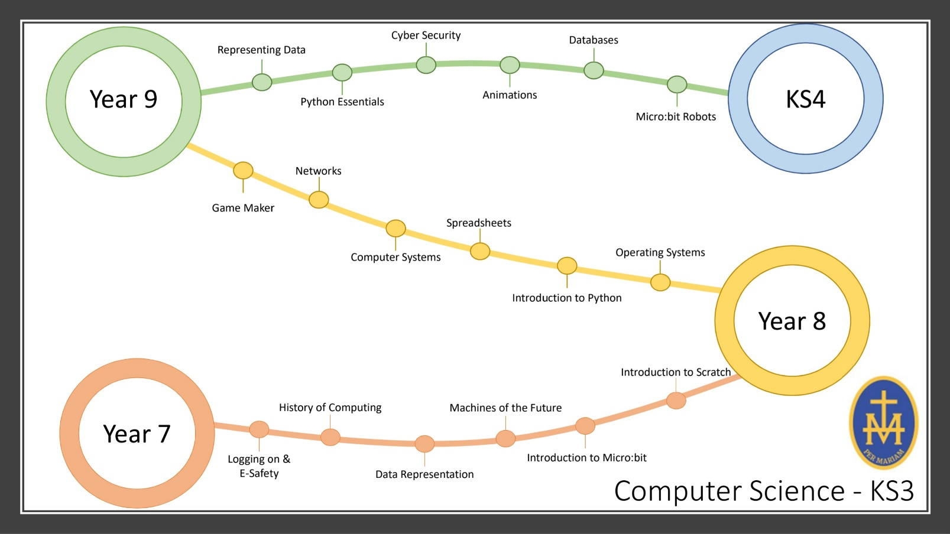

KS4


