Despite my initial dread of the 24-hour coach journey, it is fair to say that it was well worth it in the end! Our pilgrimage to Lourdes this summer was a completely unforgettable experience for all of us, from enjoying free time, getting to know new people or having the opportunity to spend some quiet time in prayer during the night visits to the grotto. Every moment was so special in this unique and life-changing place.
Personally, my journey to Lourdes began with my mum trying to encourage me that it would be a memorable and enjoyable experience, and the more I thought about it, the more I looked forward to the idea of a pilgrimage. As soon as we arrived it was clear to me that the upcoming week was going to be like nothing I had ever experienced before. Despite our fatigue after the mammoth journey, we were soon energised and excited about exploring our new surroundings.
While we had time in Lourdes socialising and perusing the many stalls, we also spent time celebrating Mass and other services, which we all valued greatly. The true meaning and purpose of the pilgrimage soon became apparent, and we all immersed ourselves from the outset. In particular, the services were an opportunity to reflect and think about others and the support we could offer to them. The services came in all shapes and sizes, ranging from attending Mass in our hotel as just the St Mary’s group to gathering with all other pilgrims saying the Rosary together at the Grotto. We also took part in the torchlight procession which was broadcast throughout the world – an unforgettable experience.
During our week in Lourdes, I forged friendships that will endure, met people I will never forget and laughed more than I ever thought possible!
For me, what stood out so significantly was how at ease everyone on pilgrimage felt. I attribute this to Lourdes being such a special place of healing where we could let go of our troubles and feel completely relaxed in the compassion of others and the very present goodness of God. My personal highlight from the trip were the grotto visits at night because we had the opportunity to reflect, feel the love of God and those around us. It felt incredible to realise the magnificence of what took place there with St Bernadette in 1858, and to thank others for making the pilgrimage so special. It felt incredibly emotional just to be there in such moments.
During our stay we also managed to fit in a day trip up in the Pyrenees, something else I absolutely loved. The picturesque mountains, rivers and waterfalls were stunning in the sunshine. We also had a trip to the seaside town of St Jean De Luz and, once again, the sun shone on us so we were able to fully enjoy the beach, the sea and, most importantly, the ice creams!

By the end of the week in Lourdes we were all reluctant to leave given how special and affirming the whole experience had been. We even faced the return coach journey without complaint as many friendships, new outlooks and incredible memories had been formed over the course of the week.
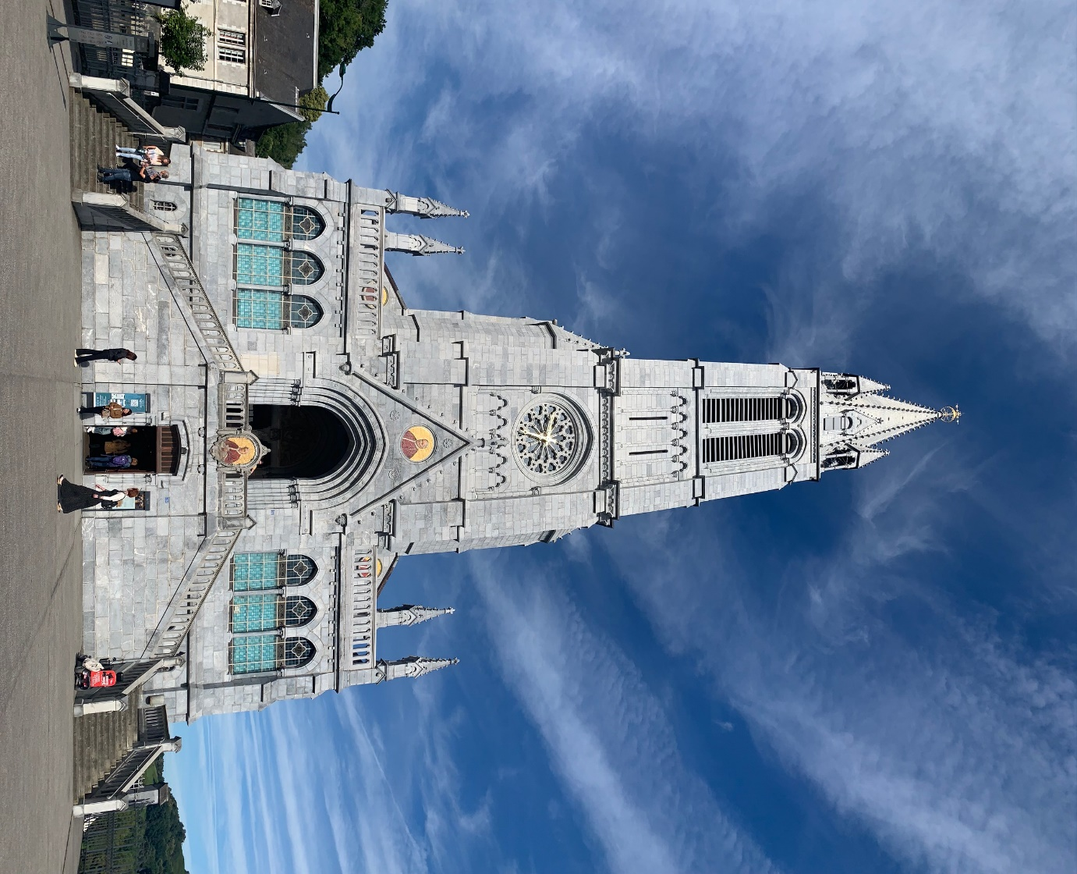
﻿Lourdes was one of the best school trips I have ever been on. It was a perfect mix of a powerful and meaningful pilgrimage, as well as experiencing a new country and culture. If I could, I would go again in a heartbeat!
Noah, Year 11


