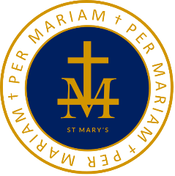
ST MARY’S RC HIGH SCHOOL
PER MARIAM
Science: KS3 End of Year Revision List.
Year Seven
Introduction to science
Cells
Particles
Organising a body
Acids and alkalis
Waves: Light and Sound
Reproduction
Chemical reactions
Atoms and elements

Year Eight
Microbes
Space
Periodic table
Respiration
Electricity
Magnetism
Food and digestion
Separation Techniques
Energy

