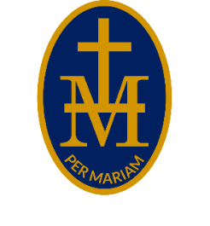
S T M A R Y ’ S R C H I G H S C H O O L
P E R M A R I A M
HEADTEACHER: Mr S Wetson BA [Hons] PGCE NPQH



01432 850416
admin@stmarys-high.hereford.sch.uk
HR1 4DR

May 2026

Dear Parents/Carers
Instrumental/Vocal Tuition
We have a vibrant, dynamic and enthusiastic team of ten visiting music teachers who deliver instrumental lessons within the school day. They teach a range of musical styles to suit each student and offer an approach which will motivate them and promote enjoyment of all types of music – both solo and ensemble. Students will be able to join the many music groups we have on offer, and take part in a range of concerts and shows.
We offer tuition on Trumpet, Trombone, Flute, Saxophone, Clarinet, Oboe, Bassoon, Guitar, Ukulele, Piano, Violin, Viola, Harp, Drum-Kit and Voice. If there is an instrument missing off this list that you would like to learn, get in touch! Our team of staff are:
Sarah Rees Flute/Clarinet/Saxophone/Harp
Charlotte Hold Oboe
Hazel Landey Bassoon
John Griffiths Brass
John Hymas Violin/Viola
Jane Bovell Voice
Kathryn King Piano/Keyboard
Anna Phelps Piano/Keyboard
Ian Russell Drum Kit
Neil Taylor Guitar/Ukulele

All of our teachers are self-employed accredited teachers with Encore Music Service, have undergone a rigorous interview process and have relevant DBS clearances. Lessons take place on a rotational basis during the school day to ensure that students do not miss the same lesson every week, and although payment and contracts are made with the teacher directly, we can put them in touch with you if your child is interested in starting lessons.
If you would like to hire a musical instrument, this is done directly with the Music Service, please fill in the form on their website https://www.encore-enterprises.com/instrumenthire or contact Alex McWilliams at alex@encore-enterprises.com. Free hire is available for those who receive free school meals.
The Herefordshire Music Fund also offers lesson bursaries for these students, as well as families above the support threshold who would struggle to pay for musical tuition but would love to learn, details can be found at https://www.encore-enterprises.com/herefordshiremusicfund.
If you are interested in your child learning or continuing to play a musical instrument, then please click on the link here and submit the form to St Mary’s Music Department by Friday 17th July 2026. Alternatively, you can email me your child’s details at sturley@st-maryshigh.hereford.sch.uk. The relevant teacher will then be in touch with you with more information and to arrange the lessons. If you have any questions about music tuition, please do not hesitate to contact me.
Yours sincerely
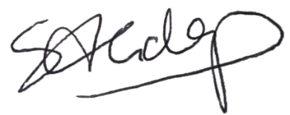
Mrs S Goldup
Head of Music

