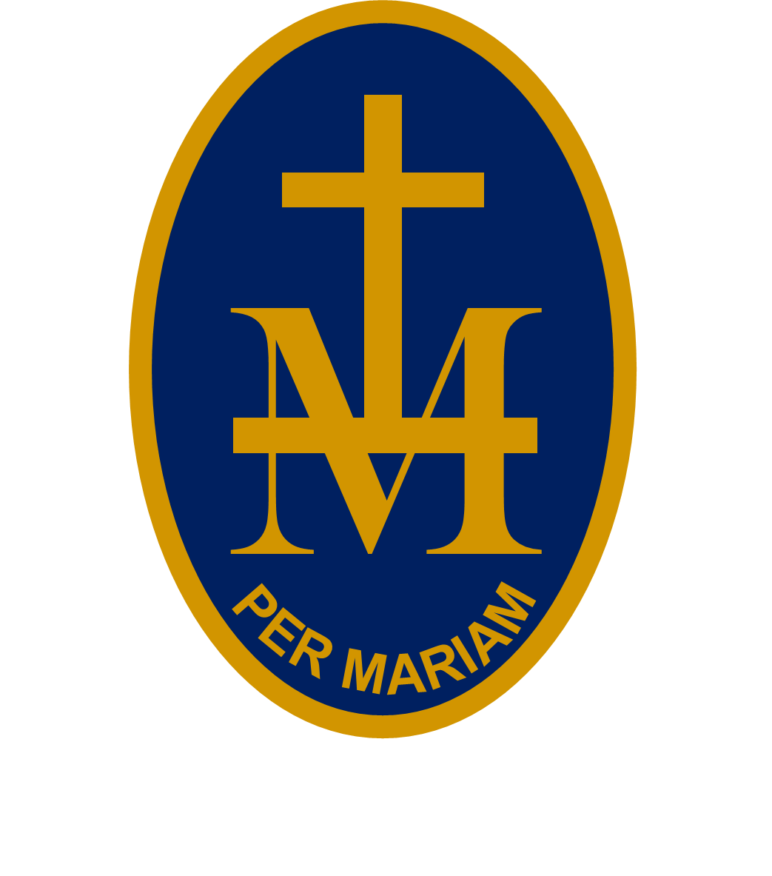
23rd

S T M A R Y ’S R C H I G H S C H O O L

BULLETIN
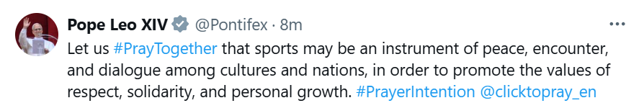

W/C 15 JUNE 2026 - WEEK 1
PUPILS: CHECK EACH WEEK AS PLANS CAN CHANGE!
MONDAY 15 JUNE:
8.55-9.30am | Main hall | Yr 7 Assembly | Miss Deegan
8.55-9.15am | 24 | Touch Typing Intervention (invite only) | Mrs Watkins
3.30-4.30pm | Textiles | Yrs 8&9 Textile club (pre sign up only) | Miss Lloyd
4.45-5.45pm | Main hall | Stop the Bleed first aid training session (pre sign up only) | Mrs Tanton
TUESDAY 16 JUNE:
8.55-9.15am | Main hall | Yr 8 Assembly | Mrs Walton
9am-4.30pm |  | Yr 10 Cold Knap Beach fieldtrip | Mrs Hughes, Mrs Corbin & Mr McDonald
8.55-9.15am | 24 | Touch Typing Intervention (invite only) | Mrs Watkins
Lunchtime | Music | Orchestra | Mrs Goldup
3.30-4.30pm | Art | Yr 10 Art revision | Miss Deegan
WEDNESDAY 17 JUNE:
Lunch | Music | Music Theory | Mrs Goldup
Lunch | LC1 | Youth SVP | Miss Leslie
12.35-1pm | 4 | Yr 7 Geography club | Mrs Hughes
3.30-4.30pm | 24 | Yrs 7-10 Homework club | Mrs Corrick
3.30-4.30pm | Music | Yr 10 GCSE coursework session | Mrs Goldup
THURSDAY 18 JUNE:
8.55-9.15am | Main hall | Yr 9 Assembly
8.55-9.15am | 24 | Touch Typing Intervention (invite only) | Mrs Watkins
Lunch | Music | Choir | Mrs Goldup
Lunch | Music | String Ensemble | Mrs Kinnaird
3.30-4.30pm | Music | Yr 10 GCSE coursework session | Mrs Goldup
4.30-11.15pm | - | The Tempest Trip at Stratford Upon Avon | Mrs Robins
6pm | Main hall | Yr 10 Prefect Presentation Evening | Mr Coyne &  Yr 10 Tutors
5-7pm | - | Hereford Sixth Form – final open event this year
FRIDAY 19 JUNE:
8.55-9.15am | Main hall | Yr 10 Assembly | Mr Coyne
8.55-9.15am | 24 | Touch Typing Intervention (invite only) | Mrs Watkins
Lunch | Music | Keyboard | Mr Watson
Lunch | 25 | Yrs 7&8 Computer Science club (sign up only) | Mr Pearce & Mr McDonald
Lunch | EAL room | EAL drop in | Mrs Hicks
Lunch | LC1 | CAFOD club | Miss Leslie
UPCOMING EVENTS:
Monday 22 June : 5.30-7.30pm Hereford College of Arts - open evening
Tuesday 23 June : Sports Day
Thursday 25 June : All day Yr 10 University Visits
Thursday 25 June : 6.30pm Yr 11 Prom at Hereford Racecourse
Saturday 27 June - Wednesday 1 July : Morocco trip
Saturday 26 June - Tuesday 30 June : Battlefields trip
Monday 29 June : 7.30am-7pm Yr 11 Alton Towers Miss Deegan
Wednesday 1 July : 7am-7pm Yr 8 Alton Towers Mrs Walton
Thursday 2 July : Yr 6 moving up day
Thursday 2 July : Sports Day reserve date
Thursday 2 July : Yr 8 Careers Day
Friday 3 July : Yr 10 Cadbury World business studies trip Mrs Avery
Friday 3 – Sunday 5 July : Manorbier PE trip Mr Griggs
Tuesday 7 July : 6.30pm Summer Concert
Wednesday 8 & Thursday 9 July : Yr 6 Science Festival
Monday 29 June : All day Yr 7 Careers Day
Tuesday 30 June : Yr 10 Three Colleges Taster Day
Thursday 2 July : All day Yr 8 Careers Day
Wednesday 15 & Thursday 16 July : Eisteddfod
Friday 17 July : End of Summer Term

