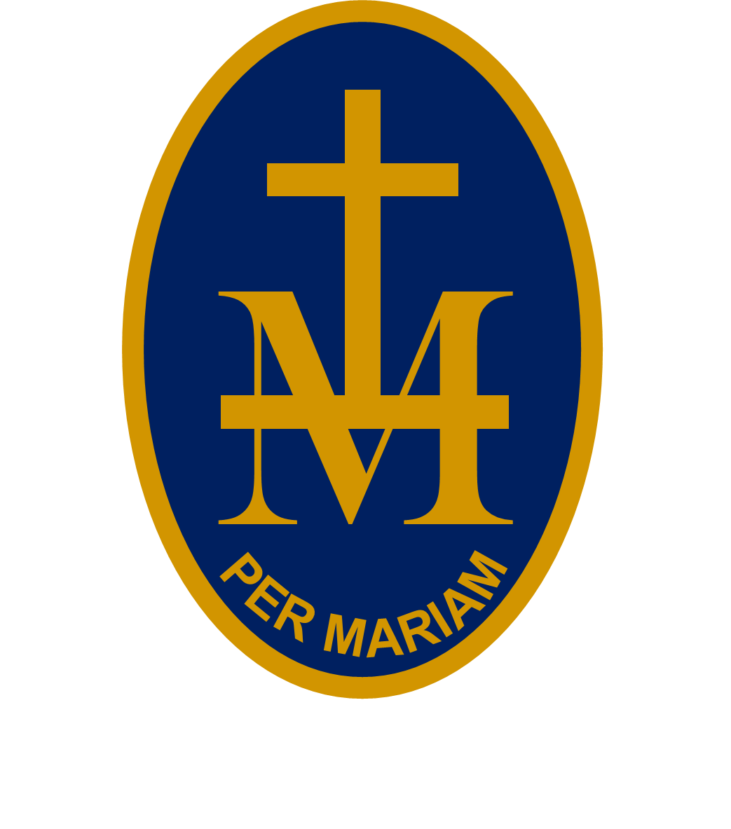
23rd

S T M A R Y ’S R C H I G H S C H O O L

BULLETIN


W/C 31 AUGUST 2026 - WEEK 2
PUPILS: CHECK EACH WEEK AS PLANS CAN CHANGE!
MONDAY 31 AUGUST:
 |  | SCHOOL HOLIDAYS
TUESDAY 1 SEPTEMBER:
 |  | INSET 1
WEDNESDAY 2 SEPTEMBER:
 |  | INSET 2
THURSDAY 3 SEPTEMBER:
 |  | PUPILS RETURN TO SCHOOL
All day |  | Yr 7 Day with Tutors | Yr 7 Tutors
1pm | Hall | Yr 7 photographs | Yr 7 Tutors
FRIDAY 4 SEPTEMBER:
9am | Chapel | Volunatary Mass | Fr Augustine
1.25pm | Hall | Yr 7 Assembly | Mr Wetson
All day |  | Yr 7 Teambuilding day | Yr 7 Tutors
UPCOMING EVENTS:
Thursday 10 September : 1pm Year 10 photographs
Thursday 24 September : Here Girls Can at The Courtyard
Thursday 24 September : Macmillan Coffee Morning (staff)
Thursday 1 October : 4.30pm Open Evening
Friday 2 October : Inset 3

