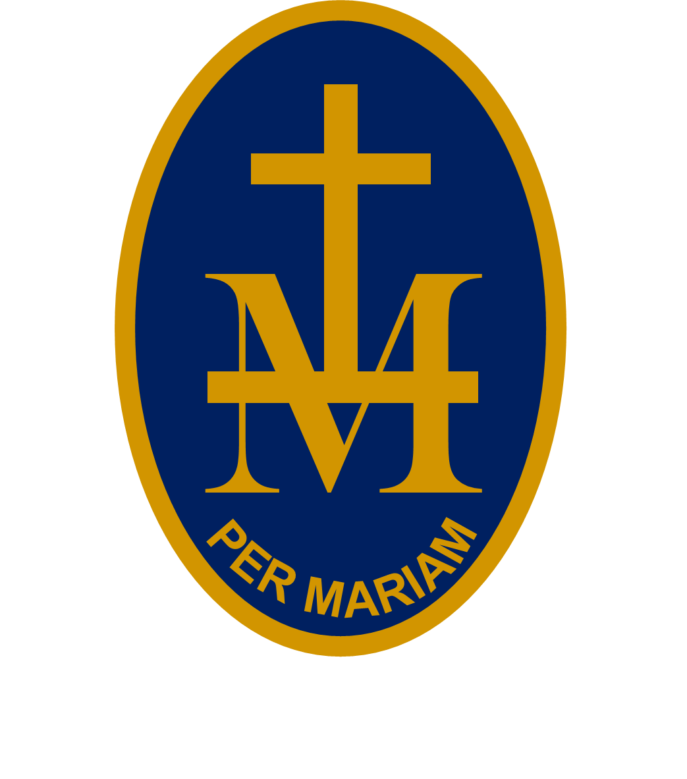
23rd

S T M A R Y ’S R C H I G H S C H O O L

BULLETIN
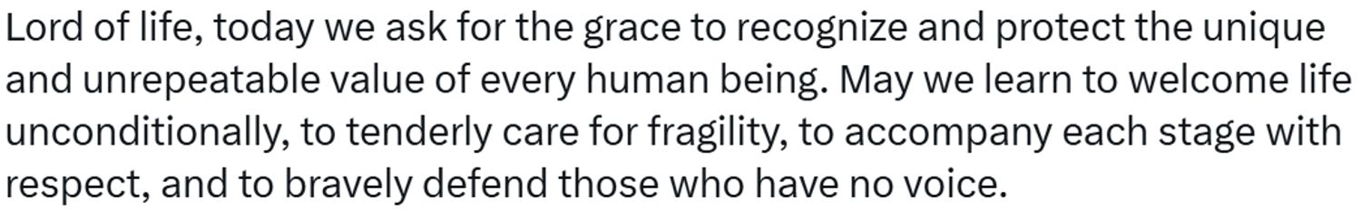

W/C 7 SEPTEMBER 2026 - WEEK 1
PUPILS: CHECK EACH WEEK AS PLANS CAN CHANGE!
MONDAY 7 SEPTEMBER:
8.55-9.15am | Hall | Yrs 8 & 9 Assembly | Mr Wetson
TUESDAY 8 SEPTEMBER:
8.55-9.15am | Hall | Yrs 10 & 11 Assembly | Mr Wetson
3.30-4.30pm | Hall | Yr 11 GCSE Revision | RE staff
WEDNESDAY 9 SEPTEMBER:
THURSDAY 10 SEPTEMBER:
1pm | Hall | Yr 10 photographs | Yr 10 Tutors
FRIDAY 11 SEPTEMBER:
10.35am-12.35pm | Sports Hall | Whole School Mass | Fr Andrew
UPCOMING EVENTS:
Thursday 17 September : Yr 7 Welcome Mass
Saturday 19 Septemver : 9am-1pm Hartpury open day
Thursday 24 September : Here Girls Can at The Courtyard
Thursday 24 September : Macmillan Coffee Morning (staff)
Thursday 1 October : 4.30pm Open Evening
Saturday 26 September : 9.30am Hereford Cathedral Sixth Form open day
Saturday 26 September : 10am-noon Lucton Sixth Form open day
Friday 2 October : Inset 3
Saturday 17 October : 9am-noon Hereford Sixth Form College open day

