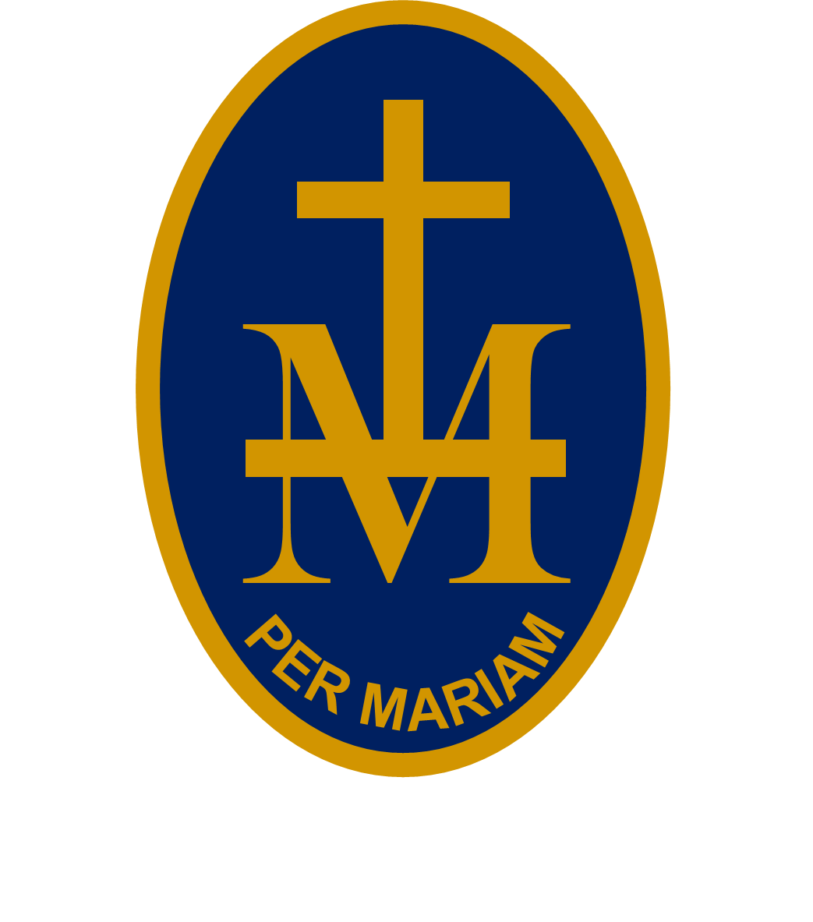
23rd

S T M A R Y ’S R C H I G H S C H O O L

BULLETIN
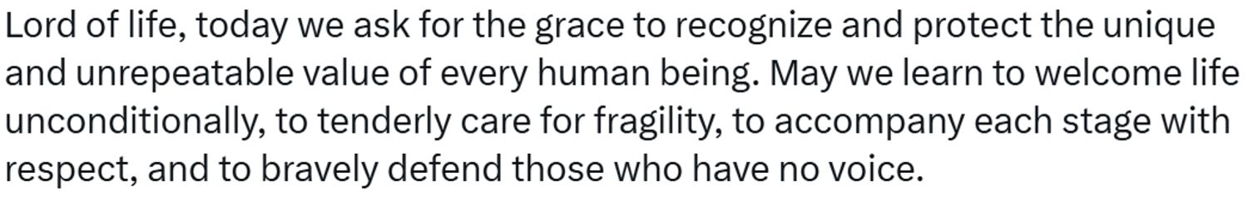
W/C 14 SEPTEMBER 2026 - WEEK 1
PUPILS: CHECK EACH WEEK AS PLANS CAN CHANGE!
MONDAY 14 SEPTEMBER:
8.55-9.15am | Hall | Marillac Assembly | Mrs Hughes
Lunchtime | Music | Yrs 10&11 Beauty & The Beast Production auditions | Miss Taylor & Mrs Robins
3.30-4.30pm | Hall | Yr 11 GCSE History revision | Mr Williams
3.25-4.25pm | DT | Yr 11 GCSE DT Group A revision | Mr Mortimer
TUESDAY 15 SEPTEMBER:
8.55-9.15am | Hall | Touret Assembly | Mr Bishop-Miller
Lunchtime | Music | School band | Mr Watson
Lunchtime | Music | Yrs 8&9 Beauty & The Beast Production auditions | Miss Taylor & Mrs Robins
3.30-4.30pm | Hall | Yr 11 GCSE revision | RE staff
3.25-4.25pm | DT | Yr 11 GCSE DT Group C revision | Mr Mortimer
3.30-4.30pm | Music | Yr 11 GCSE Music coursework support | Miss Taylor
WEDNESDAY 16 SEPTEMBER:
Lunchtime | Music | Yr 7 Beauty & The Beast Production auditions | Miss Taylor & Mrs Robins
3.30-4.30pm | Food | Yr 11 Extra cooking time | Miss Baxendale
THURSDAY 17 SEPTEMBER:
8.55-9.15am | Hall | Virgo Assembly | Mrs Beaumont
pm | Hall | Yr 7 Welcome Mass
FRIDAY 18 SEPTEMBER:
Lunchtime | Music | Audition callbacks | Miss Taylor & Mrs Robins
UPCOMING EVENTS:
Saturday 19 September : 9am-1pm Hartpury open day
Thursday 24 September : Here Girls Can at The Courtyard
Thursday 24 September : Macmillan Coffee Morning (staff)
Saturday 26 September : 9.30am Hereford Cathedral Sixth Form open day
Saturday 26 September : 10am-noon Lucton Sixth Form open day
Thursday 1 October : 4.30pm Open Evening
Friday 2 October : Inset 3
Thursday 15 October : 6-8pm Yrs 9-11 Careers Convention at Bishops School
Saturday 17 October : 9am-noon Hereford Sixth Form College open day

