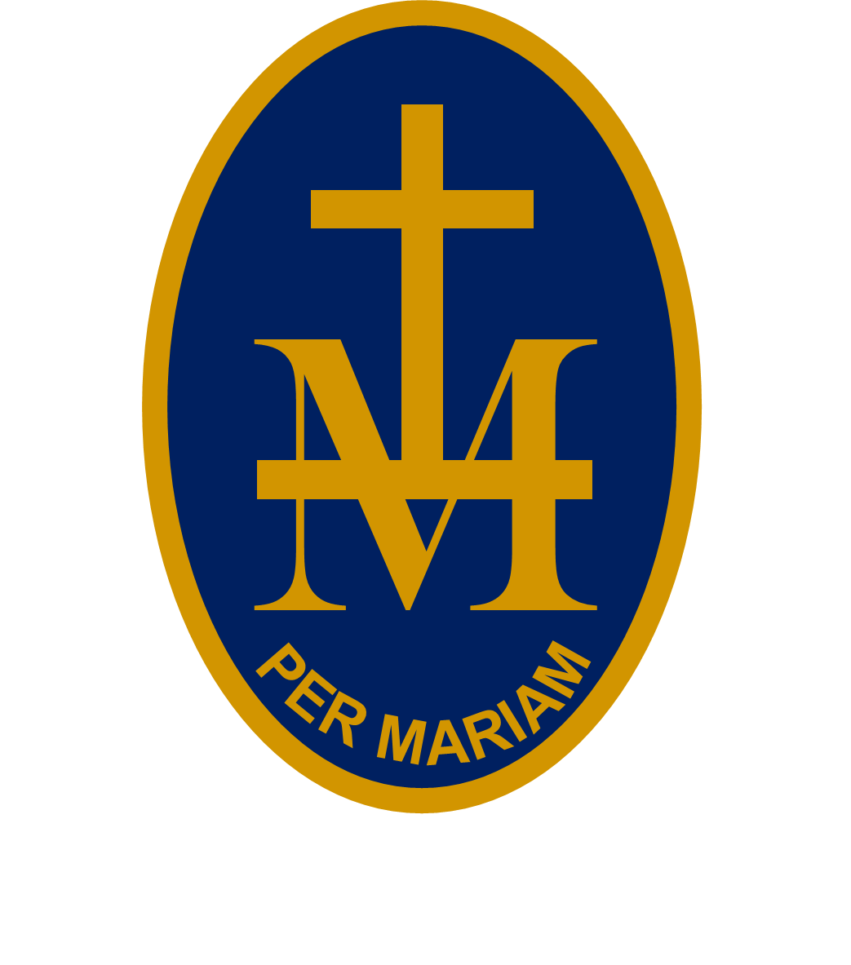
emily23rd

S T M A R Y ’S R C H I G H S C H O O L

BULLETIN
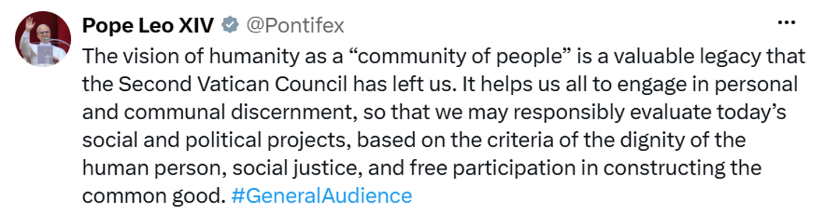
W/C 19 OCTOBER 2026 - WEEK 2
PUPILS: CHECK EACH WEEK AS PLANS CAN CHANGE!
MONDAY 19 OCTOBER:
AM reg | 20 | Yr 8 Rapid Reader (invite only) | Mrs Ede
AM reg | 24 | Yrs 7 & 8 Touch Typing (invite only) | Mrs Ede
Lunchtime | 22 | Yr 7 Activity/lunch club | Mrs Fortey & Mrs Thompson
Lunchtime | Music | Yr 11 GCSE Music Composing | Miss Taylor
12.35-12.50pm | 7 | Yr 11A French intervention | Mrs Hardwick
3.30-4.30pm | Hall | Yr 11 GCSE History revision | Mr Williams
3.25-4.25pm | DT | Yr 11 GCSE DT Group A revision | Mr Mortimer
3.30-4.45pm | Music &  Drama | Beauty & The Beast rehearsal (Les Fille, Gaston, Belle, Lefou, Mrs Potts, Madame) | Mrs Robins & Miss Taylor
TUESDAY 20 OCTOBER:
AM reg | 20 | Yr 8 Rapid Reader (invite only) | Mrs Ede
AM reg | 24 | Yrs 7 & 8 Touch Typing (invite only) | Mrs Ede
12.50-1.15pm | Music | School band | Miss Taylor
12.35-12.50pm | 7 | Yr 11A French intervention | Mrs Hardwick
Lunchtime | 22 | Yr 7 Activity/lunch club | Mrs Fortey & Mrs Thompson
Lunchtime | Library | Student Librarian meeting | Mrs Griffiths
3.30-4.30pm | Hall | Yr 11 GCSE revision | RE staff
3.25-4.25pm | DT | Yr 11 GCSE DT Group C revision | Mr Mortimer
3.30-4.30pm | 25 | Homework Club | Mrs Fortey / Mrs Corrick
3.30-4.30pm | Food | Yr 10 Cooking | Miss Baxendale
3.30-4.30pm | Music | Yr 11 GCSE Music composing | Miss Taylor
WEDNESDAY 21 OCTOBER:
12.35-1pm | 8 | Yr 11 GCSE French | Mrs Taylor
12-7pm |  | Yrs 10 & 11 Back To The Future at Bristol Hippodrome | M
Lunchtime | LC1 | CAFOD / SVP | Miss Leslie
Lunchtime | Music | Yr 11 GCSE Music Composing | Miss Taylor
Lunchtime | 22 | Yr 7 Activity/lunch club | Mrs Fortey & Mrs Thompson
Lunchtime | Library | Student Librarian meeting | Mrs Griffiths
12.35-12.50pm | 7 | Yr 11A French intervention | Mrs Hardwick
3.30-4.30pm | Food | Yr 11 Cooking | Miss Baxendale
4.30-5pm | Main hall | Parents Study Session Guide | Mr Cassidy
THURSDAY 22 OCTOBER:
8.55-9.15am | Main hall | Yr 10 Assembly – British Values | Mr Coyne
AM reg | 20 | Yr 9 Rapid Reader (invite only) | Mrs Ede
AM reg | 24 | Yrs 7 & 8 Touch Typing (invite only) | Mrs Ede
12.35-12.50pm | 7 | Yr 11A French intervention | Mrs Hardwick
12.35-1pm | 8 | Yr 11 GCSE French | Mrs Taylor
12.50-1.15pm | Music | Choir | Miss Taylor
Lunchtime | 22 | Yr 7 Activity/lunch club | Mrs Fortey & Mrs Thompson
4.30-6.30pm |  | Yrs 10 & 11 HWGTA Open Evening
FRIDAY 23 OCTOBER:
All day | Main hall, LC & Chapel | Yr 7 Retreat Day  (non-uniform and off timetable) | Mrs Surman
8.55-9.15am | Main hall | Yr 11 Assembly – British Values | Mr Coyne
AM reg | 20 | Yr 9 Rapid Reader (invite only) | Mrs Ede
AM reg | 24 | Yrs 7 & 8 Touch Typing (invite only) | Mrs Ede
Lunchtime | 22 | Yr 7 Activity/lunch club | Mrs Jones & Mrs Thompson
Lunchtime | Music | Keyboard club | Mr Watson
3.30-4.45pm | Main hall | Beauty & The Beast rehearsal (ALL cast) | Mrs Robins & Miss Taylor
 |  | HALF-TERM BREAK
UPCOMING EVENTS:
Monday 2 November : School starts
Tuesday 3 November : P5 main hall Yr 11 B band A Level Philosphy and Ethics taster session – Mrs Surman
Friday 6 November : P5 main hall Yr 11 A band A Level Philosphy and Ethics taster session – Mrs Surman
Thursday 12 November : 5-7.30pm JKHS Sixth Form Open Evening

