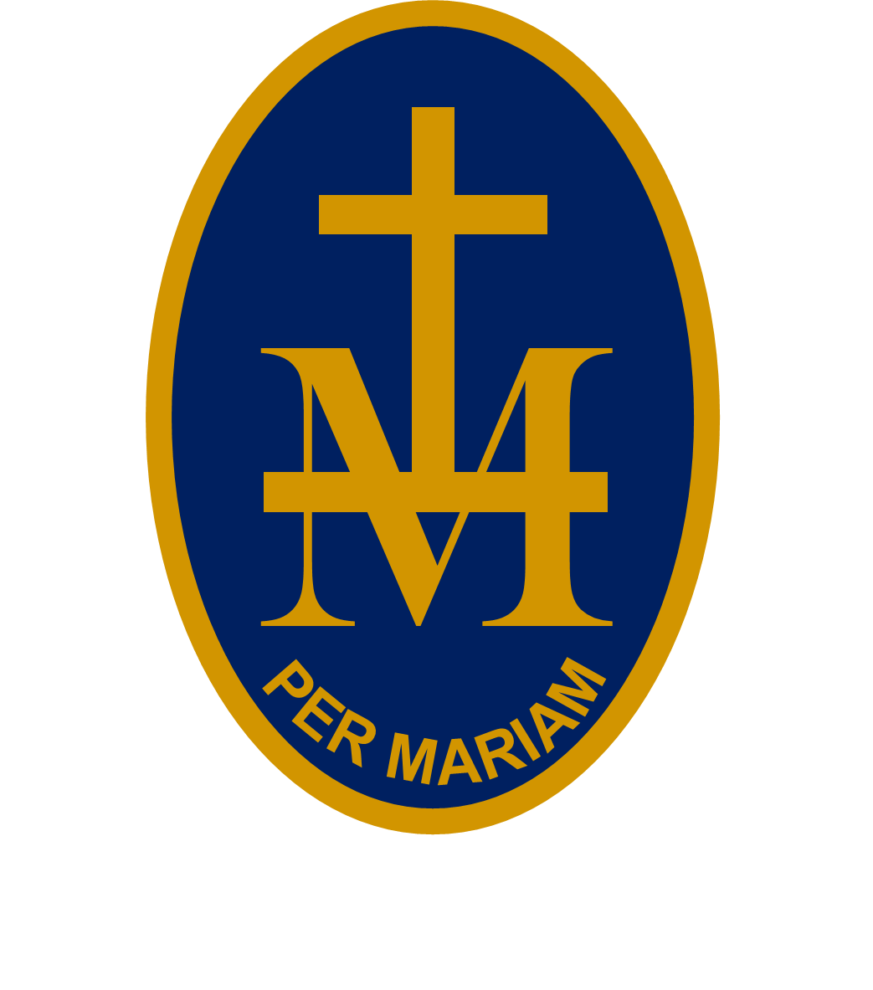
emily23rd

S T M A R Y ’S R C H I G H S C H O O L

BULLETIN
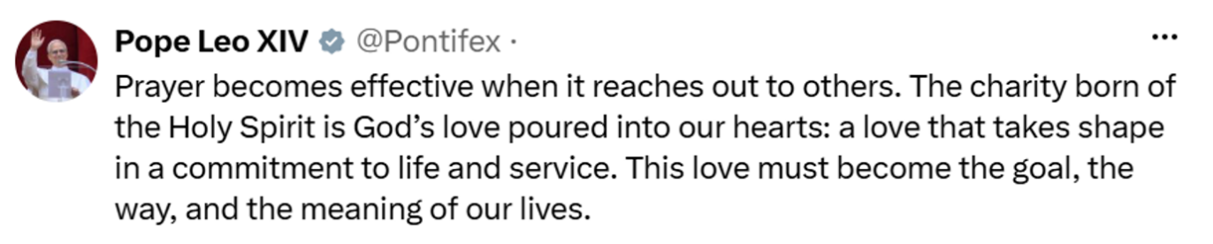
W/C 2 NOVEMBER 2026 - WEEK 1
PUPILS: CHECK EACH WEEK AS PLANS CAN CHANGE!
MONDAY 2 NOVEMBER:
8.55-9.15am | Hall | Yr 7 Assembly | Mrs Avery
AM reg | 22 | Yr 11 German invervention | Mrs Budden
AM reg | 20 | Yr 8 Rapid Reader (invite only) | Mrs Ede
AM reg | 24 | Yrs 7 & 8 Touch Typing (invite only) | Mrs Ede
Lunchtime | Caritas meeting room | Yr 11 German speaking practice | Mrs Budden
Lunchtime | 22 | Yr 7 Activity/lunch club | Mrs Fortey & Mrs Thompson
Lunchtime | Music | Yr 11 GCSE Music Composing | Miss Taylor
12.35-12.50pm | 7 | Yr 11A French intervention | Mrs Hardwick
3.30-4.30pm | Hall | Yr 11 GCSE History revision | Mr Williams
3.25-4.25pm | DT | Yr 11 GCSE DT Group A revision | Mr Mortimer
3.30-4.45pm | Drama & 18 | Beauty & The Beast rehearsal (ALL cast) | Mrs Beaumont & Miss Taylor
TUESDAY 3 NOVEMBER:
8.55-9.15am | Hall | Yrs 8 & 9 Assembly | Mrs Avery
AM reg | 20 | Yr 8 Rapid Reader (invite only) | Mrs Ede
AM reg | 24 | Yrs 7 & 8 Touch Typing (invite only) | Mrs Ede
12.50-1.15pm | Music | School band | Miss Taylor
12.35-12.50pm | 7 | Yr 11A French intervention | Mrs Hardwick
Lunchtime | 22 | Yr 7 Activity/lunch club | Mrs Fortey & Mrs Thompson
3.30-4.30pm | Hall | Yr 11 GCSE revision | RE staff
3.25-4.25pm | DT | Yr 11 GCSE DT Group C revision | Mr Mortimer
3.30-4.30pm | 25 | Homework Club | Mrs Fortey / Mrs Corrick
3.30-4.30pm | Food | Yr 10 Cooking | Miss Baxendale
3.30-4.30pm | Music | Yr 11 GCSE Music composing | Miss Taylor
WEDNESDAY 4 NOVEMBER:
12.35-1pm | 8 | Yr 11 GCSE French | Mrs Taylor
Lunchtime | LC1 | CAFOD / SVP | Miss Leslie
Lunchtime | Music | Yr 11 GCSE Music composing | Miss Taylor
Lunchtime | 22 | Yr 7 Activity/lunch club | Mrs Fortey & Mrs Thompson
12.35-12.50pm | 7 | Yr 11A French intervention | Mrs Hardwick
3.30-4.30pm | Food | Yr 11 Cooking | Miss Baxendale
4.30pm | Main hall | Yr 7 Parents Evening
THURSDAY 5 NOVEMBER:
8.55-9.15am | Main hall | Yrs 10 & 11 Assembly | Mrs Avery
AM reg | 20 | Yr 9 Rapid Reader (invite only) | Mrs Ede
AM reg | 24 | Yrs 7 & 8 Touch Typing (invite only) | Mrs Ede
12.35-12.50pm | 7 | Yr 11A French intervention | Mrs Hardwick
12.35-1pm | 8 | Yr 11 GCSE French | Mrs Taylor
12.50-1.15pm | Music | Choir | Miss Taylor
Lunchtime | 22 | Yr 7 Activity/lunch club | Mrs Fortey & Mrs Thompson
FRIDAY 6 NOVEMBER:
AM reg | 20 | Yr 9 Rapid Reader (invite only) | Mrs Ede
AM reg | 24 | Yrs 7 & 8 Touch Typing (invite only) | Mrs Ede
Lunchtime | 22 | Yr 7 Activity/lunch club | Mrs Jones & Mrs Thompson
Lunchtime | Music | Keyboard club | Mr Watson
3.30-4.45pm | Main hall | Beauty & The Beast rehearsal (ALL cast) | Mrs Robins & Miss Taylor
UPCOMING EVENTS:
Saturday 7 November : Hereford College and Holme Lacy College open mornings
Monday 9 November : 9am-3.15pm Yrs 7-11 Flu vaccination

